Presentation - accessibility with angular

Decorative and informative image

disability is not binary... rather a spectrum

demonstration of corporate social responsibility (CSR)

Section 508 (applies to all federal agencies when they develop, procure, maintain, or use electronic and information technology)

WCAG main principles - perceivable, operable, understandable, robust,

basic accessibility testing - 60-second test - headings, "no styles", focus styles

standards -

section 508

WCAG

U.S. web design standards

Show skip link example in demo, accessibility tree in chrome for headings

Disclaimer - The purpose of these talks is to share knowledge, learnings and stories with the wider technological community. This presentation relates solely to the individual presentation and does not reflect the opinion or analysis of Xero.

Most governments and big companies ai for WCAG 2.1 Level AA compliance

Headings (semantics, nesting)

keyboard (functionality, visibility)

axe DevTools (errors, omissions)

most important things - small accessibility improvements help more people than we might think

Do initial analysis for email

raise ticket for raising event on file uploaded

A strong five‑sentence argument will influence readers more than a brilliant but bloated 100‑sentence essay

Test with disabled person

WCAG 2.0, 2.1, 2.2

Automated testing is useful for things like - color contrast, suspect markup, missing content like image alt text and document <title>, touch target size

A bunch of design stuff - descriptive (alt) text makes sense, form field labels provide enough information, captions match a video's audio track, using color alone  to convey meaning, icon-only buttons,

what is landmark as questions - header, navigation, main content, sidebar with content filters, footer

Find questions which people can ask based on content

Find theory for each presentation slide

An illness, injury, or condition that makes it difficult for someone to do the things that other people do

Perceivable - people must be able to find your content (all non-text content has a text alternative) like img,

Perceivable - people must be able to find your content. all non-text content has a text alternative.

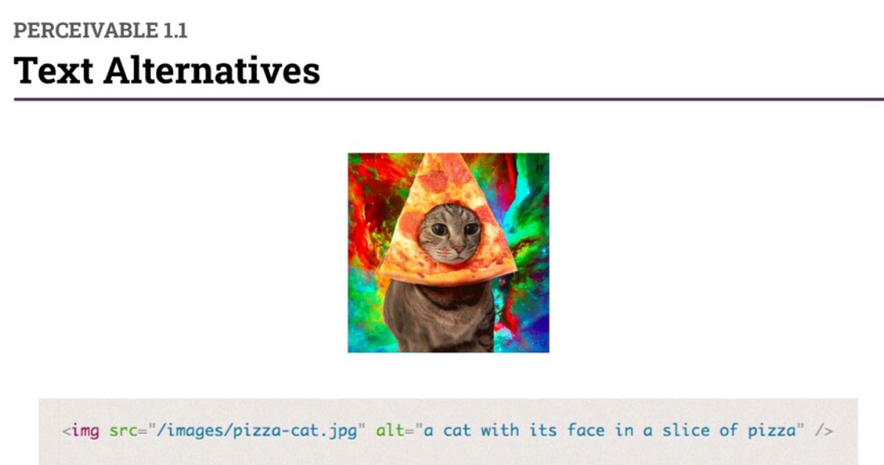

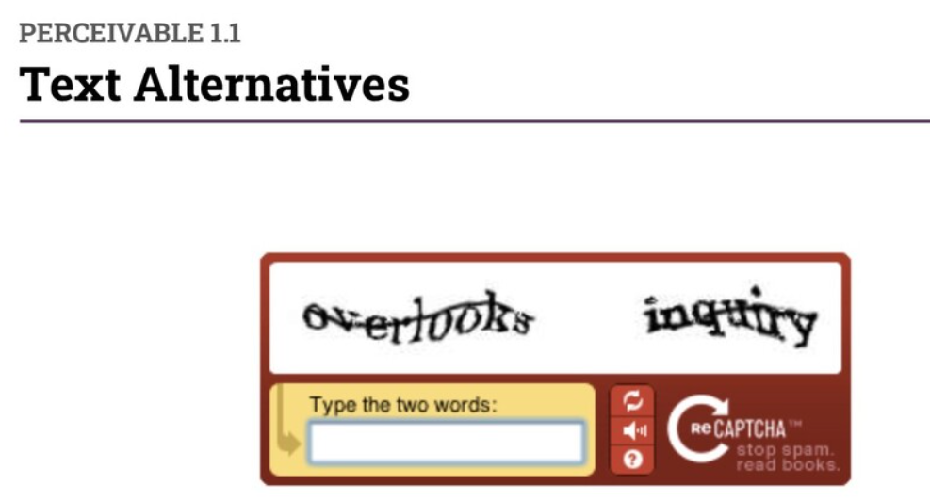

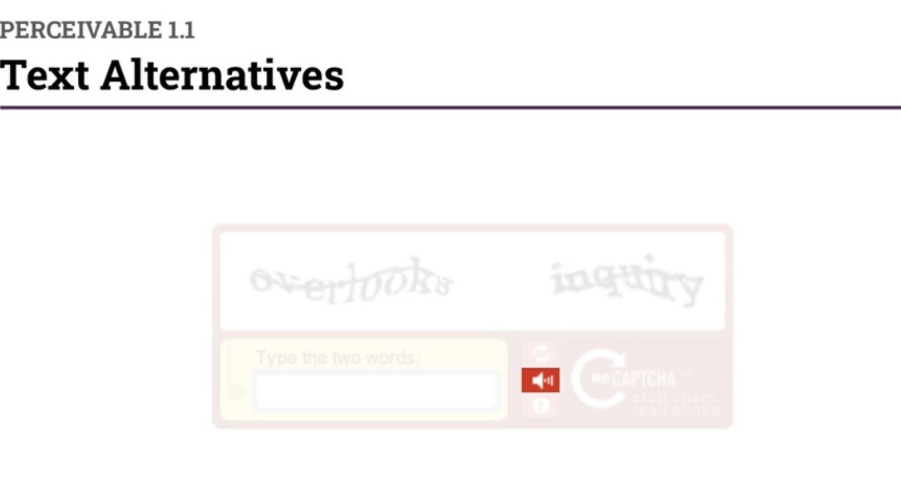

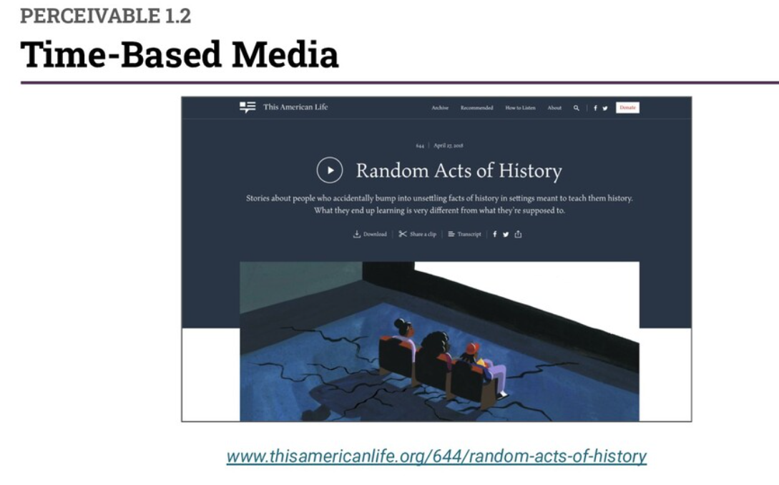

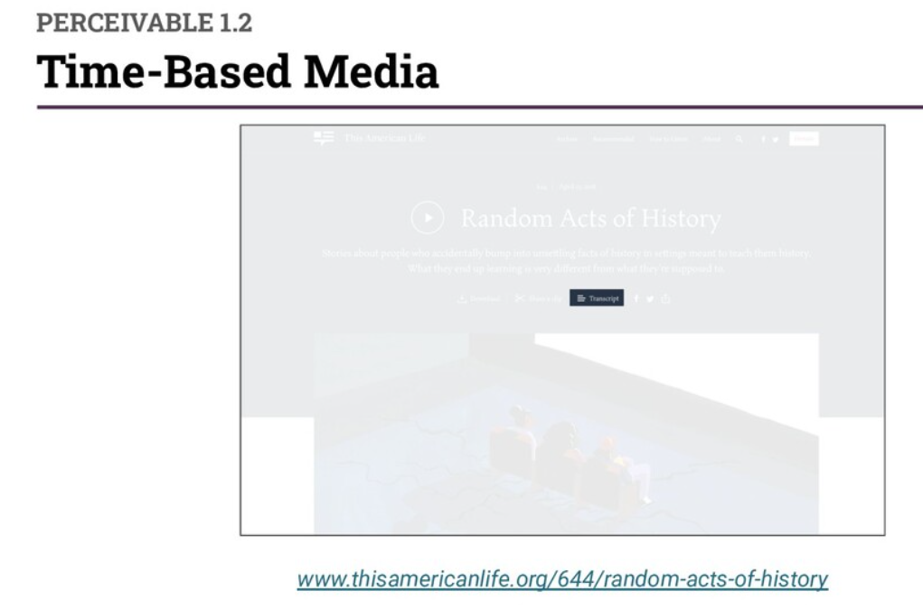

Adaptable – content ca be presented in different ways without losing context.

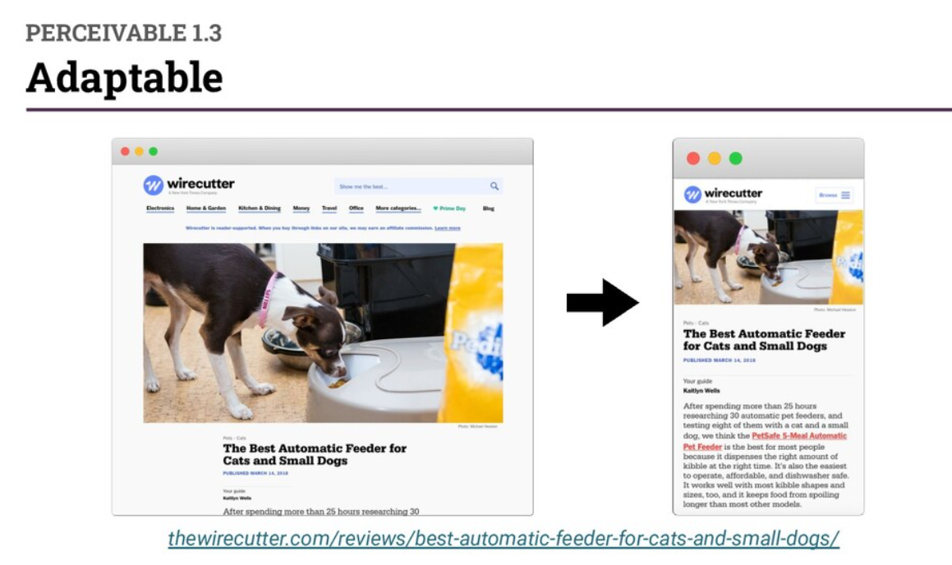

Operable – people must be able to use your website.

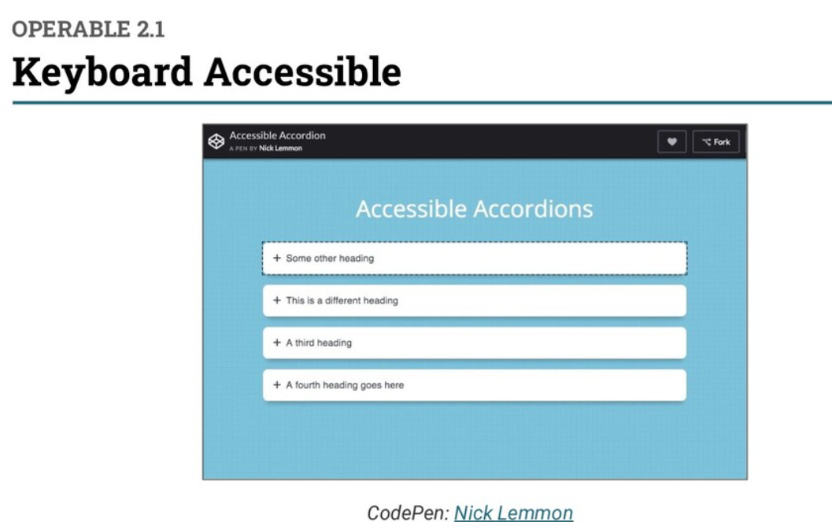

All parts of a website can be accessed using other input devices besides a keyboard. Input modalities - mouse touch screen, speech to text.

Understandable – people must be able to understand your website. Readable – use simple language and avoid jargon when possible.

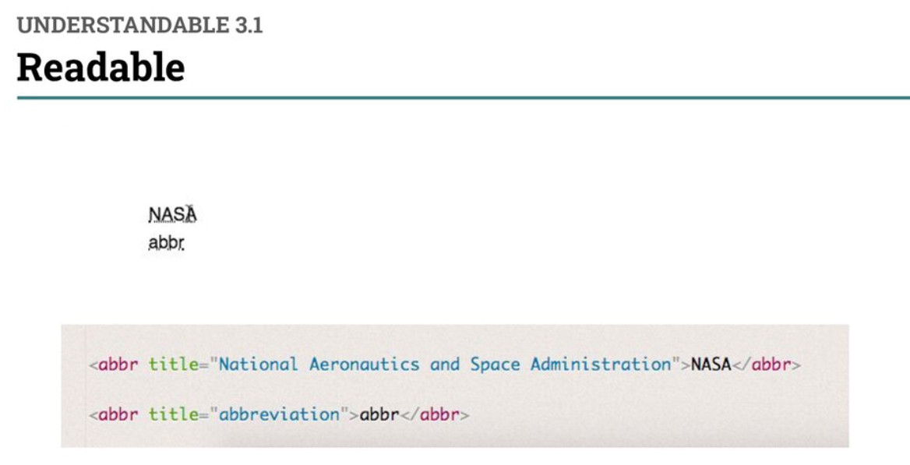

Use code pen like below for live demo

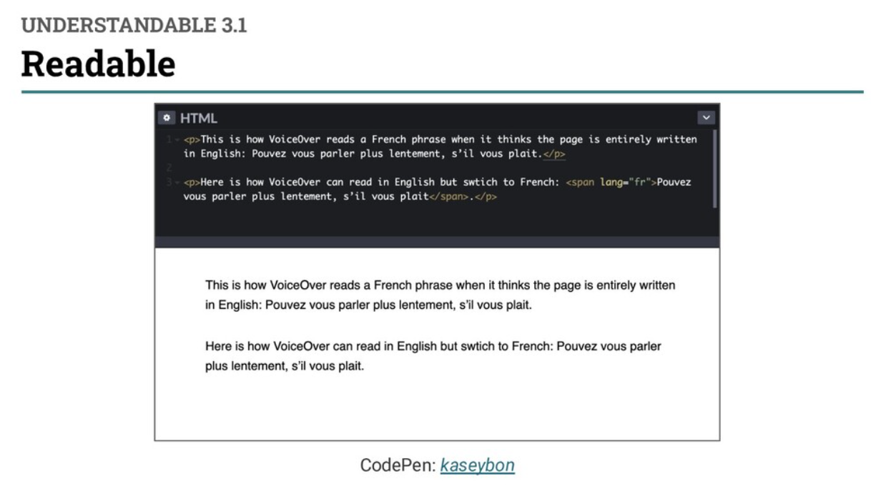

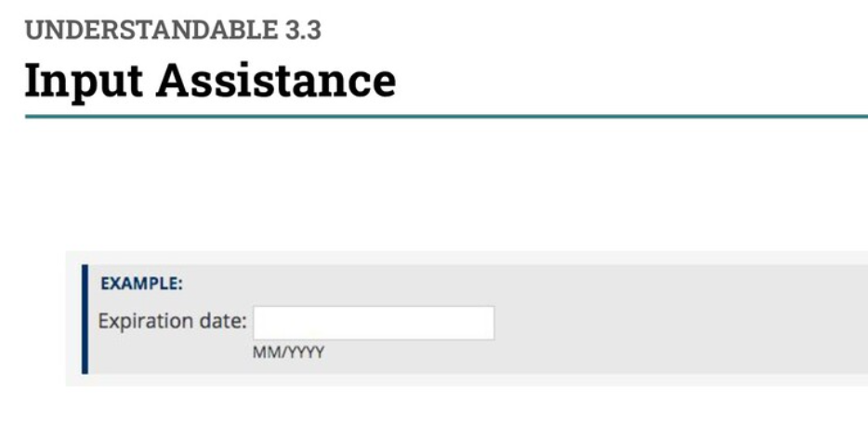

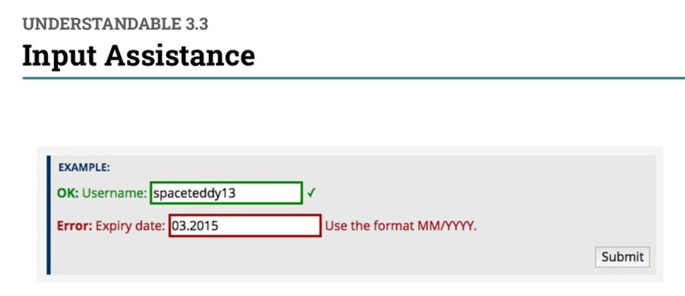

Robust – your website must work with different technologies. Compatible – build websites that work with current and future assistive technology. Compatible – write valid, sematic HTML.

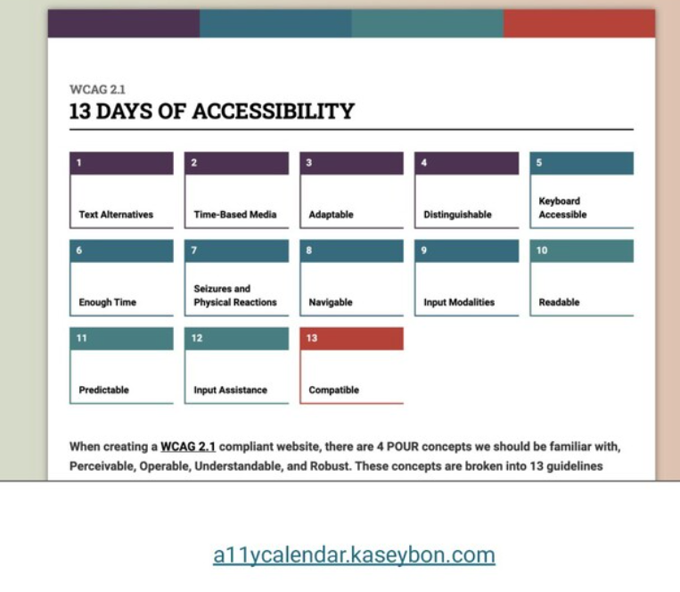

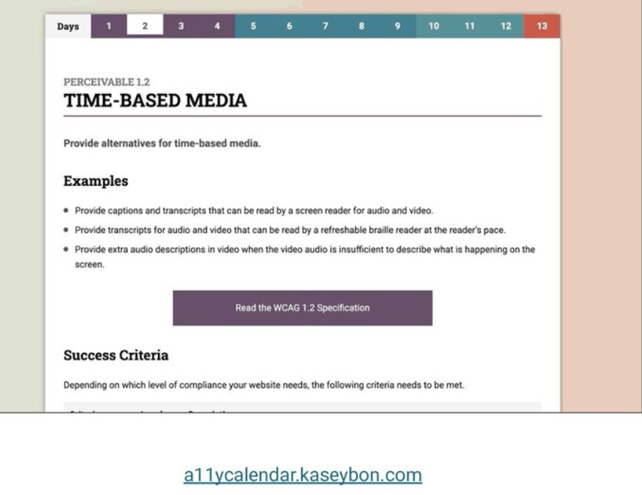

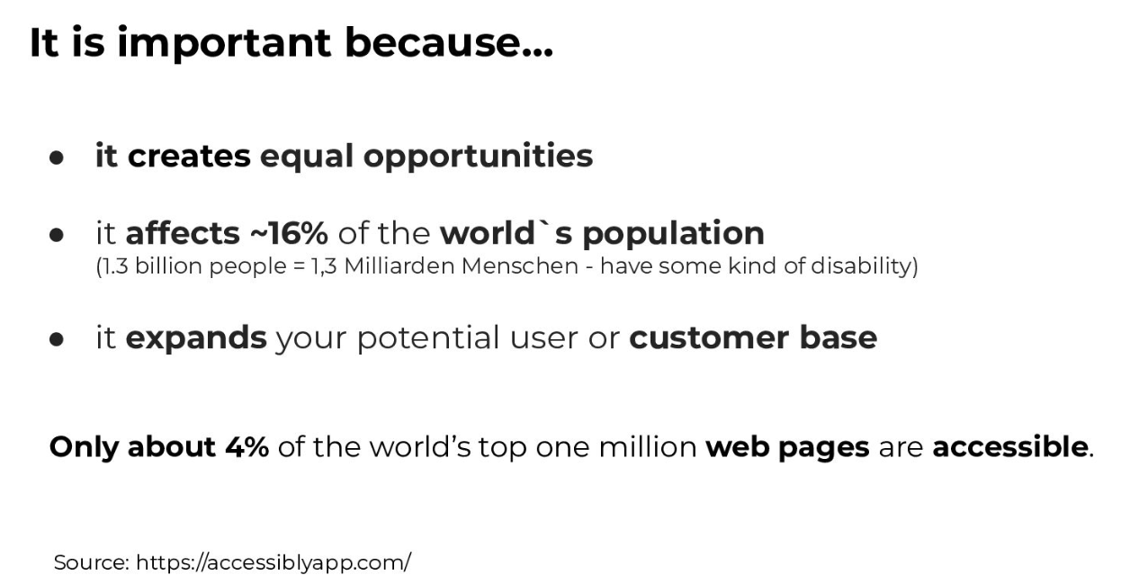

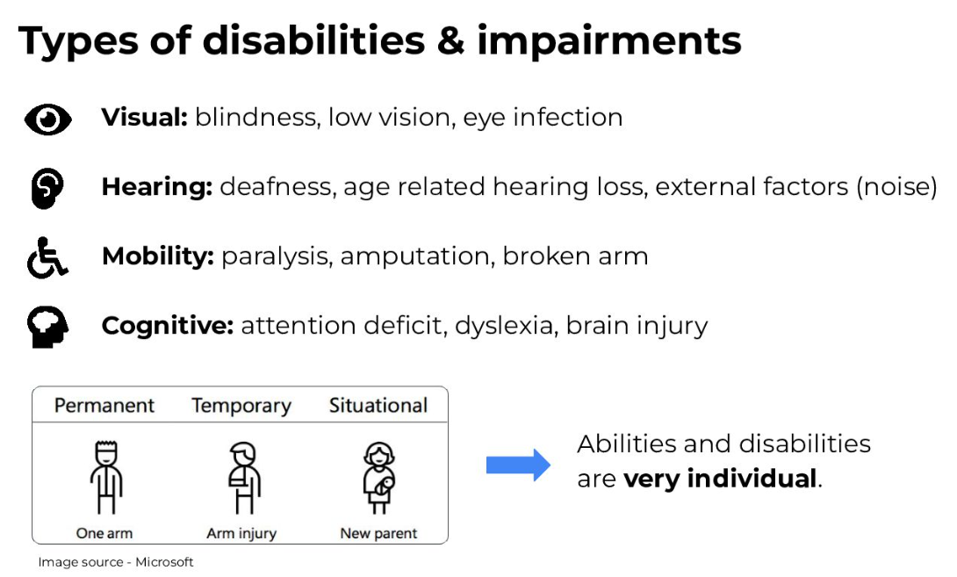

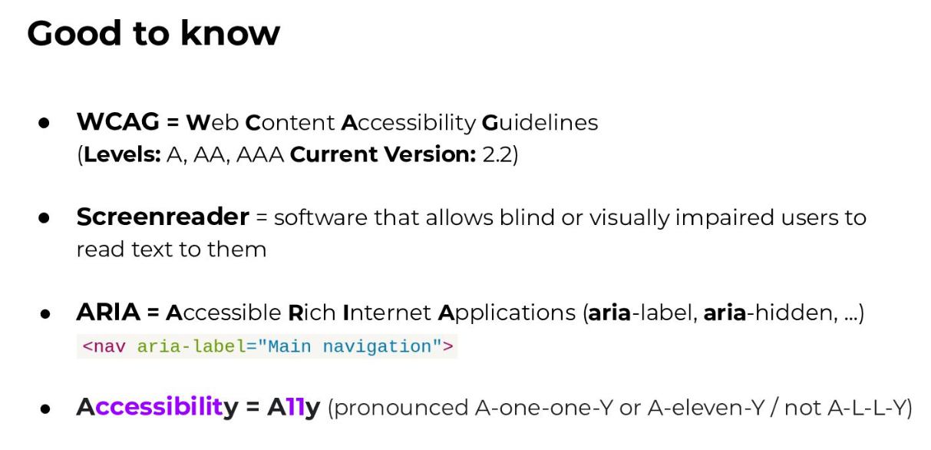

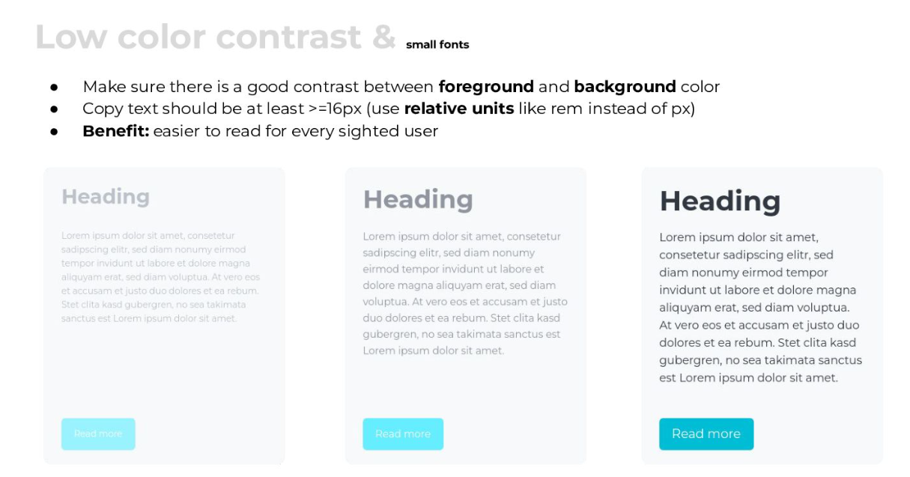

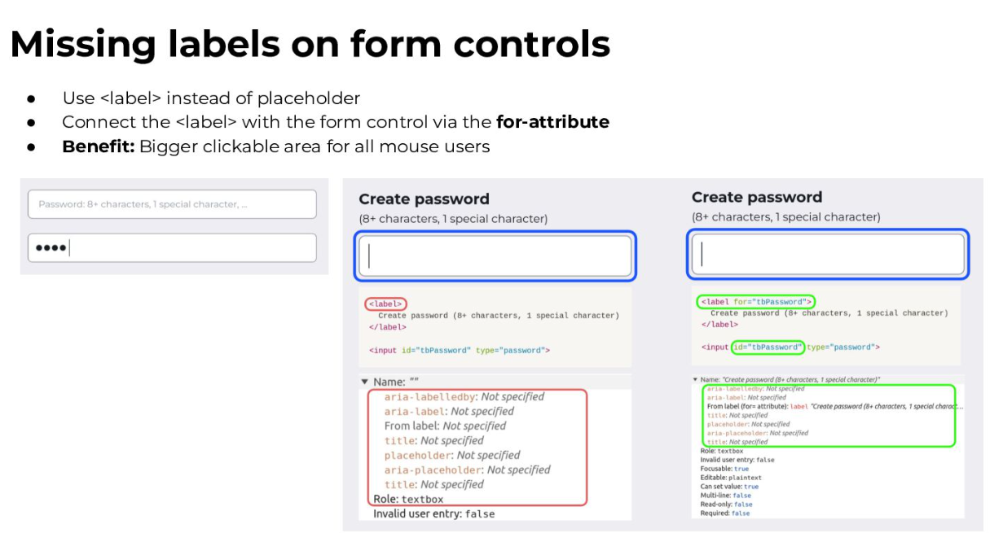

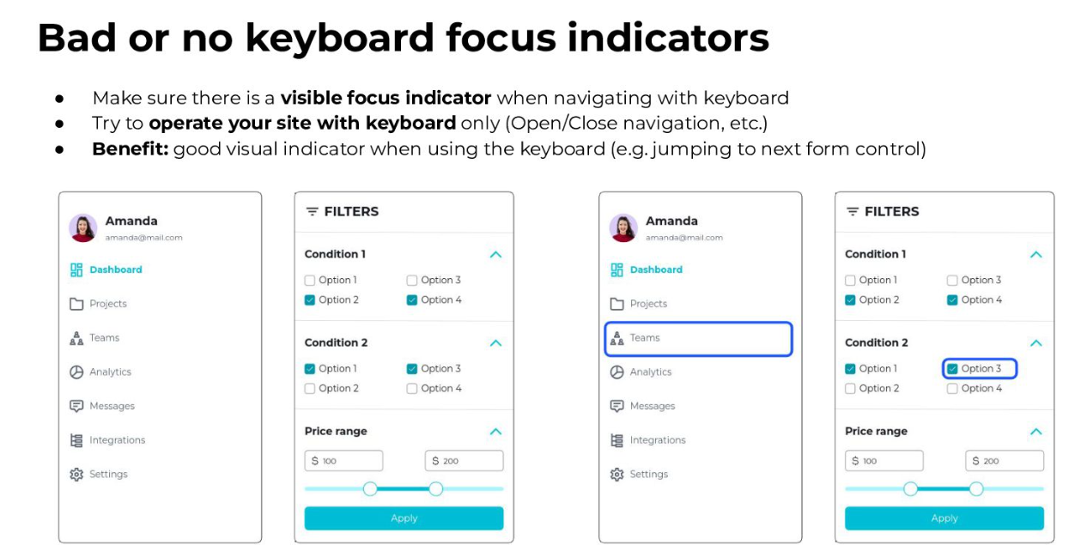

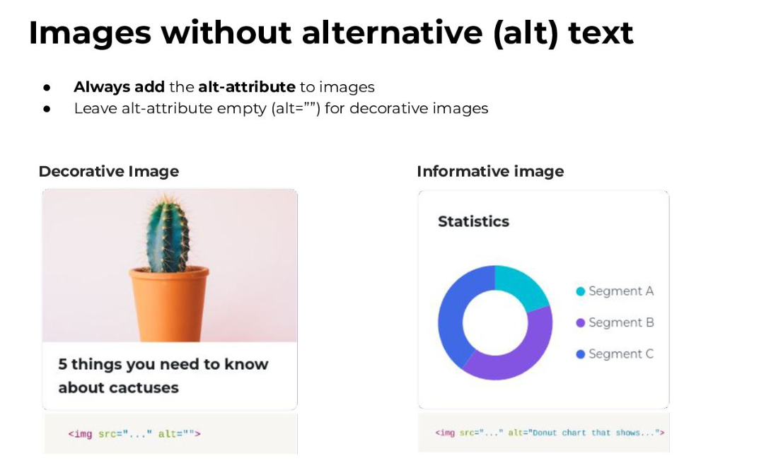

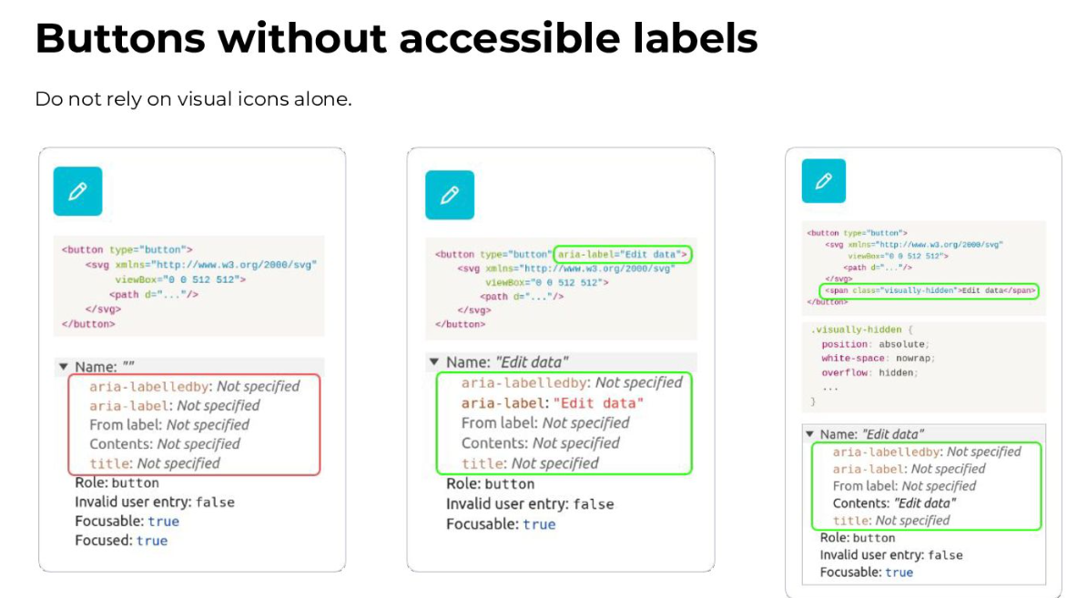

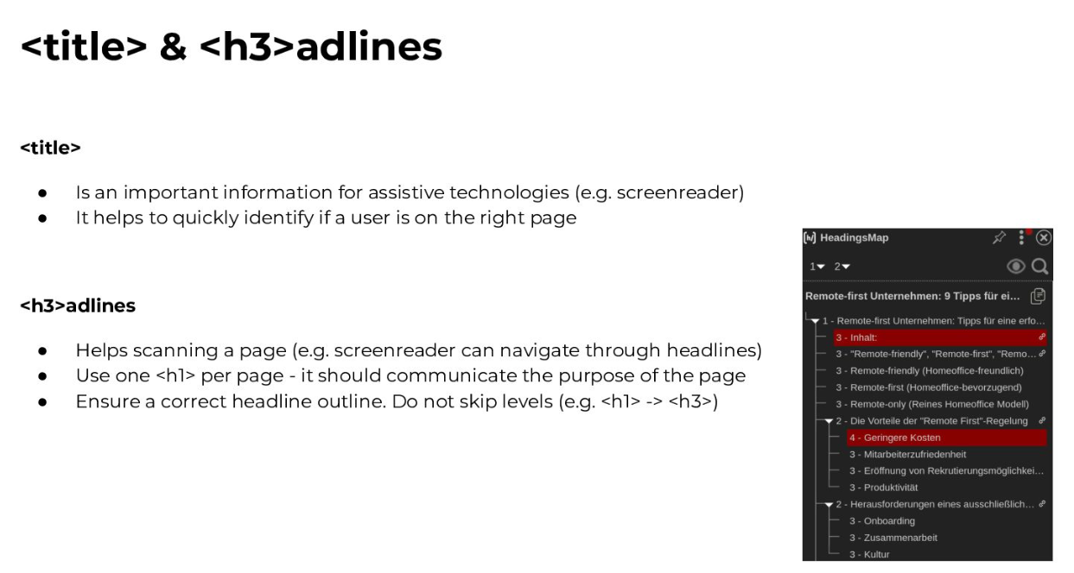

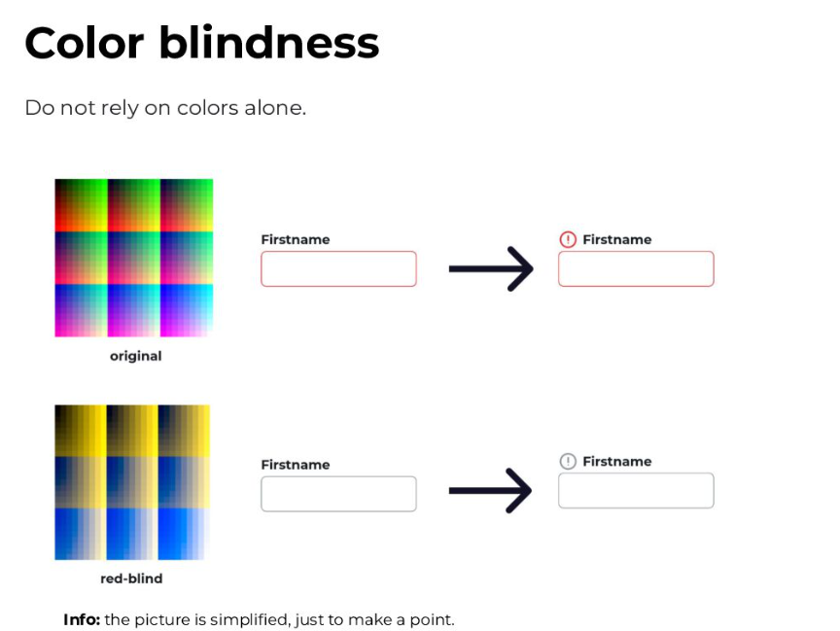

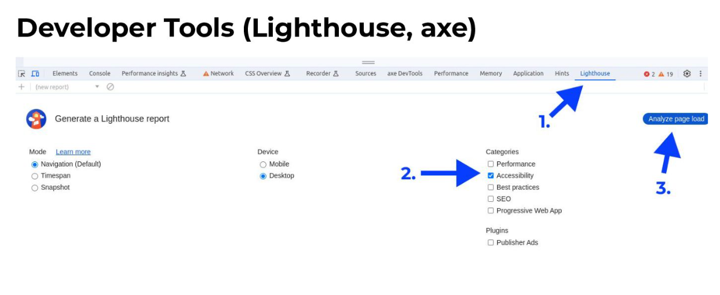

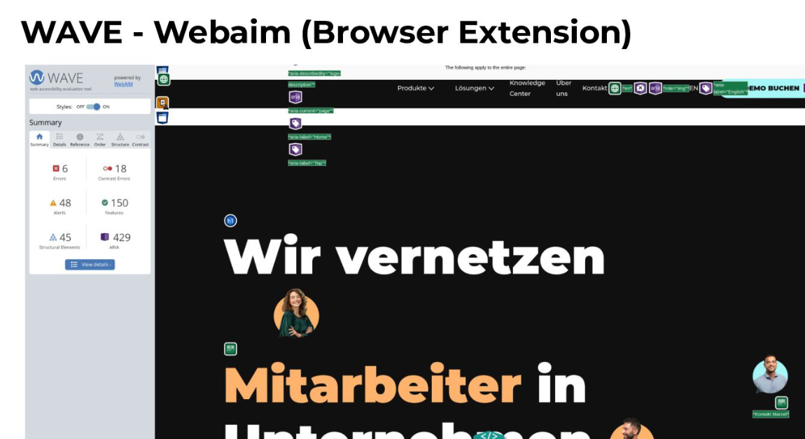

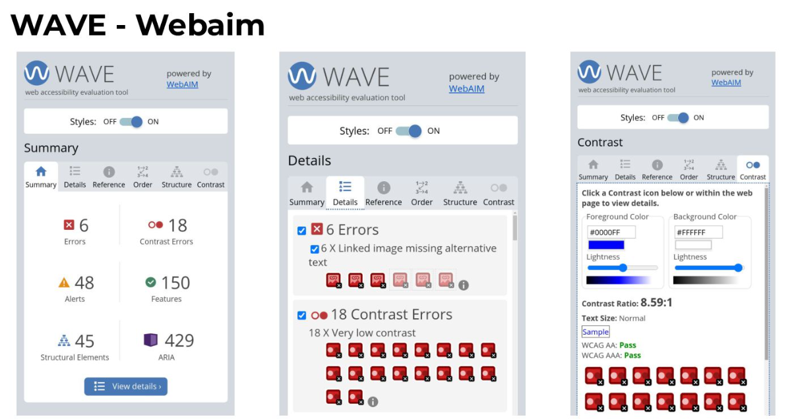

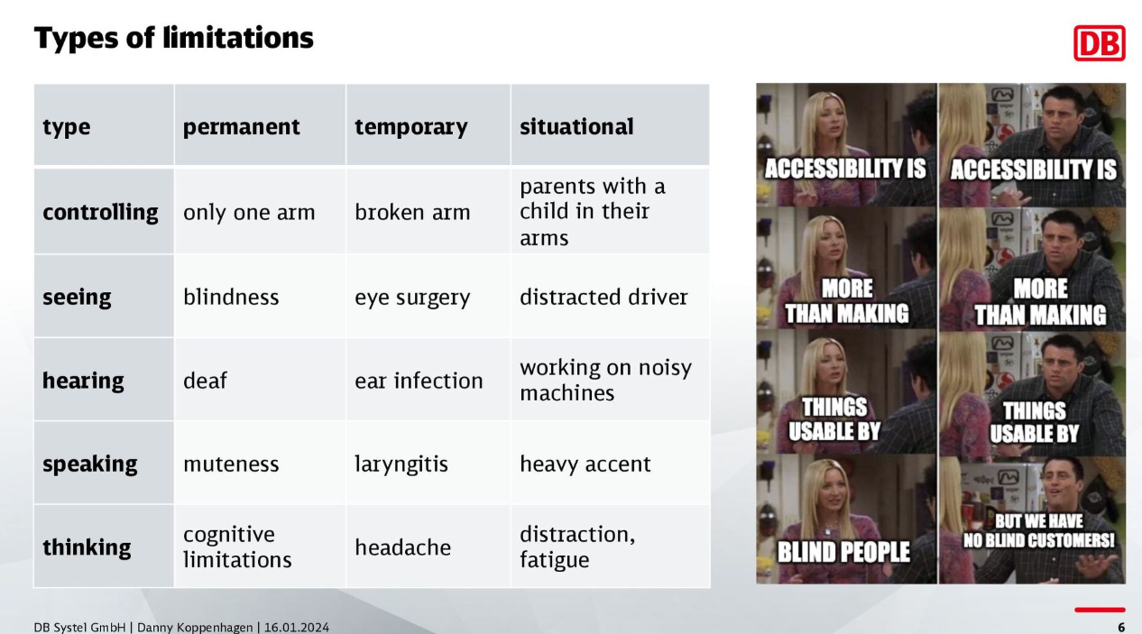

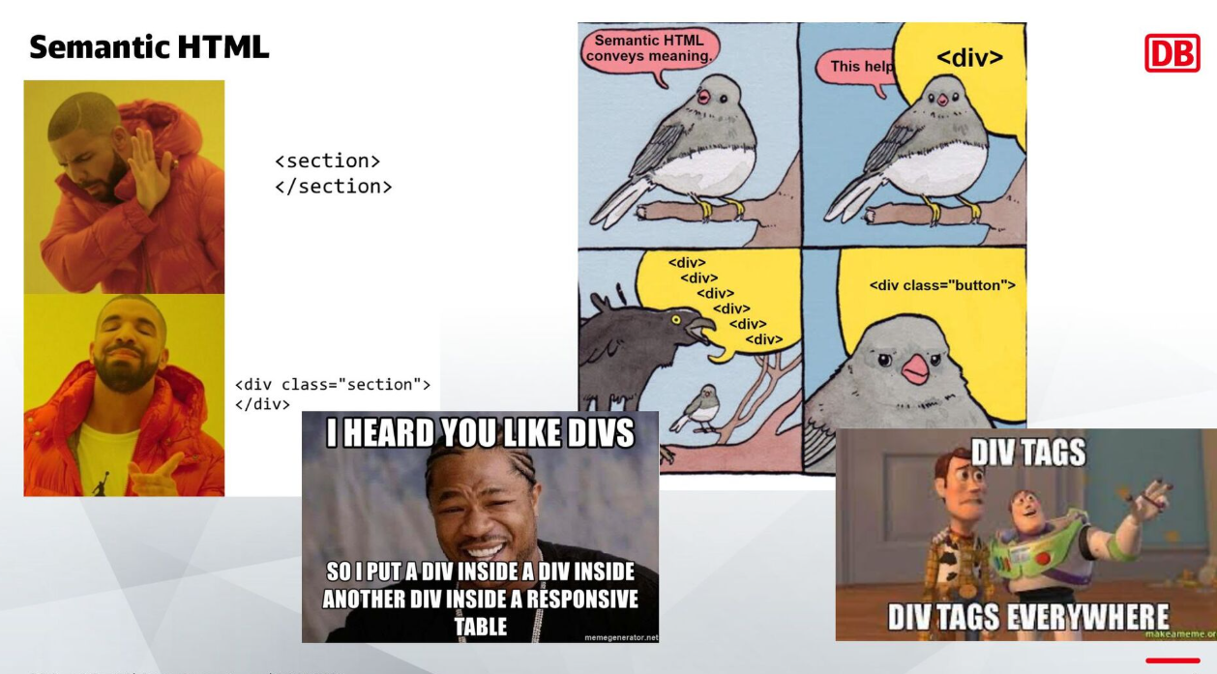

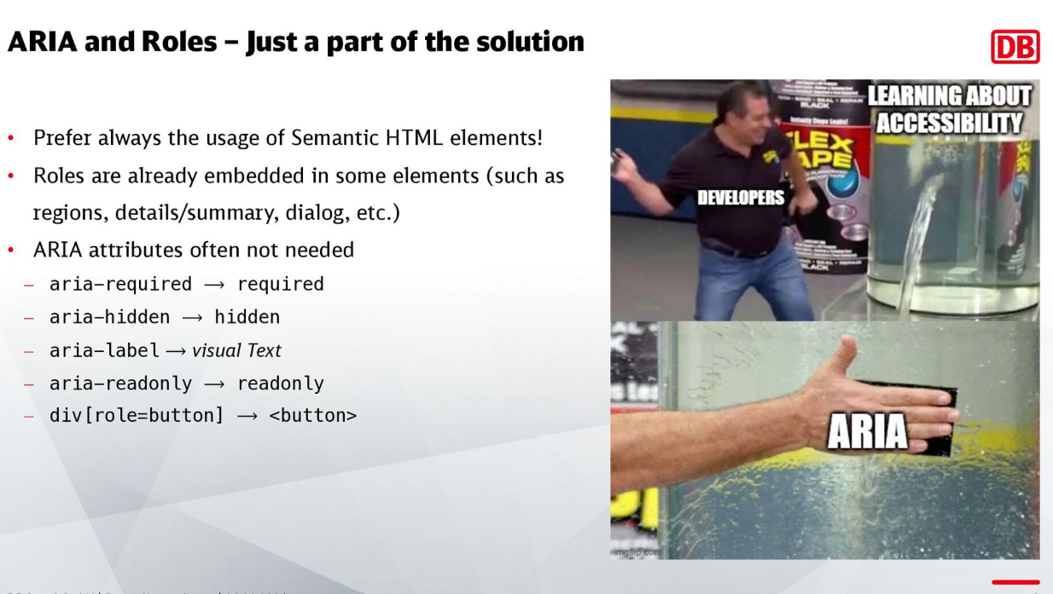

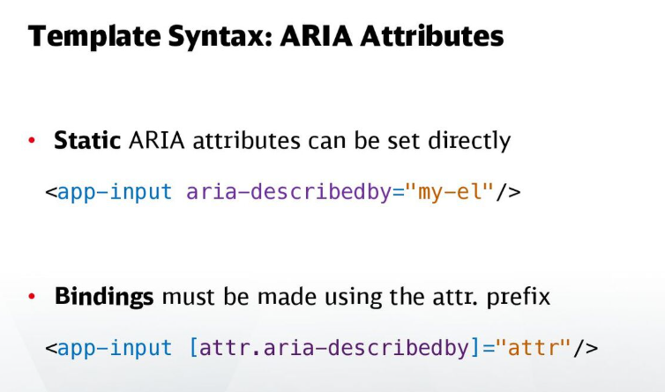

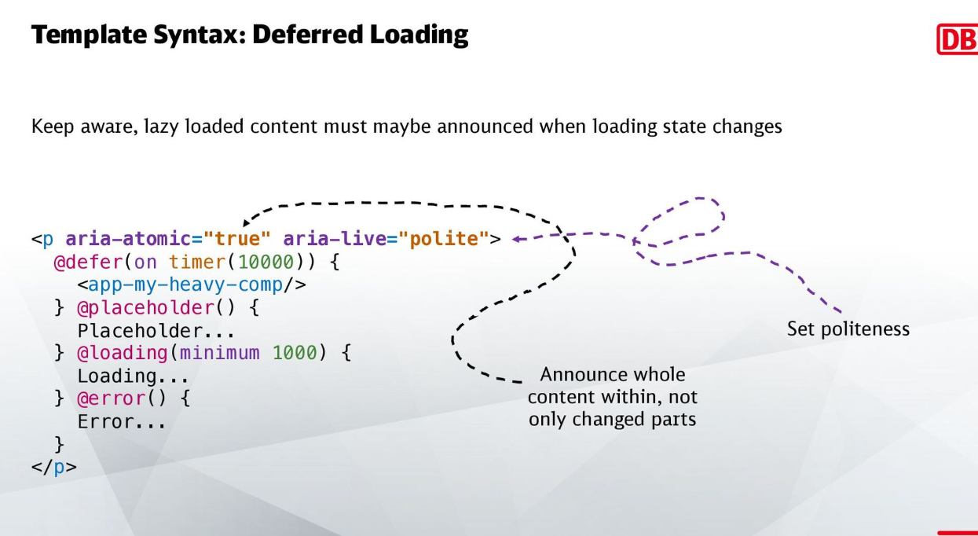

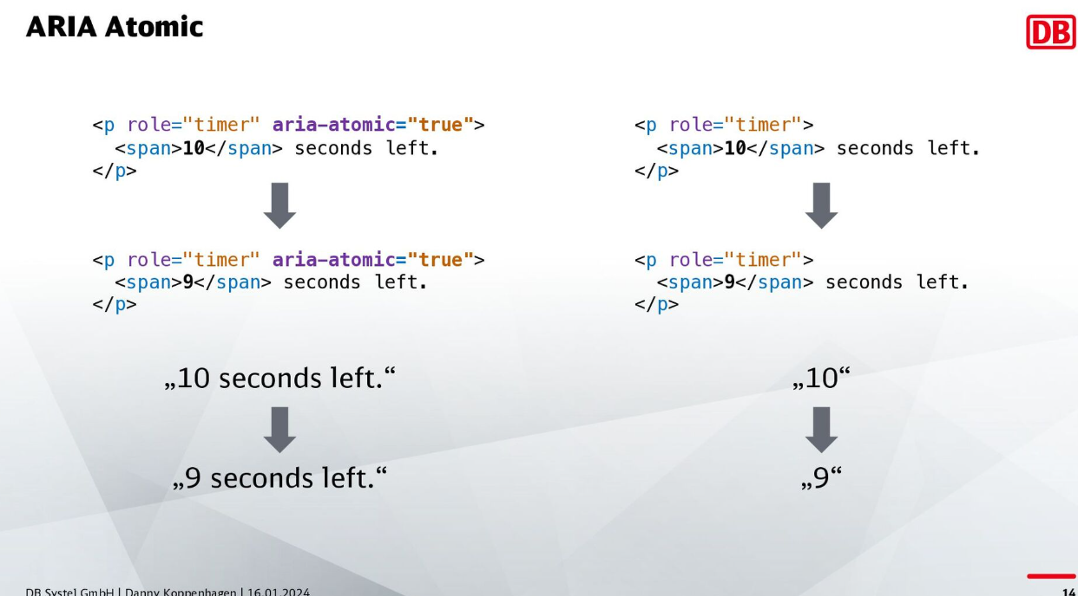

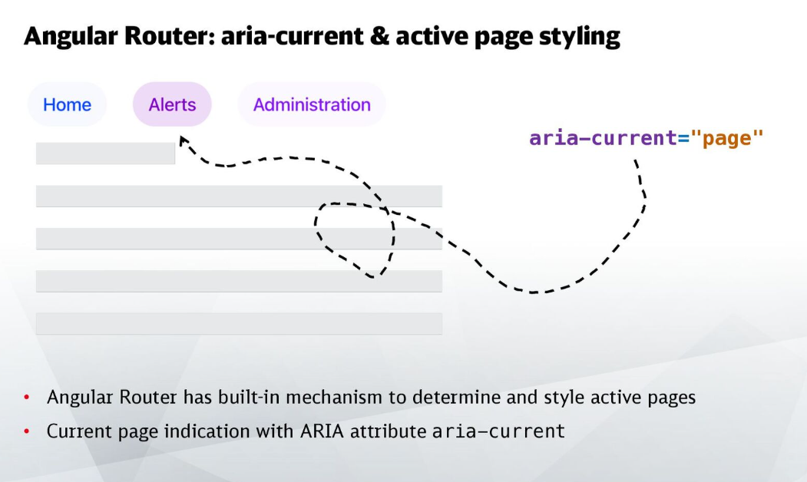

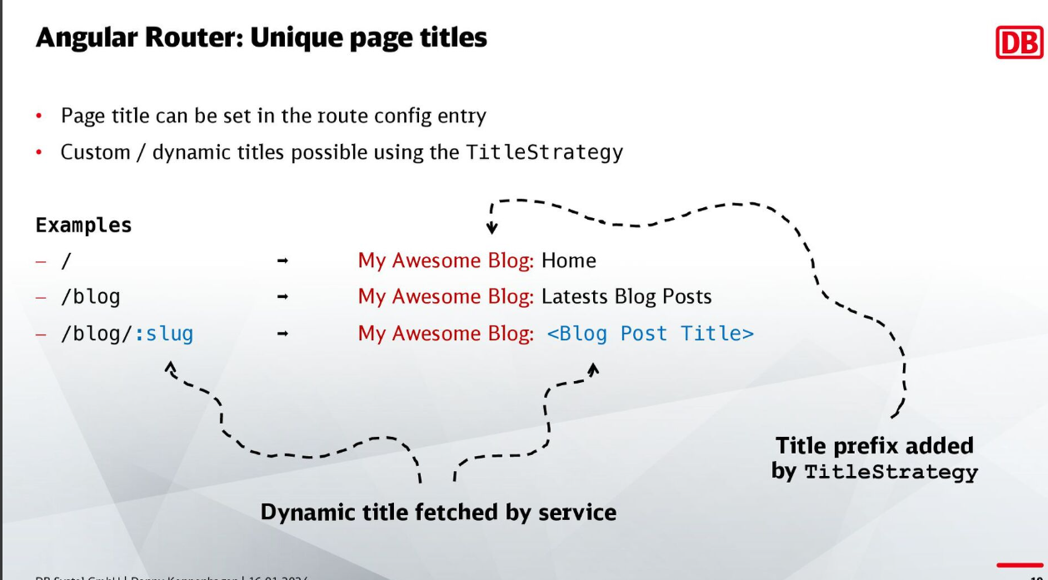

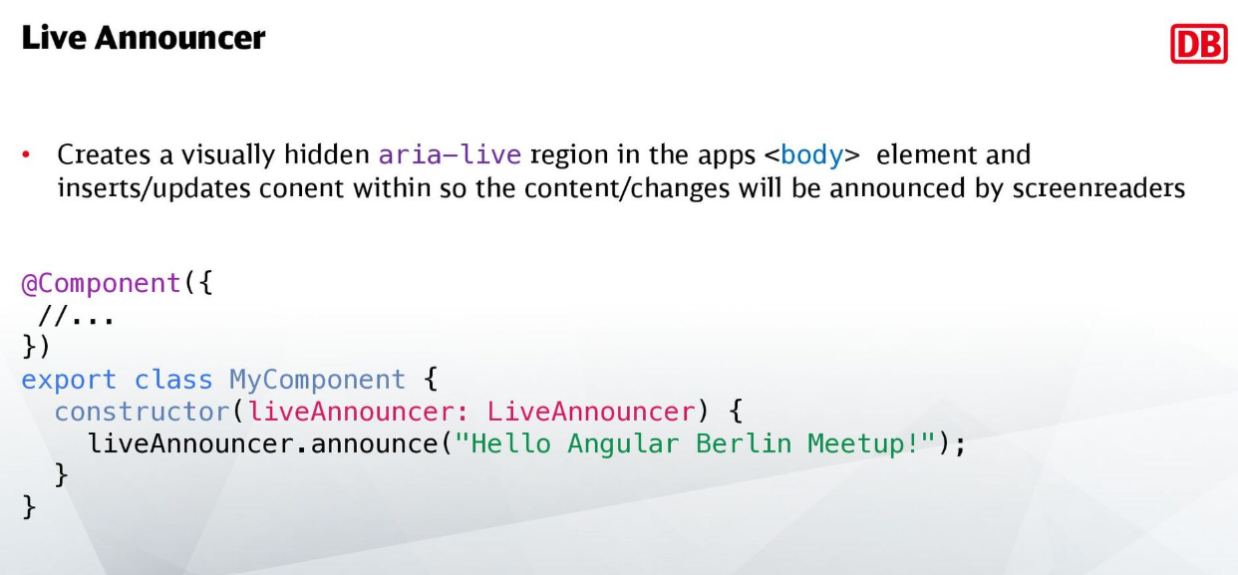

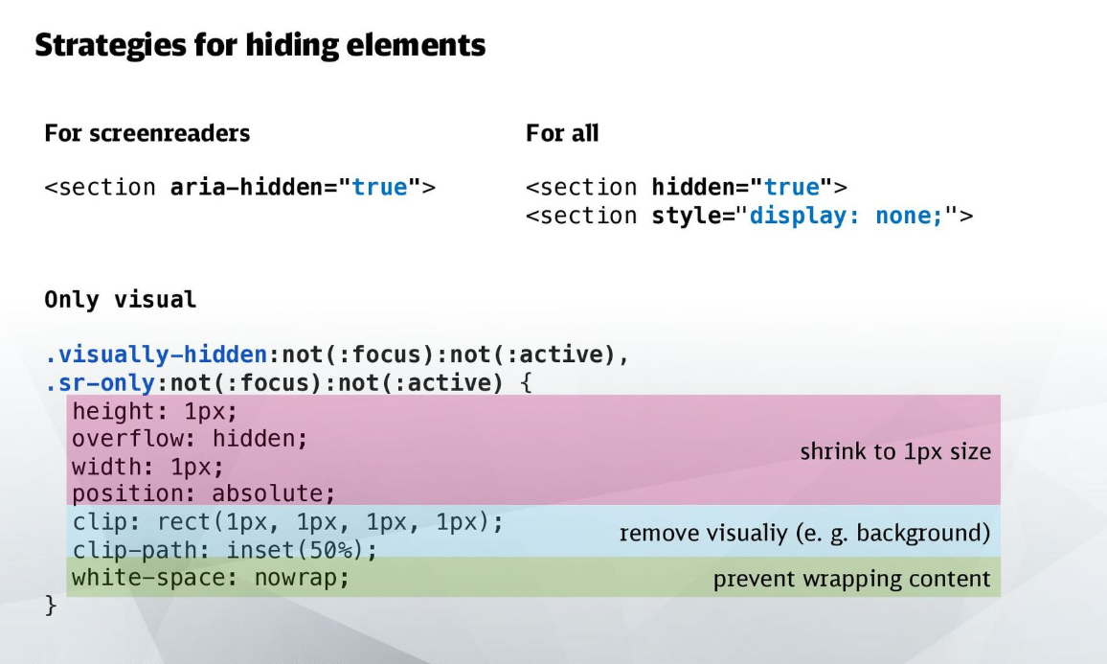

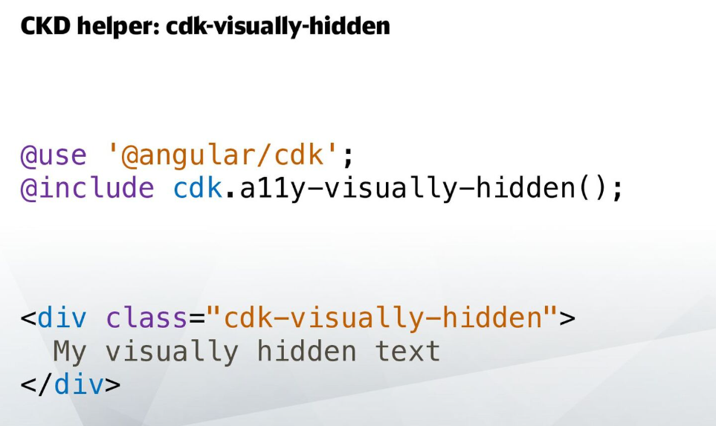

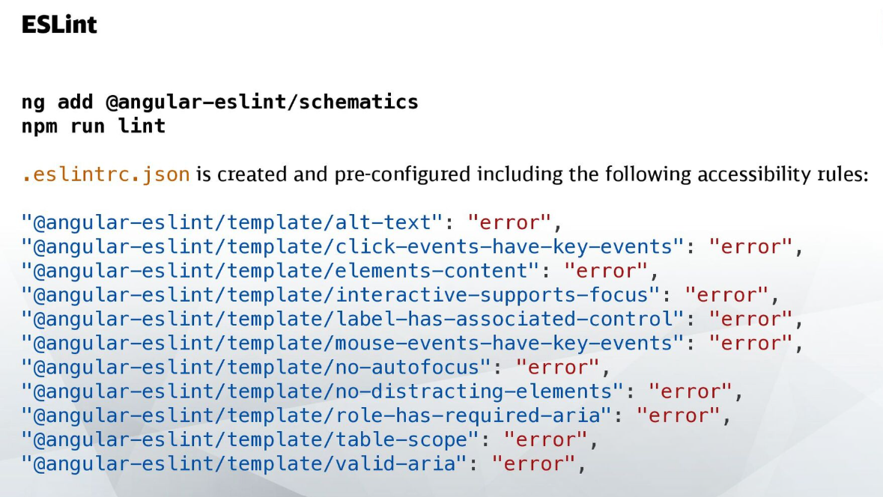

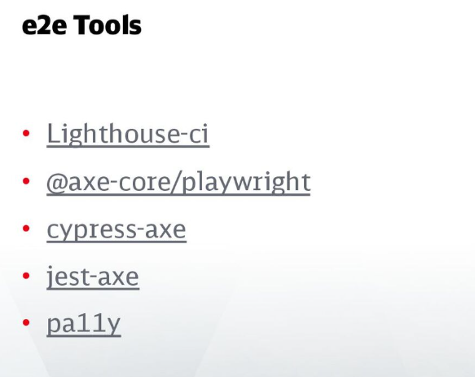

Include QR code for slides and source code like below –

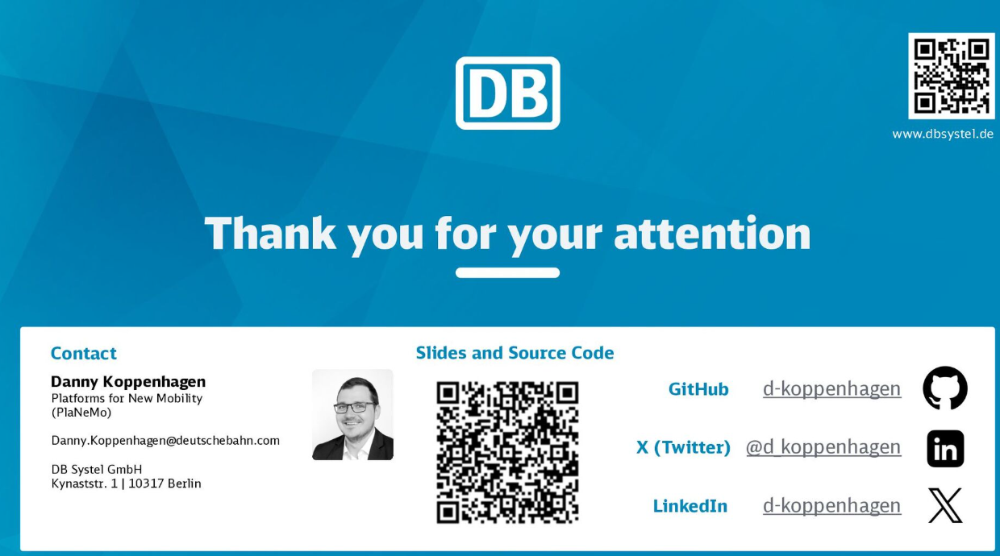

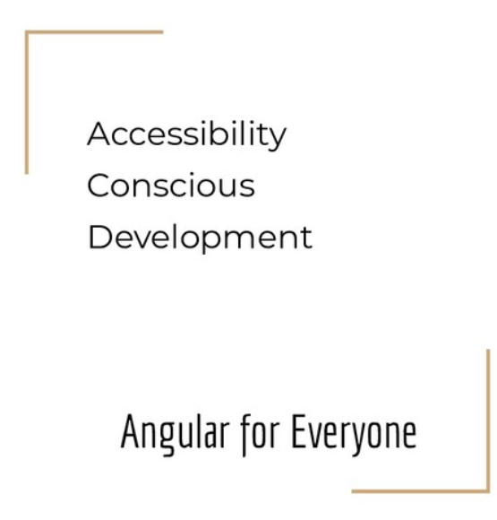

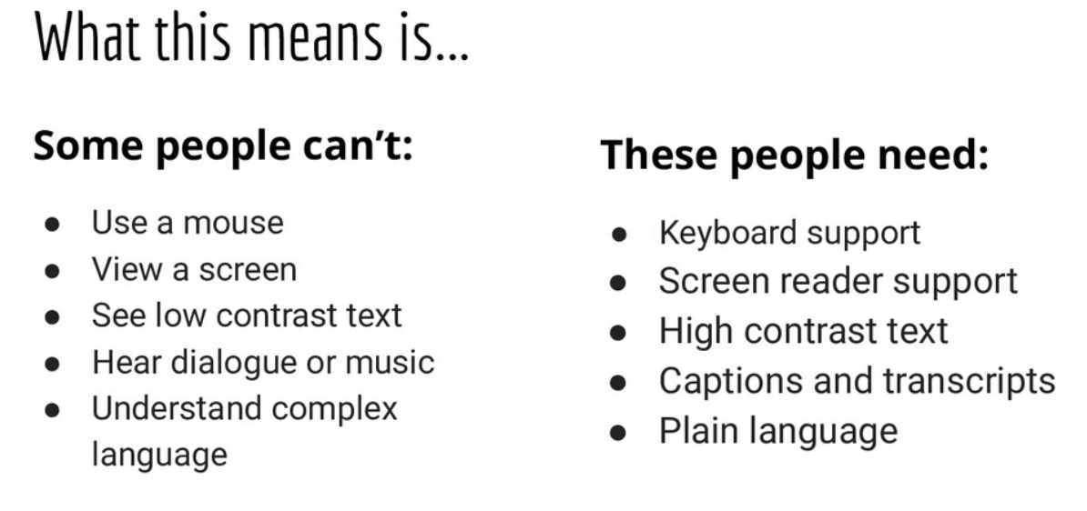

Small button or fat figure issues

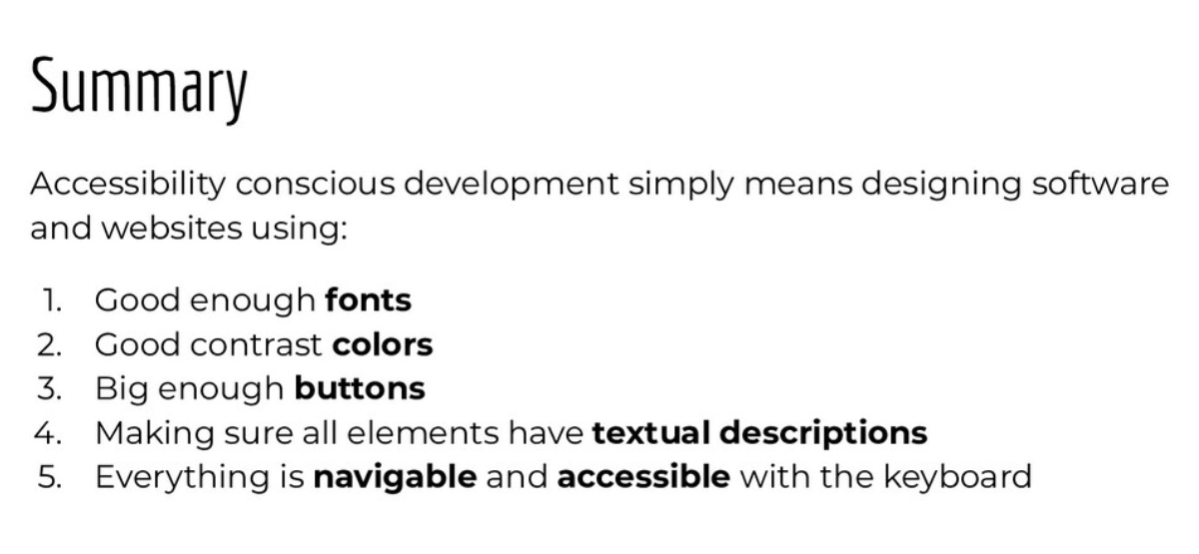

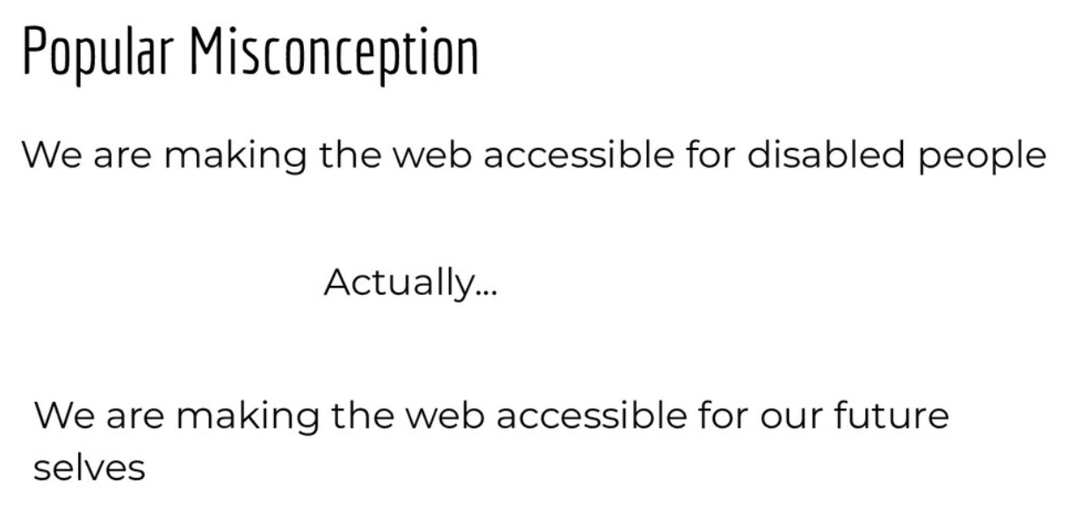

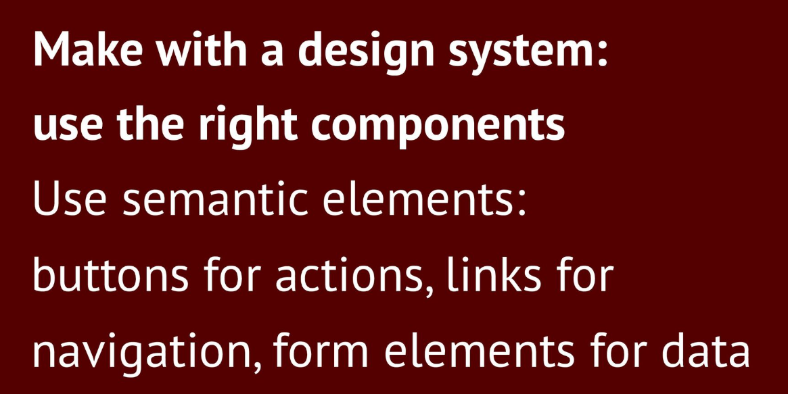

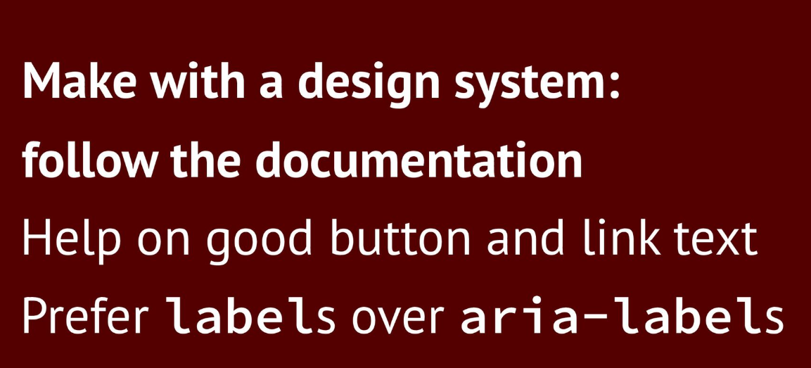

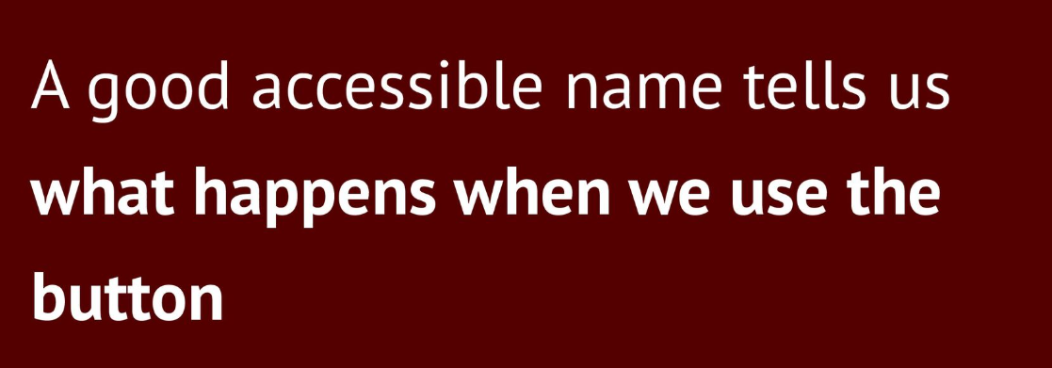

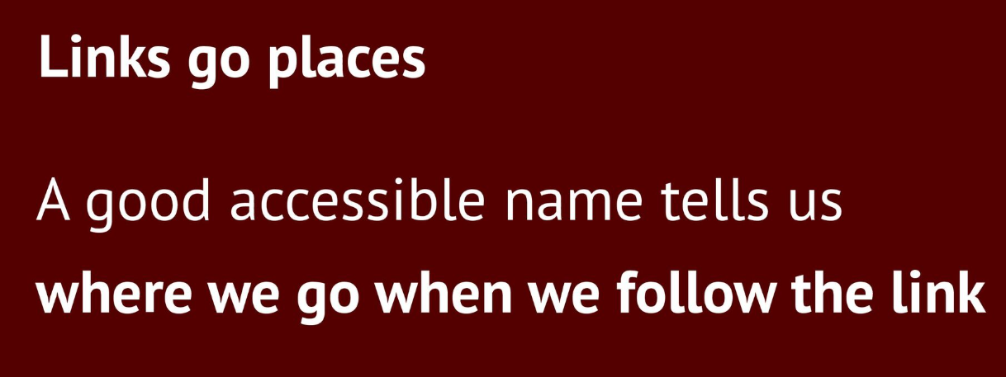

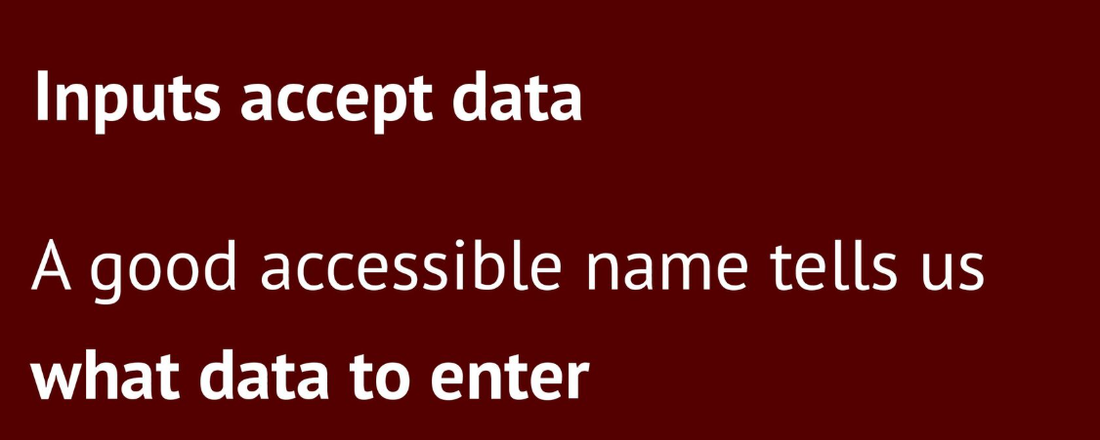

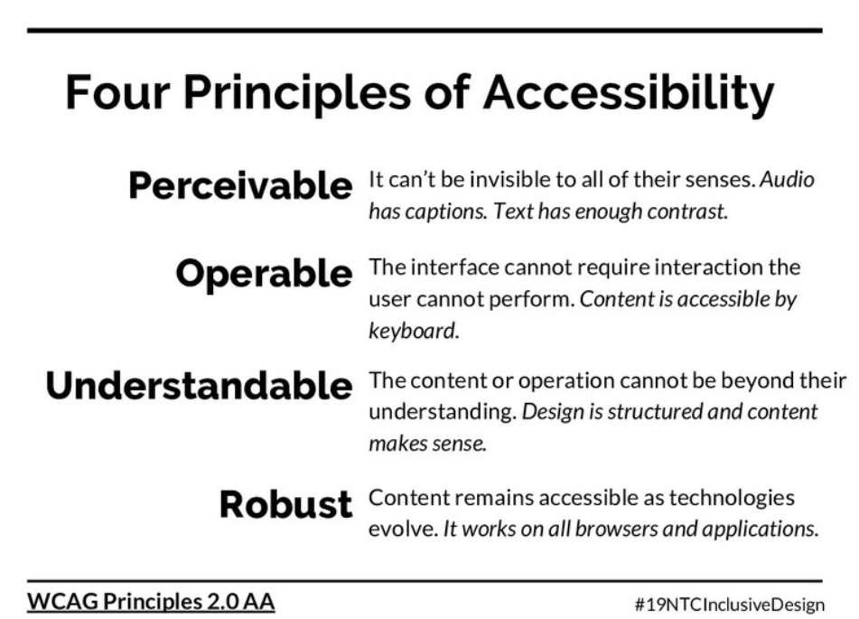

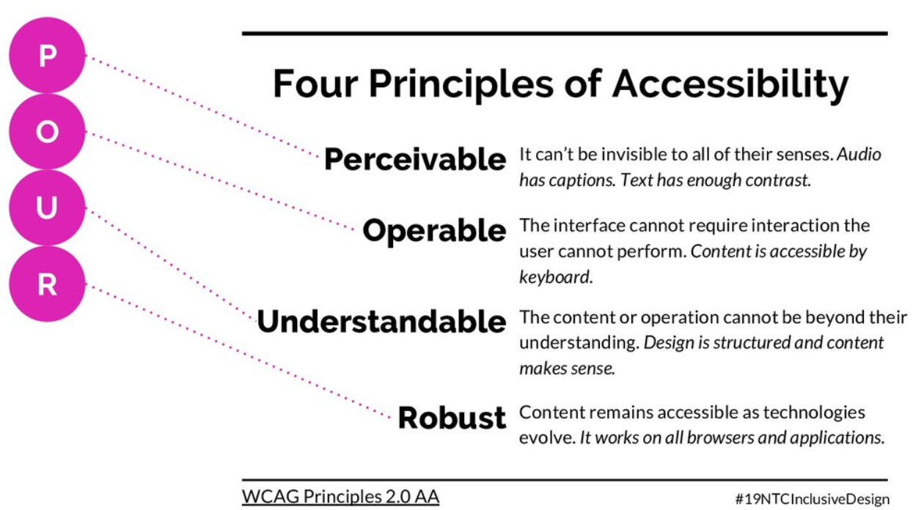

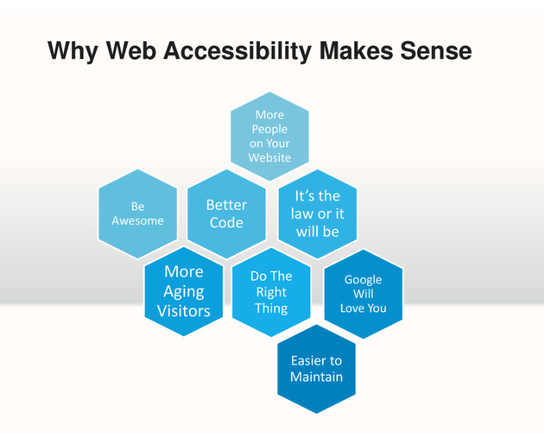

Plan for accessibility from beginning.

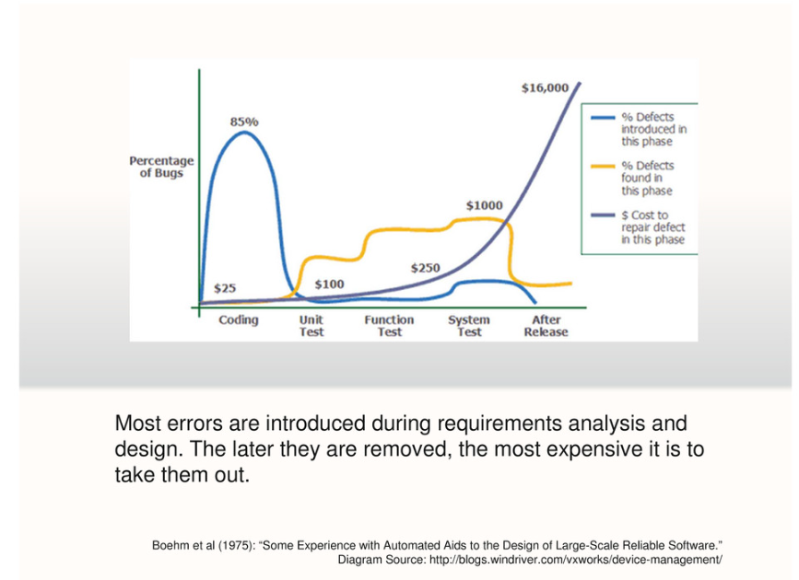

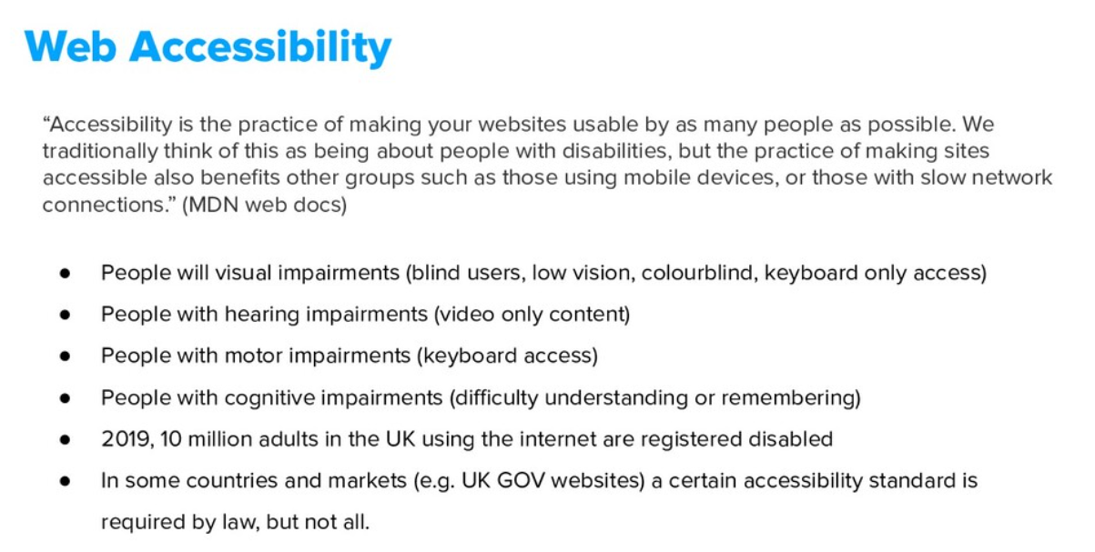

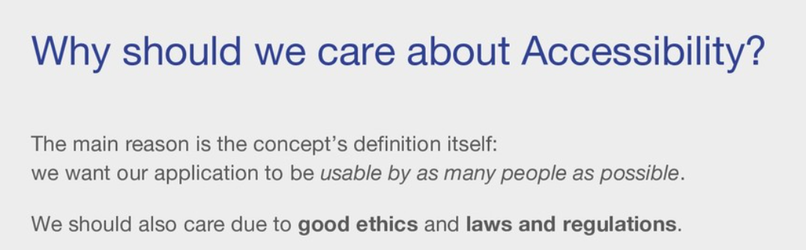

Use chrome extension for live color blindness simulation.

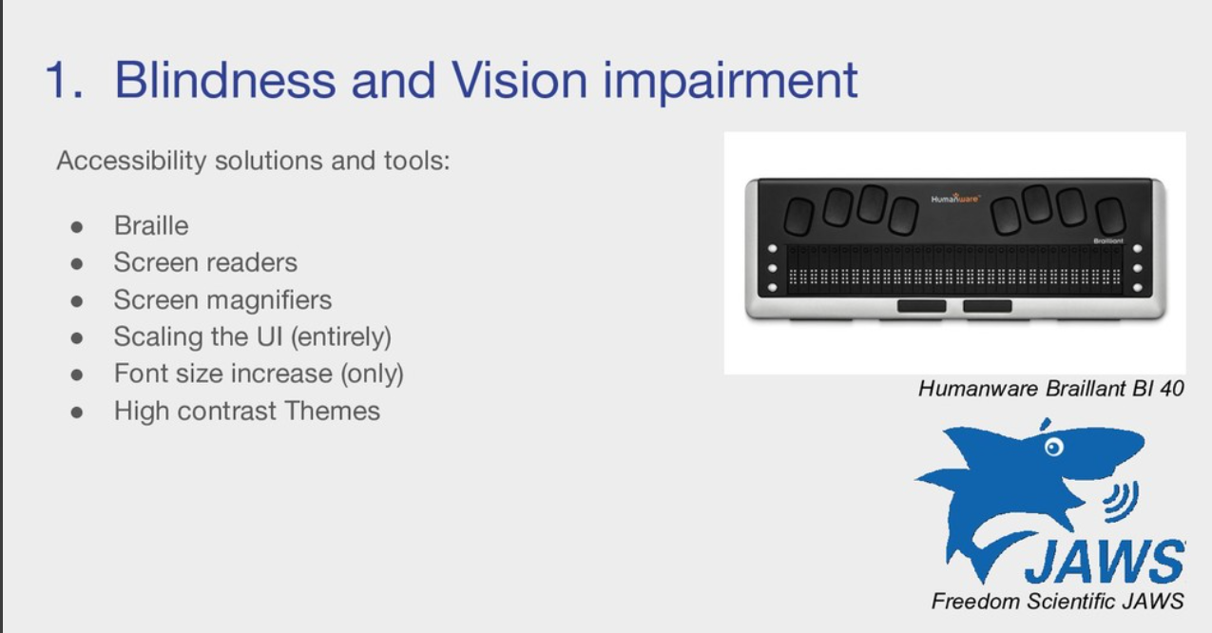

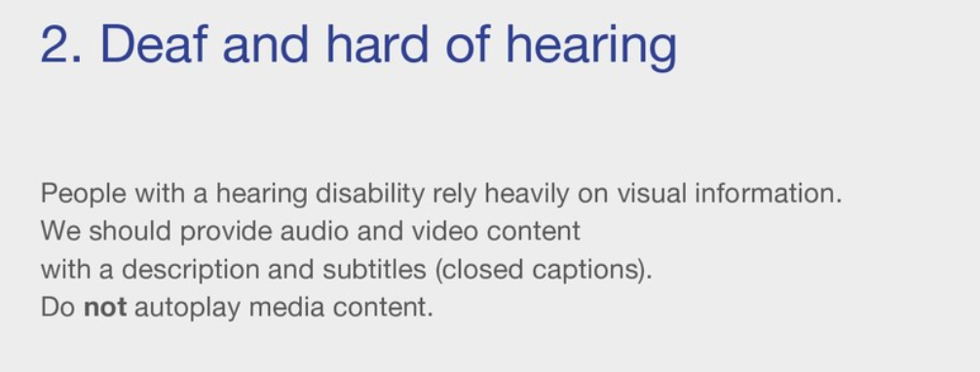

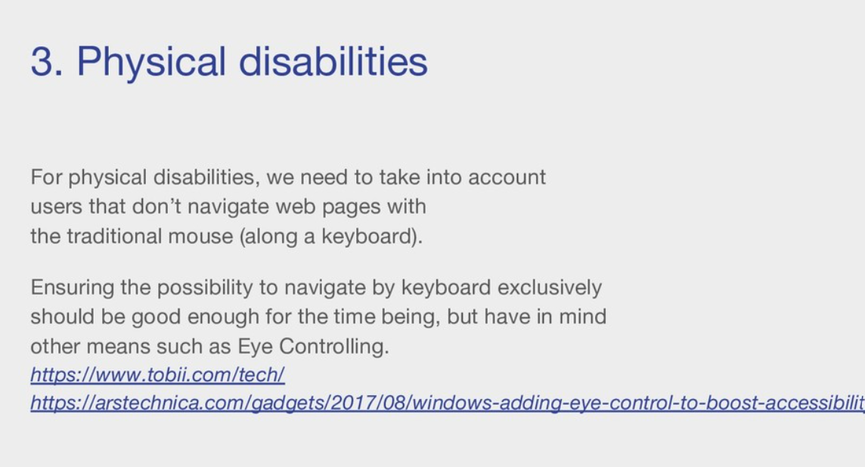

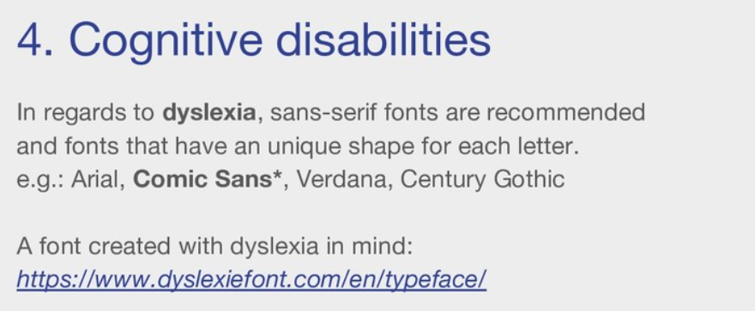

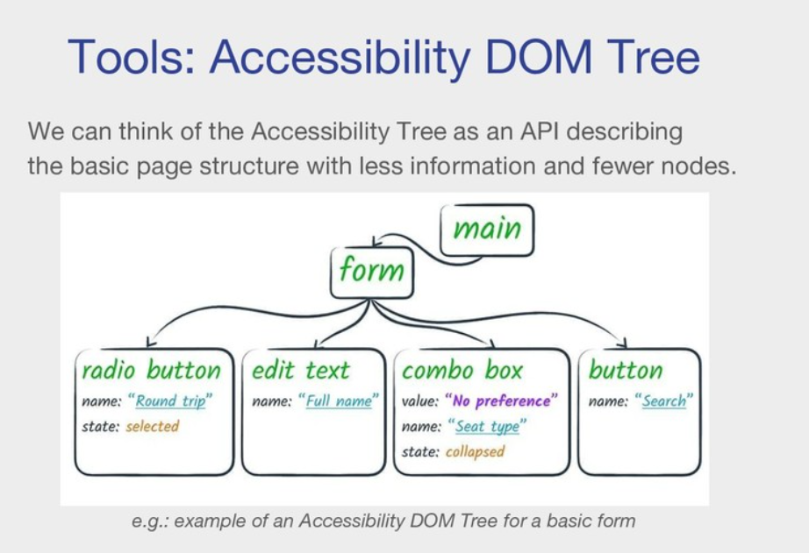

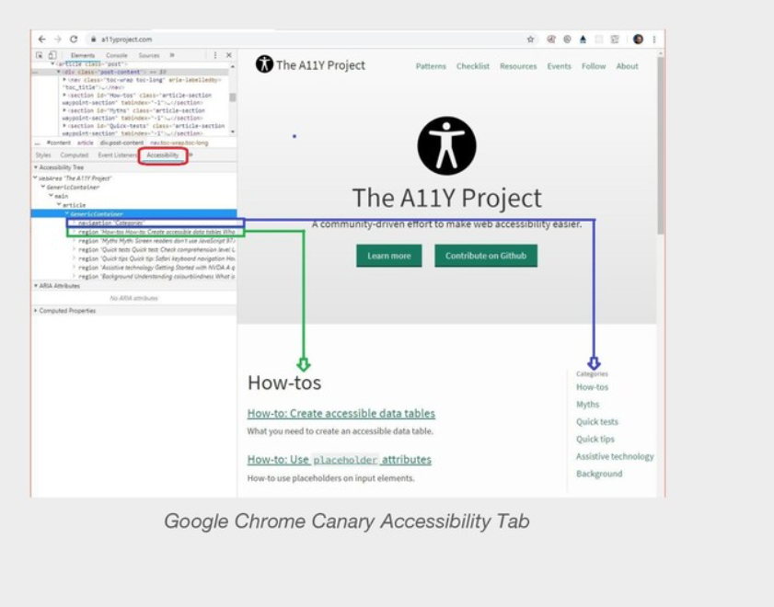

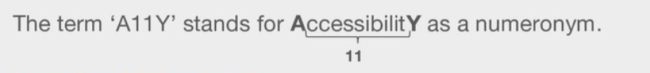

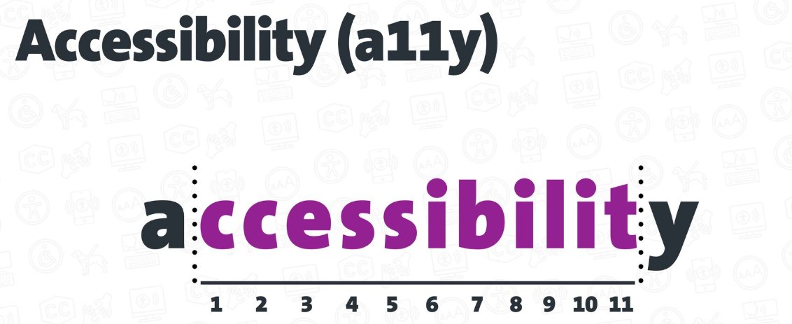

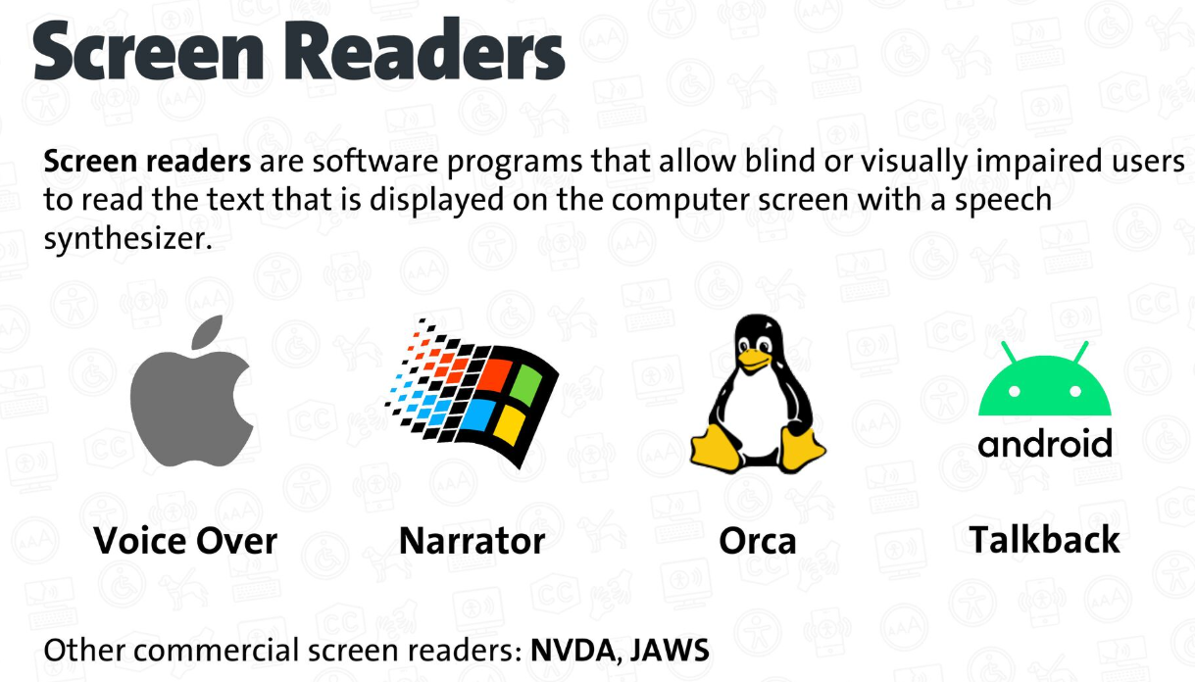

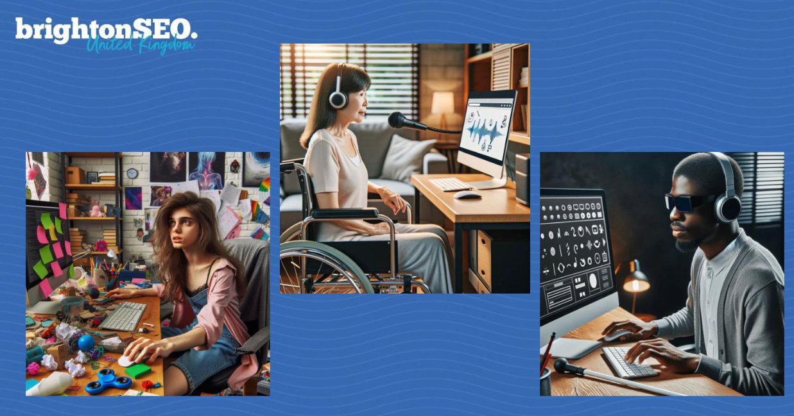

SEO is born from Web Accessibility.

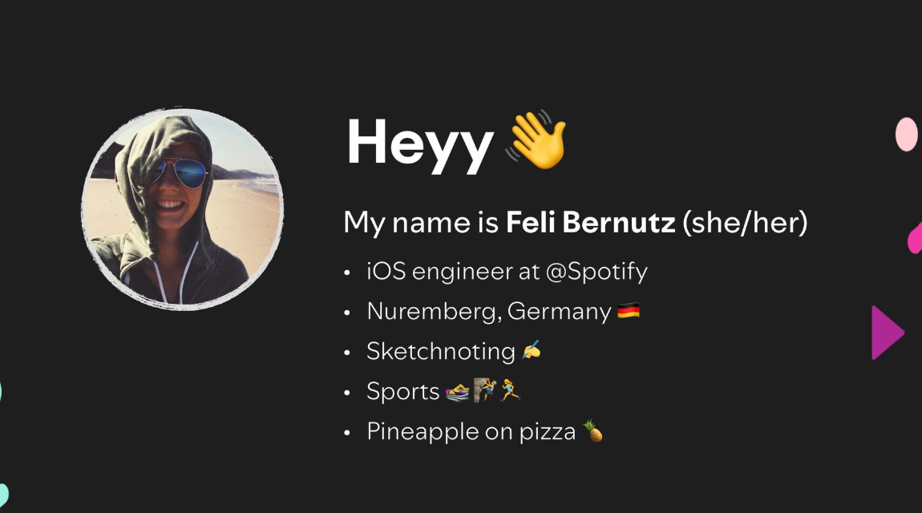

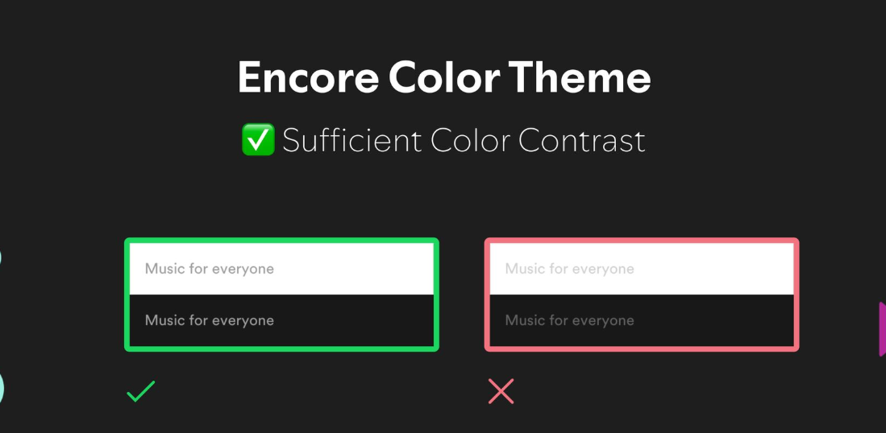

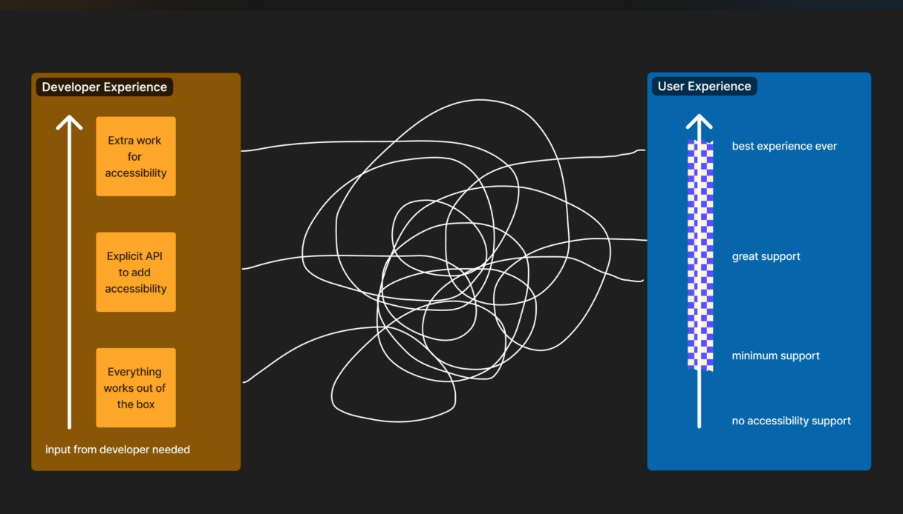

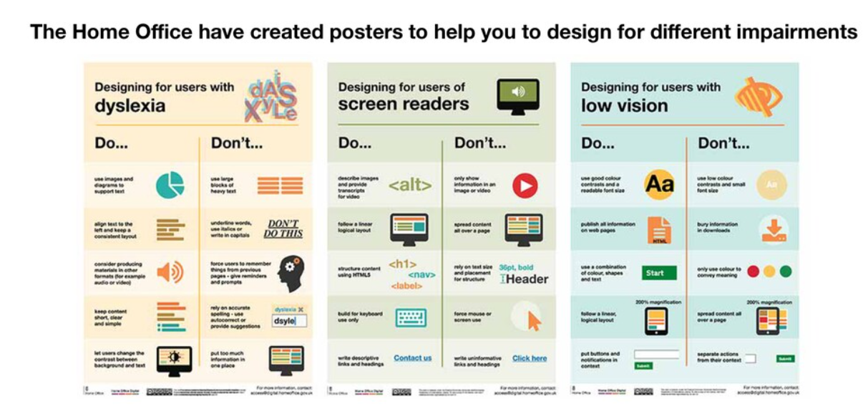

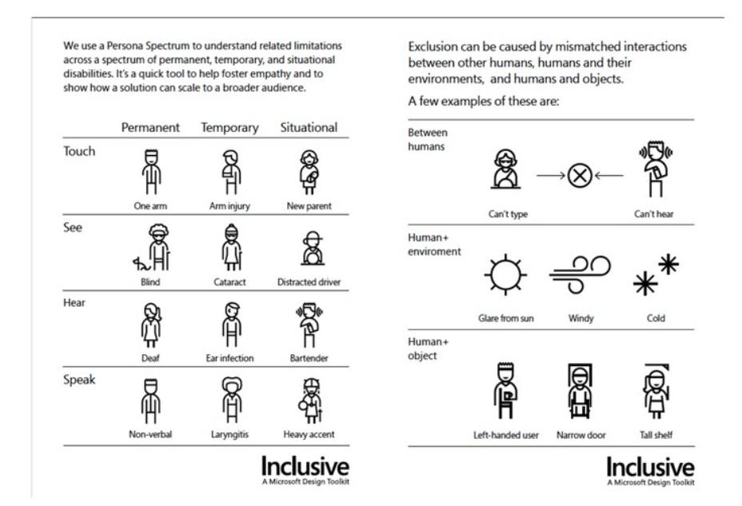

Solving problems for people with one arm solves problems for people with a broken arm, people with bags or people carrying children.

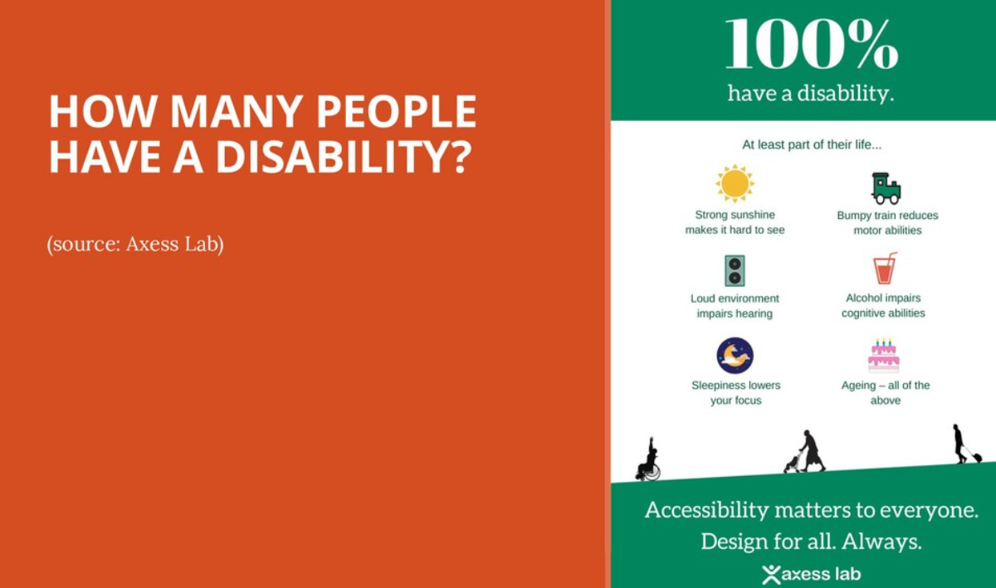

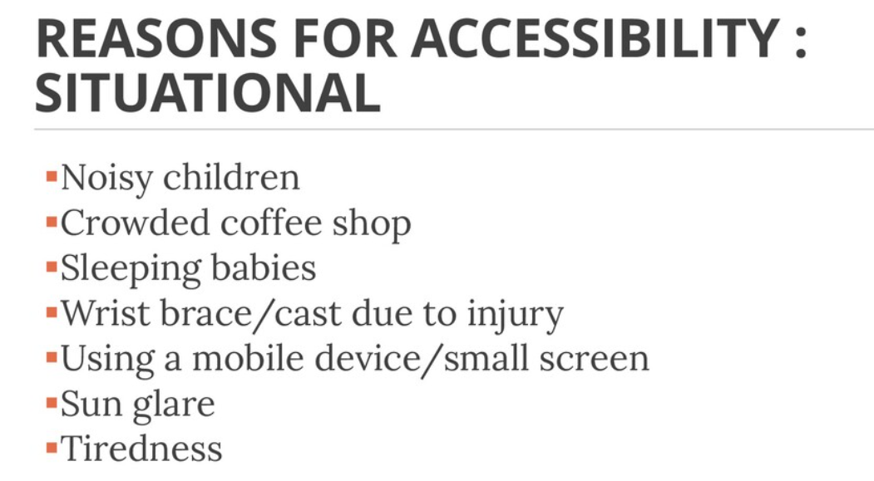

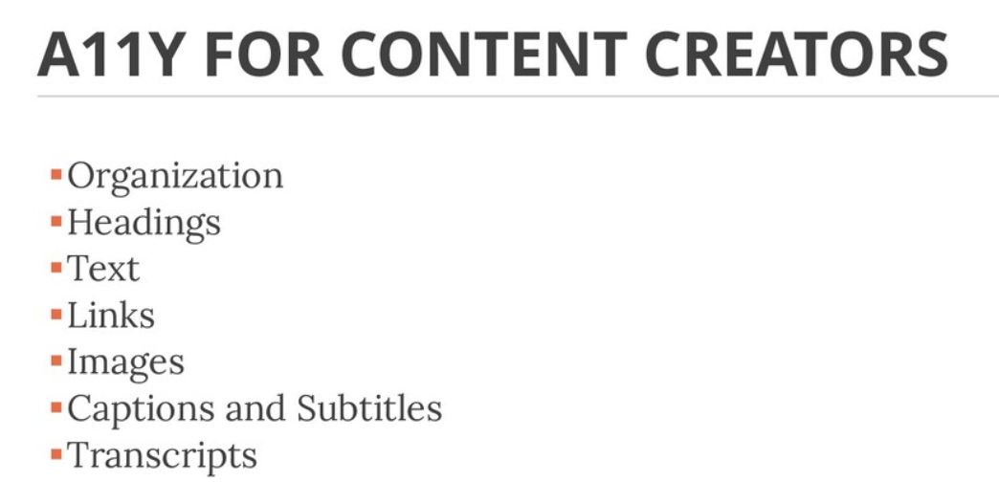

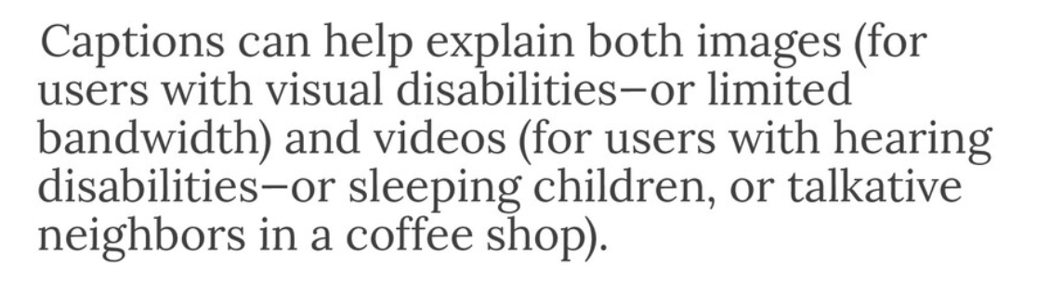

Visual – a broad range from no vision (total blindness) to limited or low vision.

Impairment – an impairment is medical. It is the condition or symptoms that person experiences. Disability – when a person finds it difficult to perform everyday tasks to a level that is considered normal for most people.

People are not always disabled by their impairments; they are disabled by poorly designed environments.

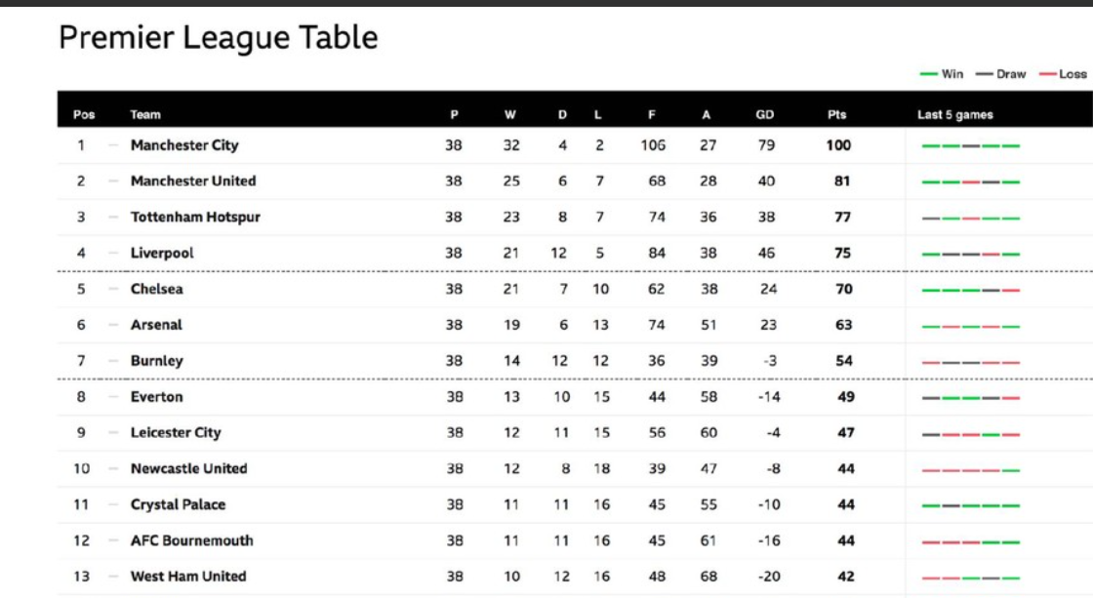

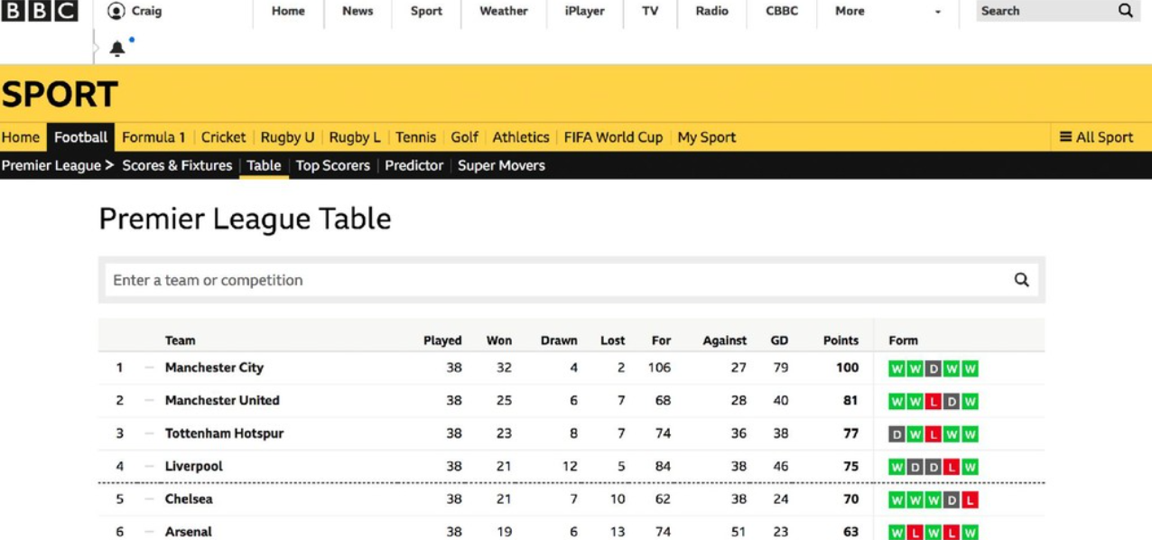

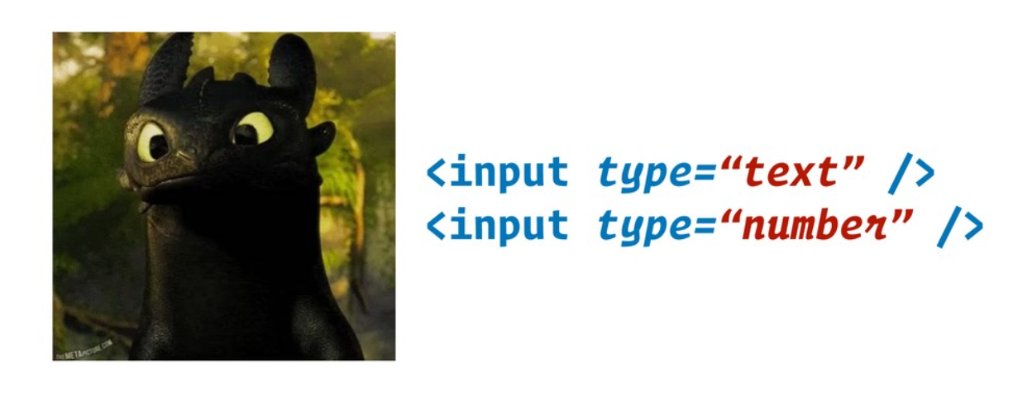

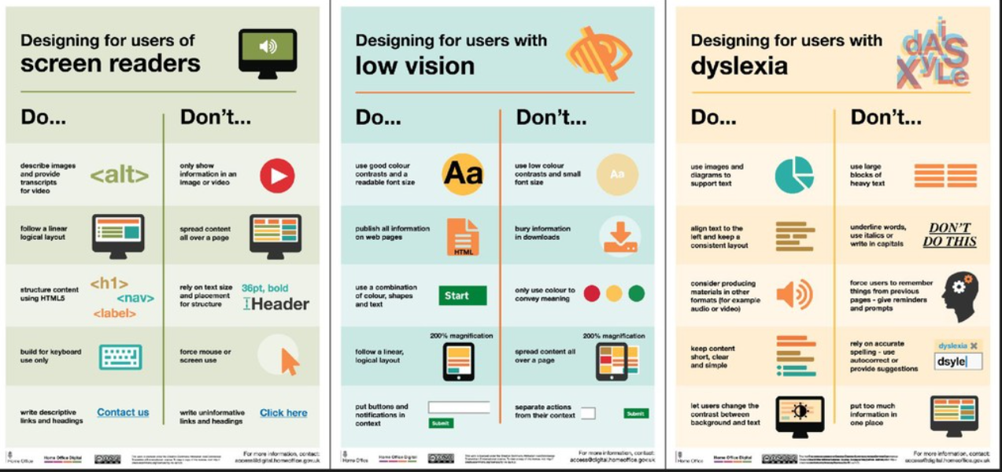

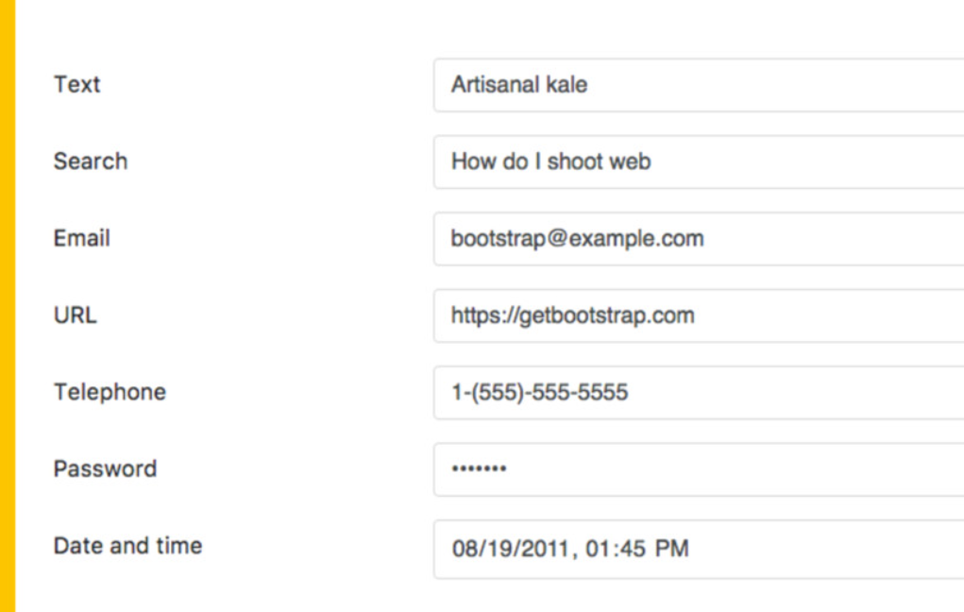

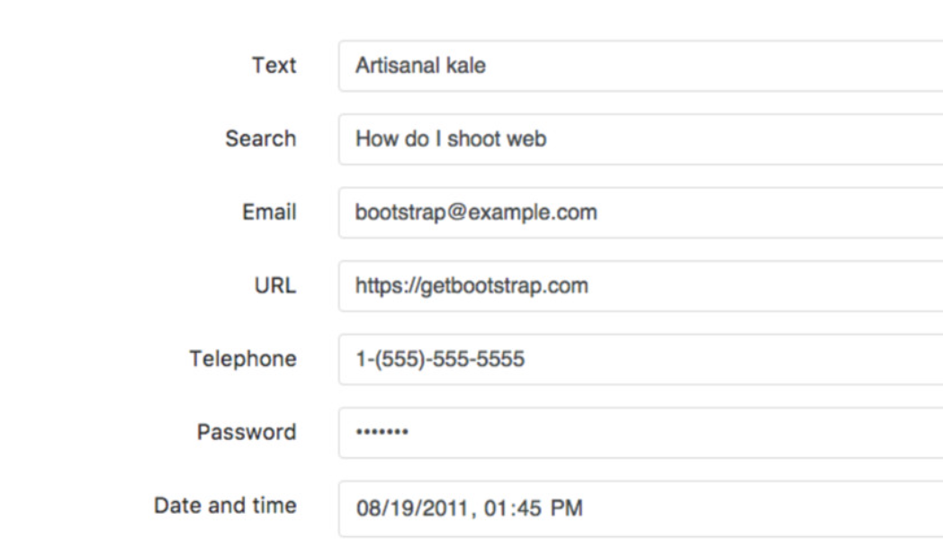

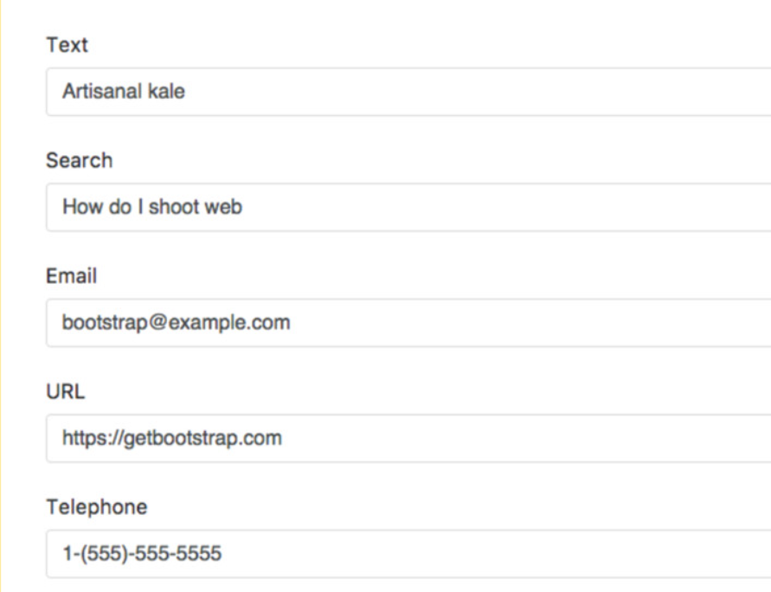

Don’t rely on color only, to show distinctions –

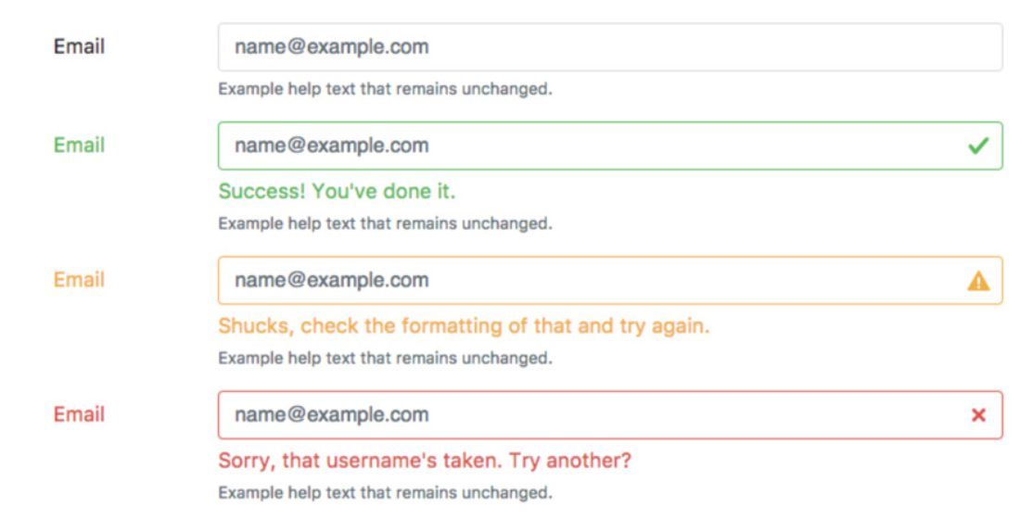

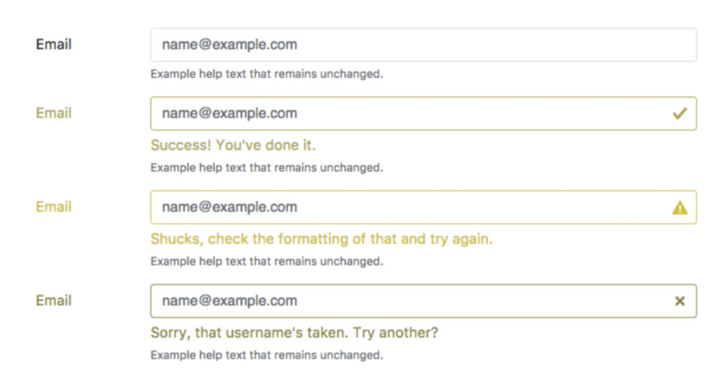

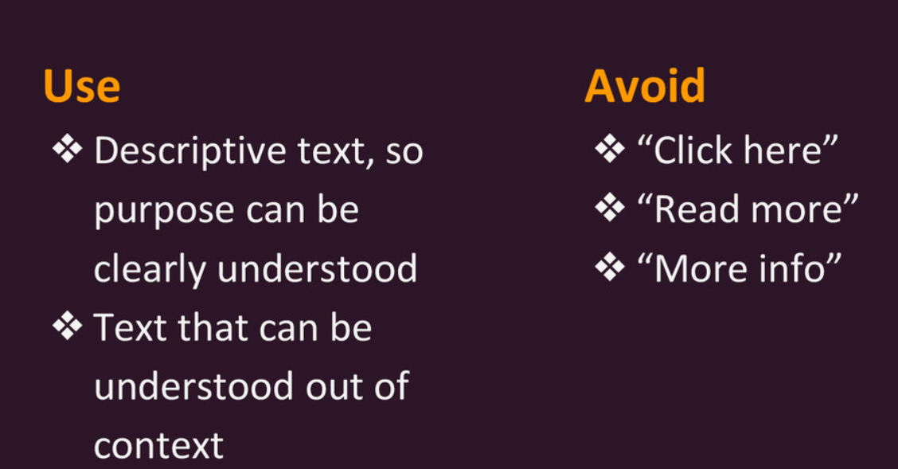

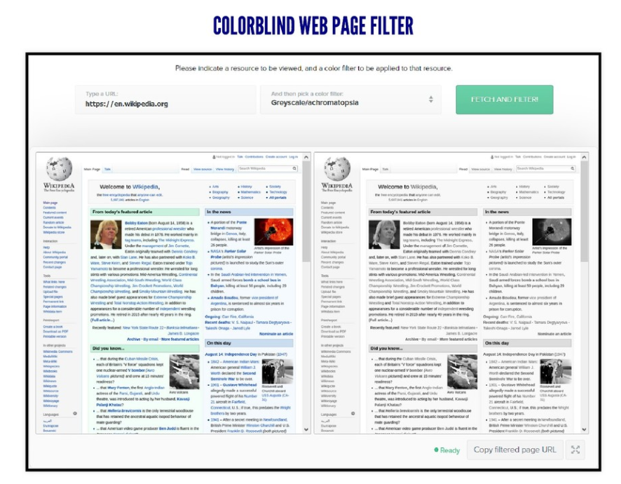

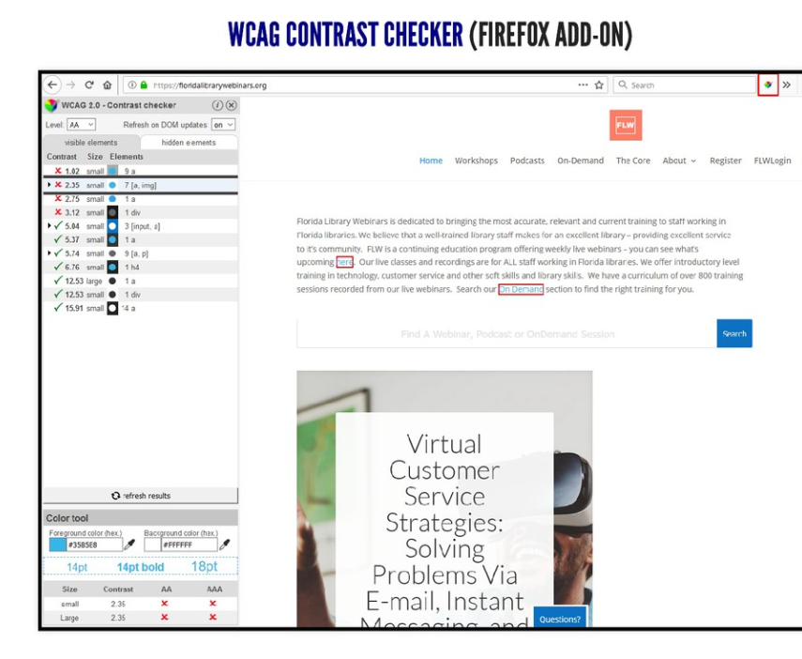

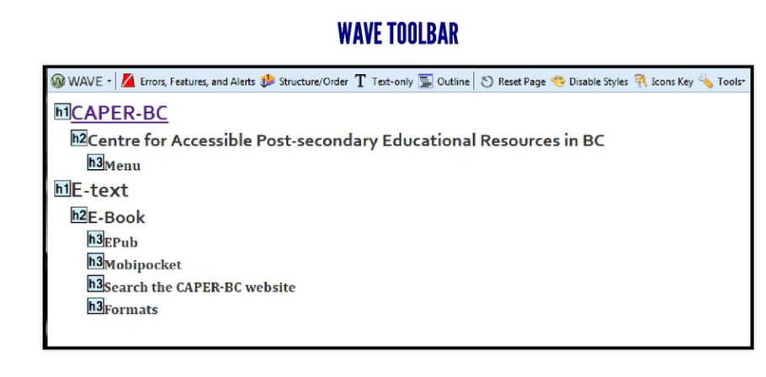

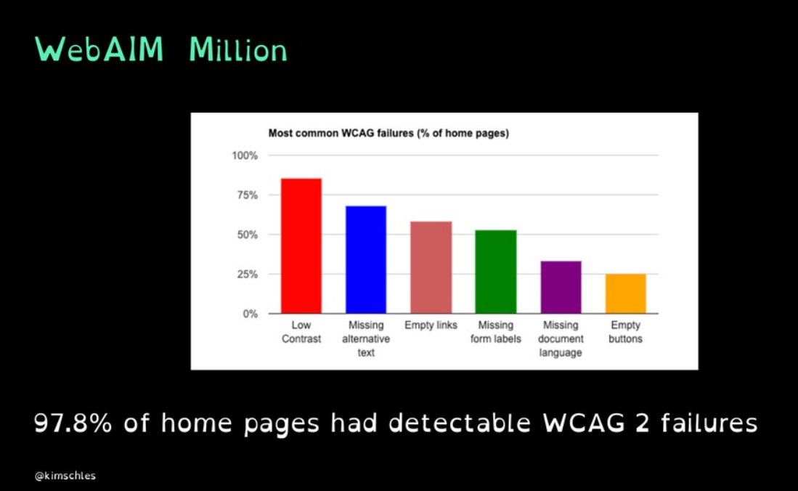

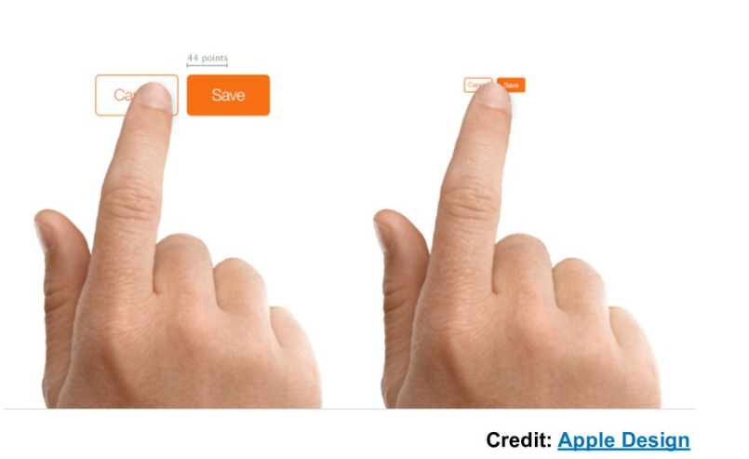

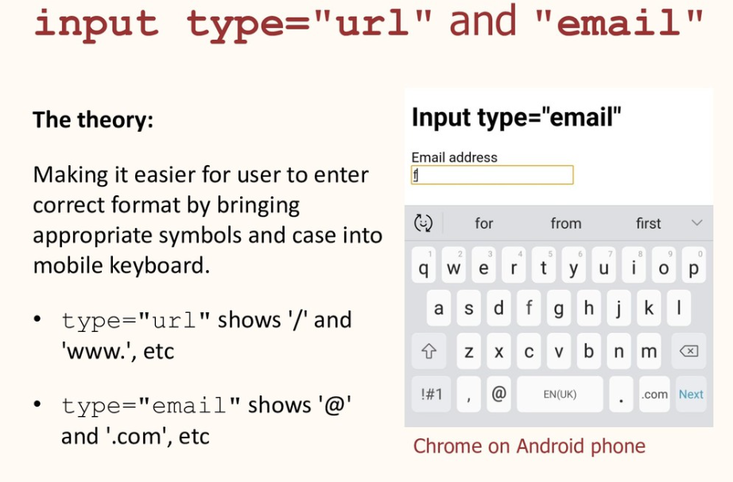

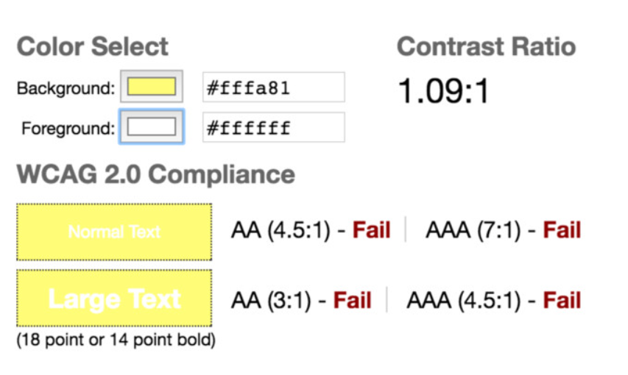

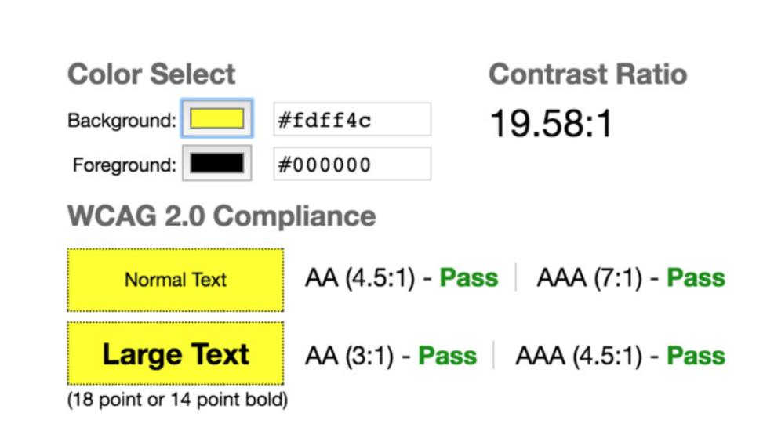

Use proper heading’s structure (H1 > H2 > H3…)

Demo – show contrast, skip links, headings structure.

History of Accessibility –

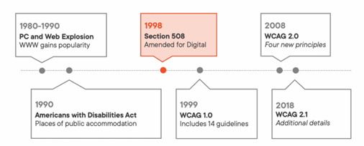

Who needs Accessibility –

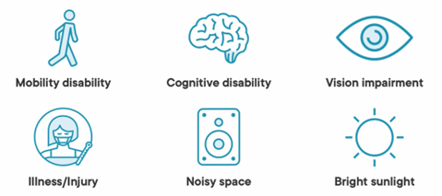

- Create accessible forms – each control should have label or aria-labelled-by, use grouping of controls, provide clear notifications, break up long forms. We should avoid placeholder text in your forms. It is often low contrast and difficult to see.

- Assistive technology – screen readers, screen magnification software, speech input software, head pointers, eye tracking, single switch entry devices.

- On the website load, the first tab should go to the ‘skip link’, it generally skips the site navigation or repetitive contents.

- In radio button, if a radio is selected then we need to use the arrows to move around other options, but if none is selected then we can use tab key to move around other options. It is called widget navigation where too many focusable elements on a control, it provides skip links functionality.

- ARIA is a technical specification for improving the accessibility of web pages, it allows us to update the accessibility tree.

- While ARIA is a powerful tool for enhancing accessibility, it should be used as a last resort. Native semantic HTML elements and attributes are preferred whenever possible, as they provide built-in accessibility features that ARIA does not have to replicate. Always prefer native elements like <button>, <label>, <nav> and <header> over their ARIA counterparts. For example, instead of using role="button" on a <div>, use a <button> element. Speaking about ARIA roles, they define what an HTML element is or how it should behave – when native HTML elements are not applicable. They tell assistive technologies how to interpret an element and its purpose within the page. Roles are particularly useful for custom components that don’t have native semantic meaning.

- 96% of the detected accessibility issues fall into 6 buckets. Here are the buckets from most to least common:

  - Low-contrast text: 79.1%

  - Missing alternative (alt) text for images: 55.5%

  - Missing form input labels: 48.2%

  - Empty links: 45.4%

  - Empty buttons: 29.6%

  - Missing document language: 15.8%

- Angular CDK Accessibility - LiveAnnouncer, FocusTrap, Regions, FocusMonitor, CSS class as cdk-visually-hidden and cdk.high-contrast.

Don’t use "click here" as link text - Avoid using vague link text like **\*\*“click here”\*\***, because it:

  - **\*\*Lacks context\*\***: Screen readers or people skimming the page may not understand where the link leads.

  - **\*\*Hurts accessibility\*\***: For visually impaired users using screen readers, hearing "click here" repeatedly doesn’t help them navigate.

  - **\*\*Reduces usability\*\***: It forces users to read surrounding text to understand what the link does.

  - **\*\*Hurts SEO\*\***: Search engines use link text to understand the content of the linked page. “Click here” gives no useful info.

  - Use **\*\*descriptive link text\*\*** that clearly tells users where they’ll go if they click. like `Learn more about our \[privacy policy].` instead of `To read more, \[click here].` This makes your content **\*\*clearer, more accessible, and user-friendly\*\***.

- aria attributes like aria-busy, aria-disabled, aria-grabbed, aria-hidden, aria-invalid.

As per WCAG, all functionalities must be operable by the keyboard alone except where function depends on the path of movement not endpoints like signature or handwriting, drawing an art program.

For complex UI/functionality, we can add a custom shortcut with message like below –

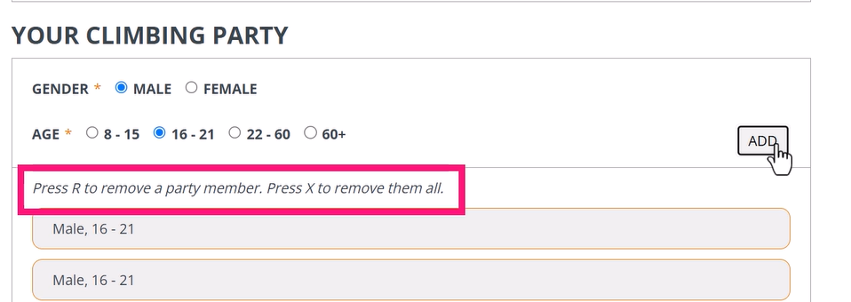

Bypass Blocks – mechanism must be available to bypass repeated content block. For this we can use a hidden skip link like below which will work for both screen reader users and other keyboard users, it will move focus on the main content area of the page –

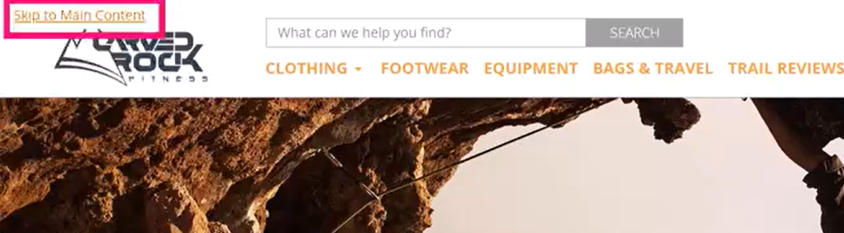

The aria-label attribute should only be used in scenarios where the visual context is clear –

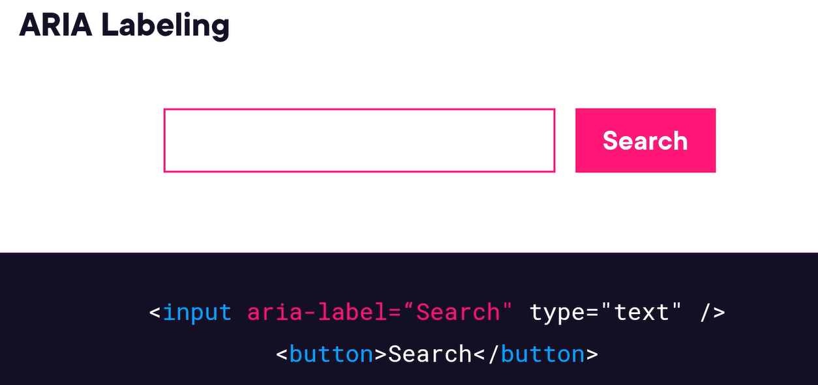

The aria-describedby use case – by this, the screen reader will read the <span> element.

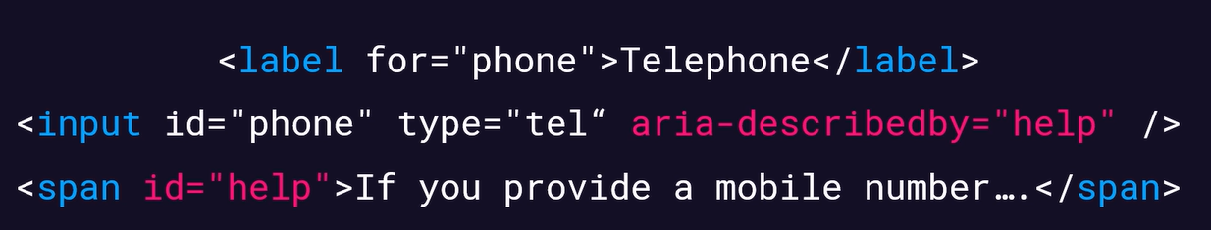

We should set the message validation summary page as a live region, by this we event don’t need to set focus on the error summary page on top of the form, but we should use any of the approach based on scenario –

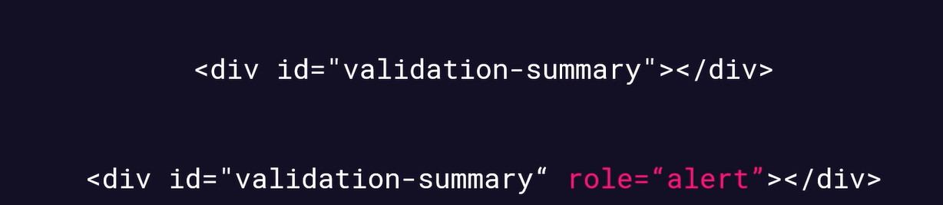

We can set the live region by role as “alert” in case to tell user that form has been submitted successfully or in case of any loading messages.

Decorative images – describing decorative images causes confusion for screen reader users. Not describing functional images means important content is missed.

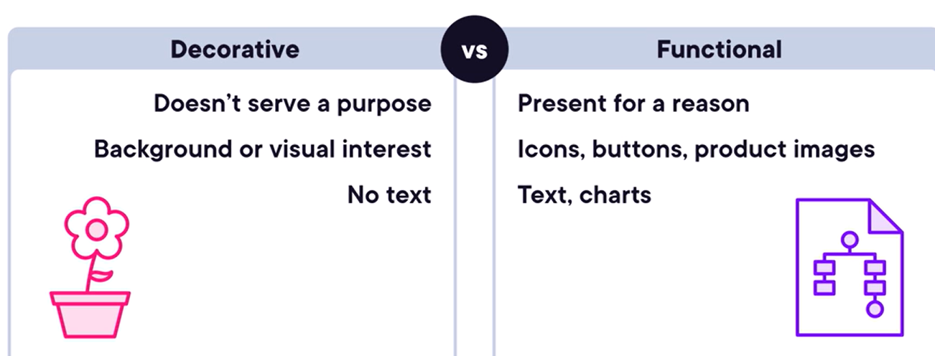

Brand logo image should be functional. Logged-in profile image will be decorative.

Screen reader will respect the CSS, so we have apply display: none or hidden on a element then screen reader won’t announce it but if we want to display image to user but not skip from screen reader then apply aria-hidden attribute.

CSS images – CSS is frequently used for background images and icons, we should apply decorative image using CSS but might be also for functional icons images. We should use aria-label for images added through CSS, this aria-label is similar to “alt” attribute.

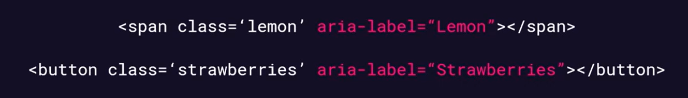

Element roles - <span> does not have a role but button does as button does some kind of action it has a purpose. Screen readers use roles to determine what content to read out. To avoid this we should replace CSS images with actual image tags.

If “alt” text is very long, then we should use aria-describedby attribute which is a preferred approach–

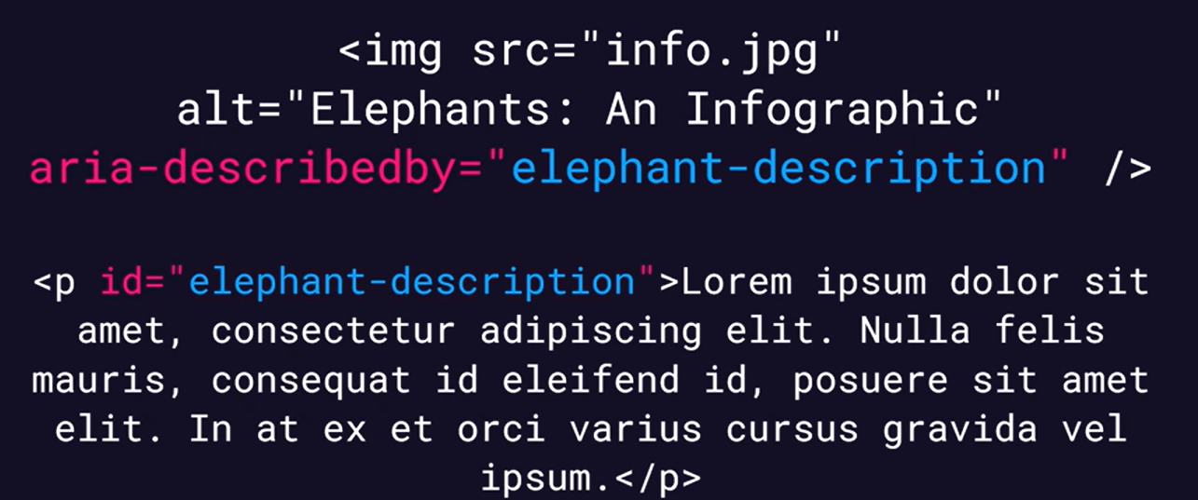

For audio-only content we should have transcript for users who have hearing problem. We can use aria-label and aria-describedby attribute –

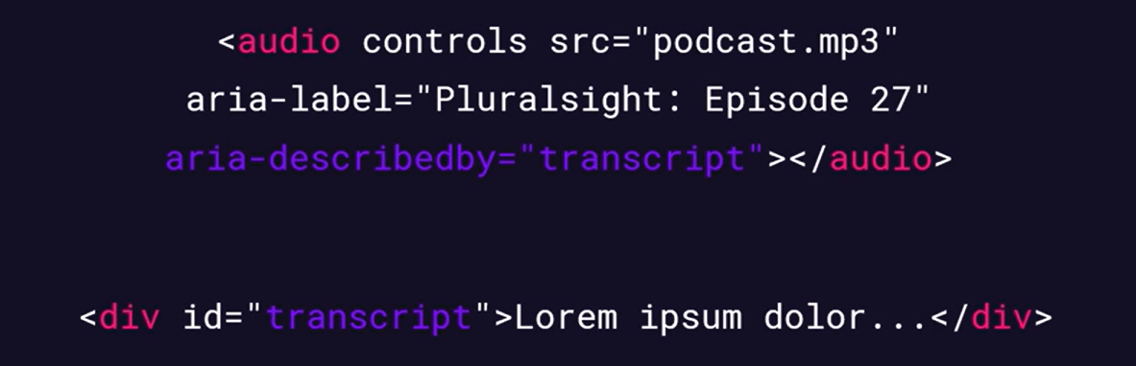

For animation and video-only content (without accompanying audio or with simple melody song) – user with poor vision, we should have audio alternate for it or full text alternative approach for it.

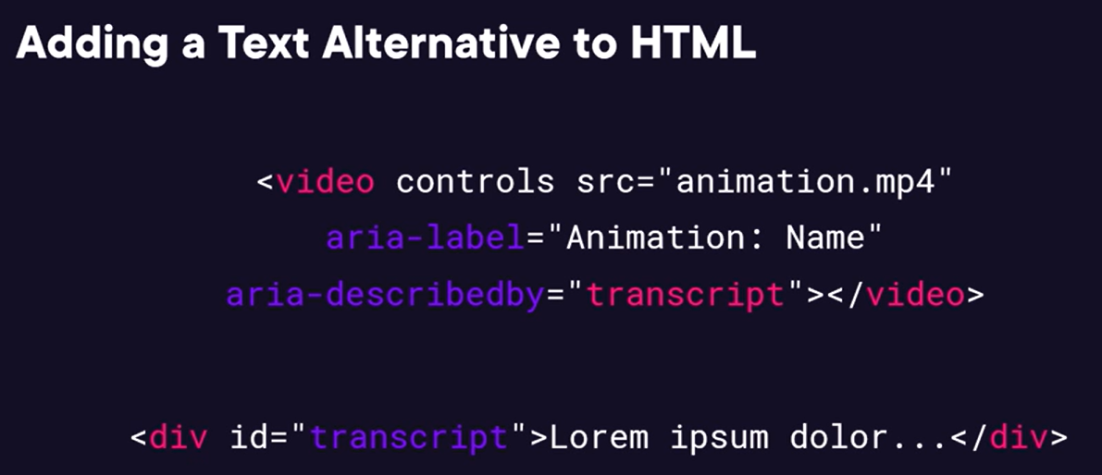

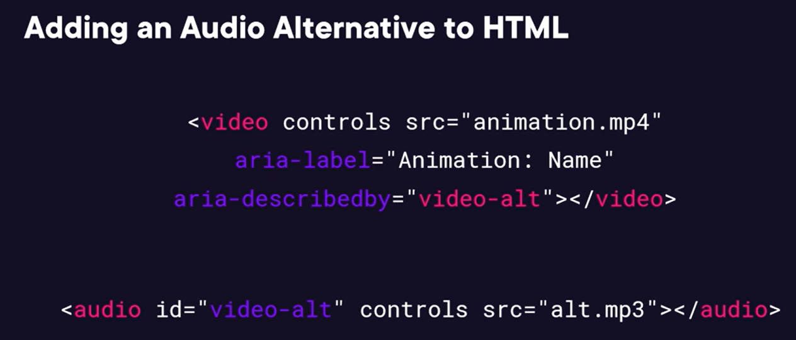

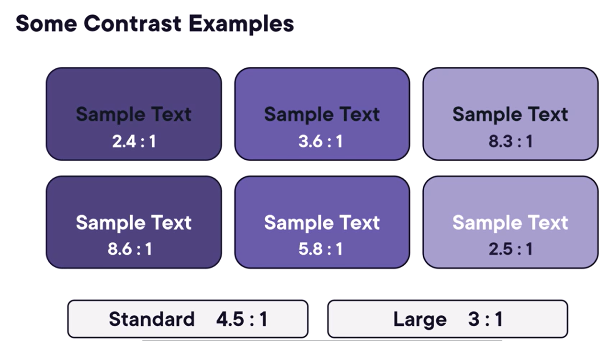

Checking the outline of HTML page by using HTML5 Outliner chrome extension. It improves content organization, used by search engines to index our page and for accessibility and also used by screen readers:

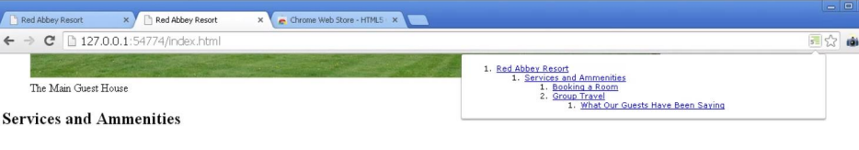

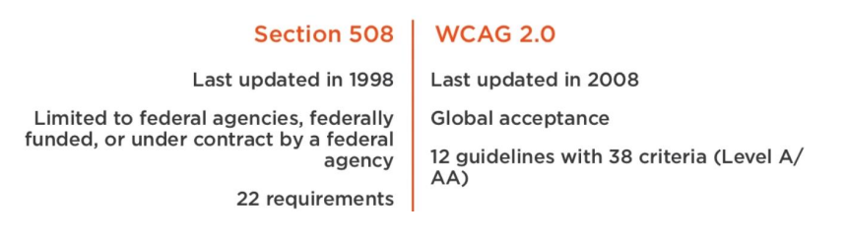

Order of content/focus – visual order must match DOM order because assistive technologies access page content via mark-up/DOM. Focus order must be in a logical an expected manner. Do not programmatically shift focus when not expected. Avoid using autofocus attribute unless you have only one field on page like google a search field.

Accessibility – title attribute on the route, localization, ESLint template rules, cdk.high-contrast() mixin, forced-colors is used in high contrast mode.

Apply these linting rules on angular application –

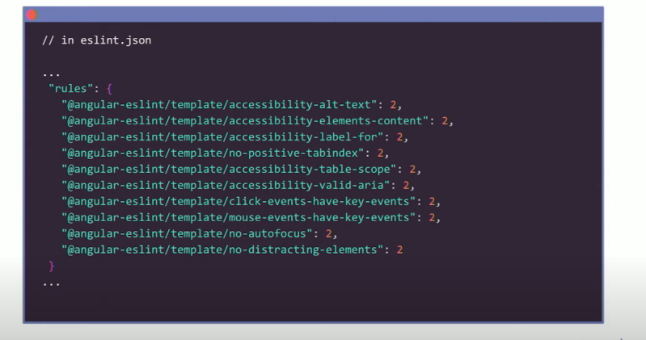

By going into the rendering tab, we can emulate different vision related tests –

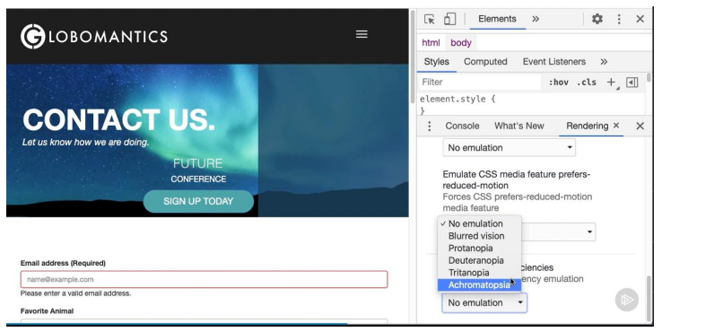

We can use accessibility tab in chrome dev tools to check computed property –

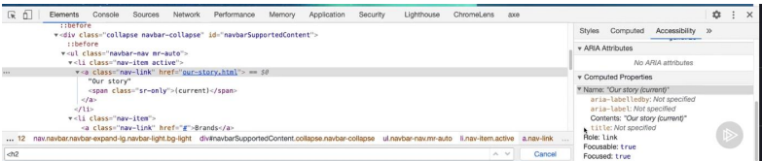

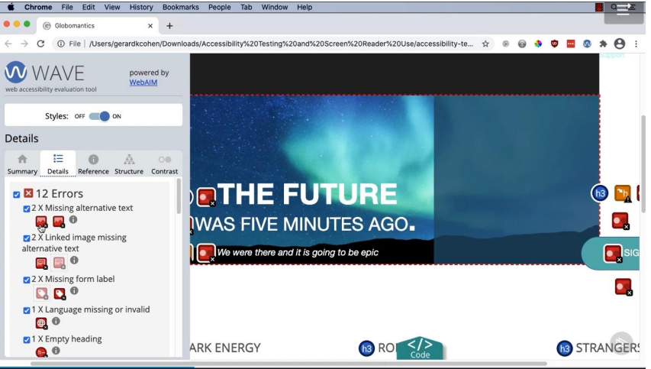

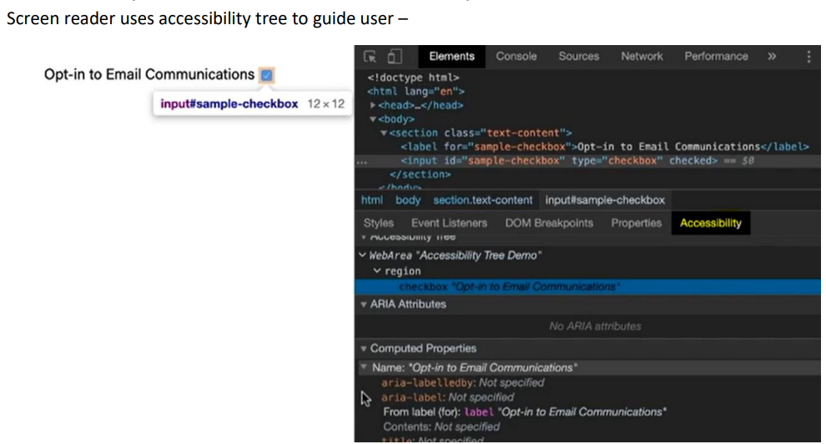

For complex image like chart we can use longdesc attribute for long description text, it can also contain URL also:

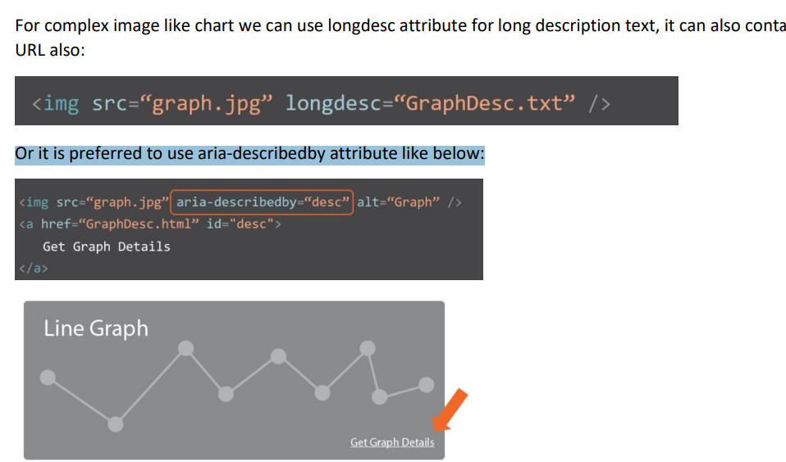

if there are too many links before the main content then use a Skip to Main Content like before the navigation menu:

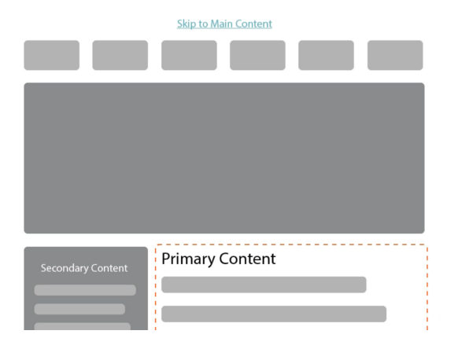

Use **Angular CDK** for low-level reusable behaviors like drag-and-drop, overlays, or accessibility.

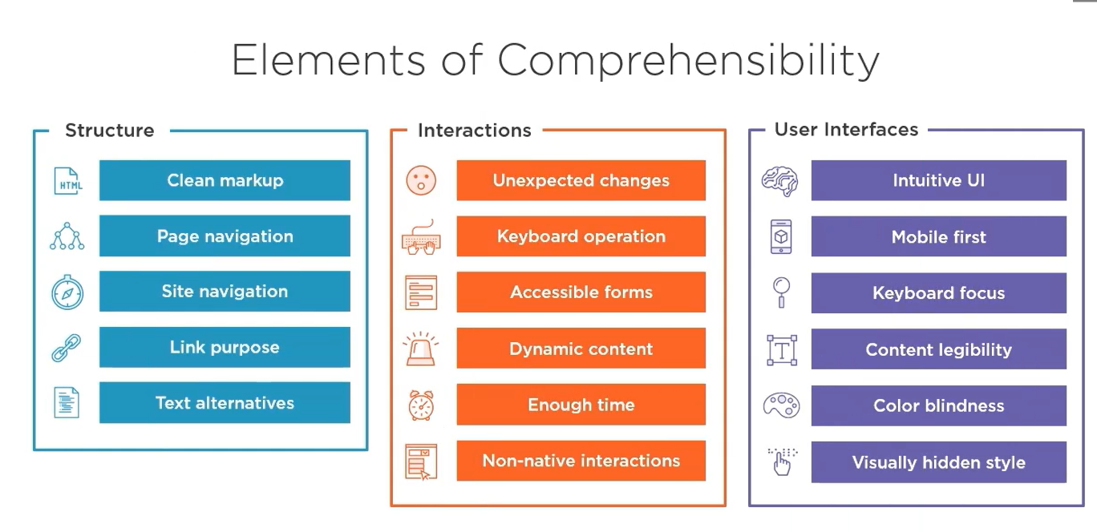

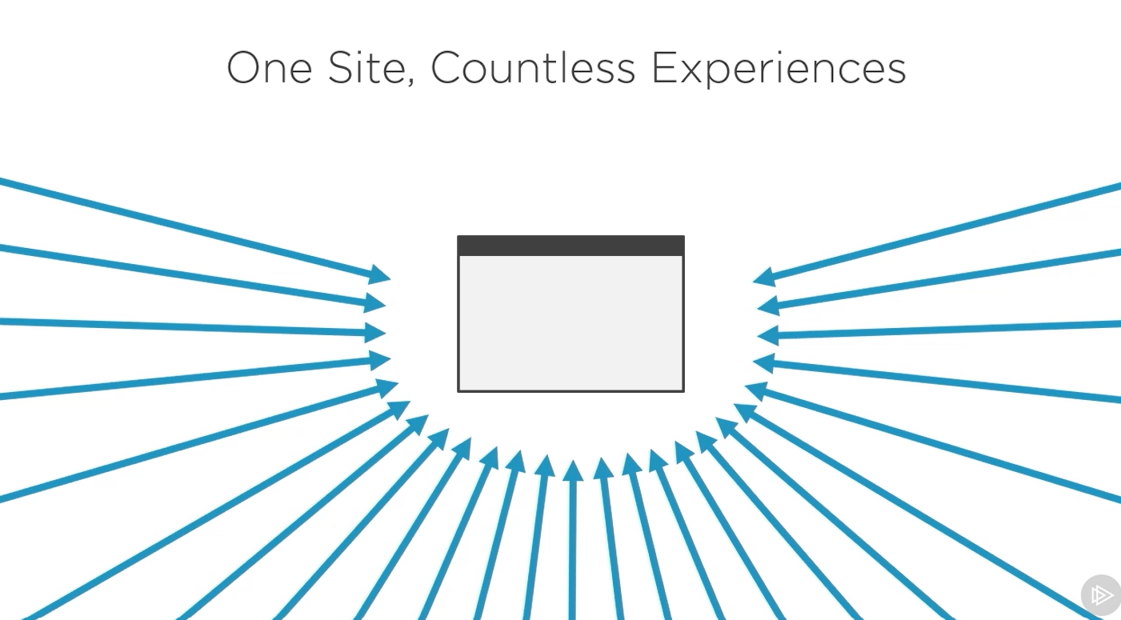

Screen readers – it is a assistive technology which conveys information through speech.

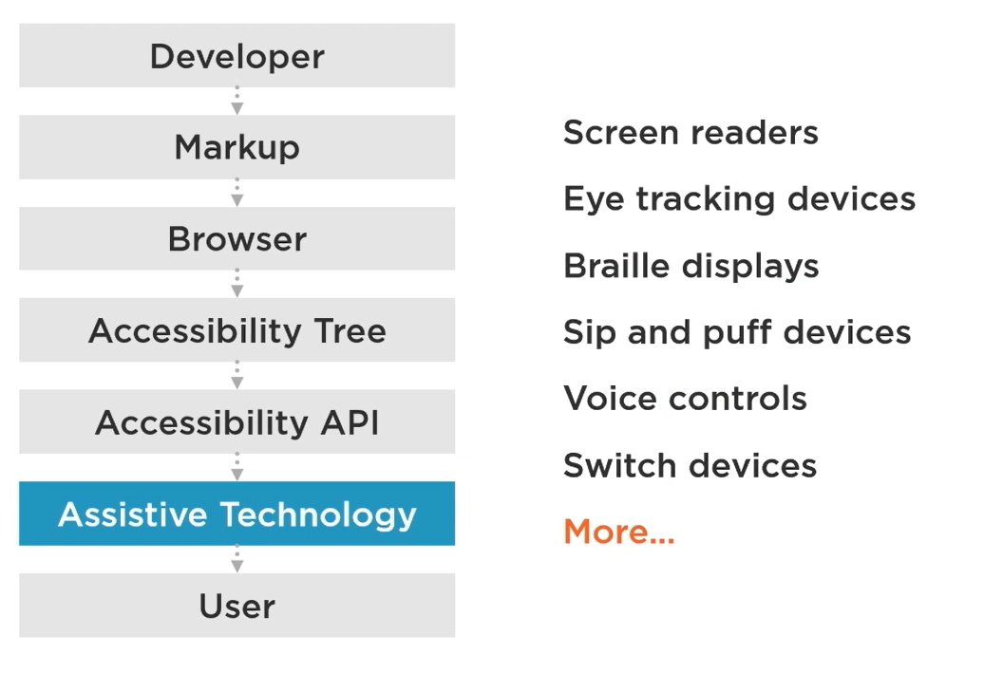

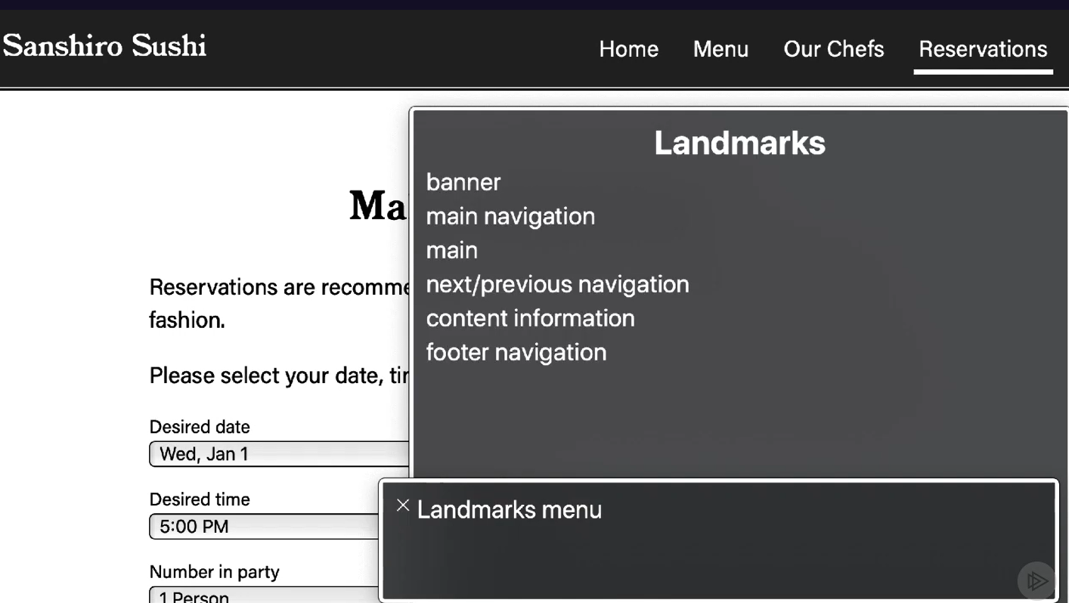

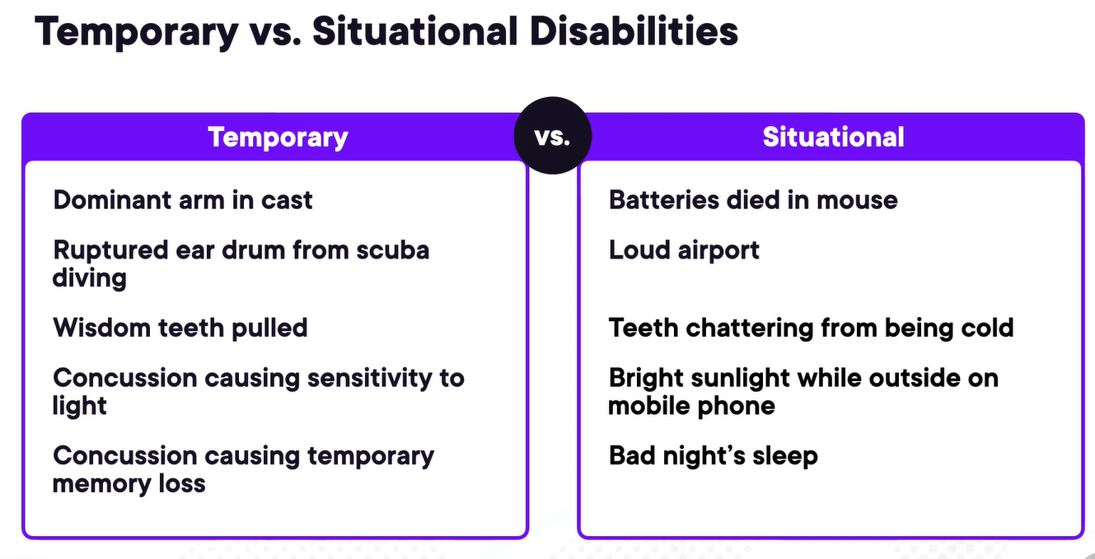

Large celebrities with disabilities.

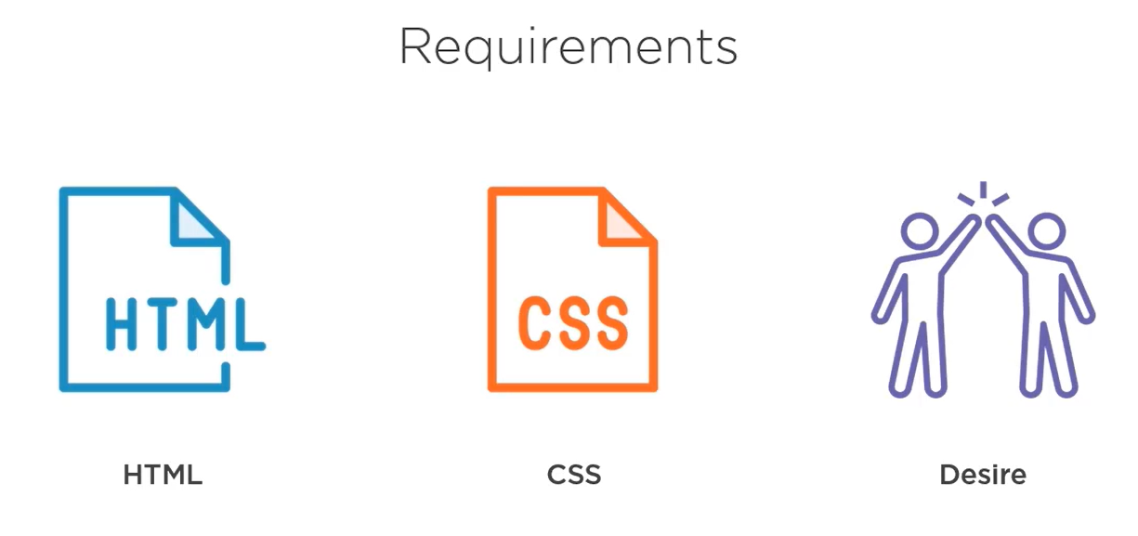

Types of disabilities –

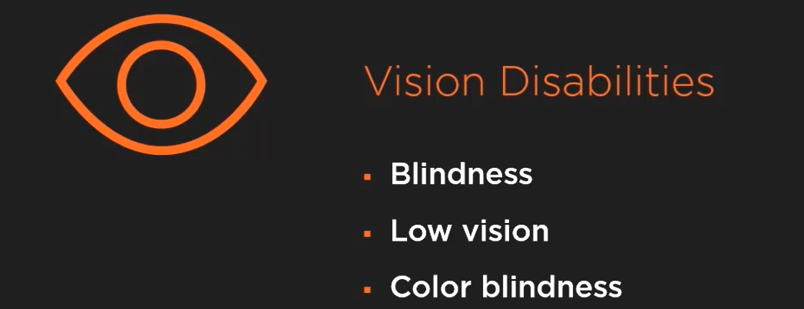

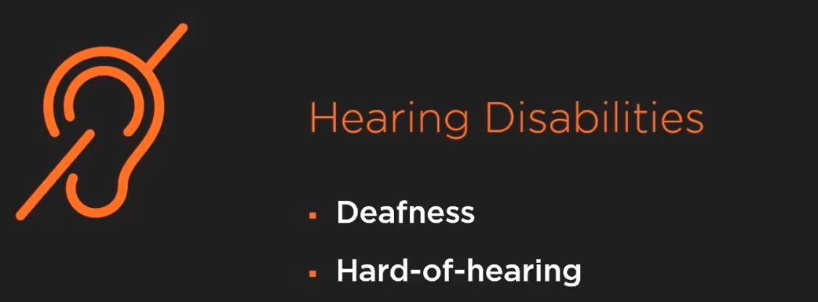

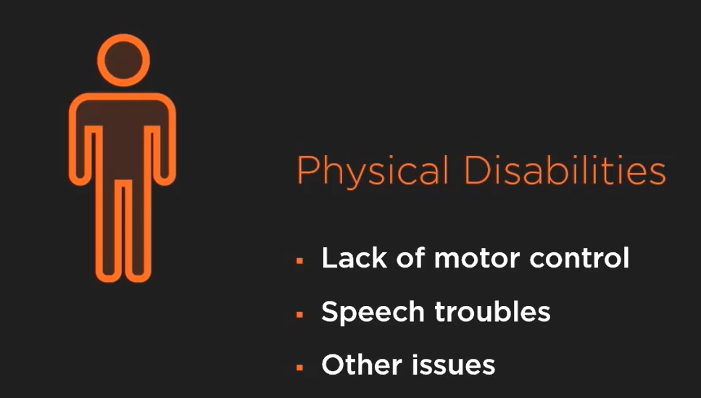

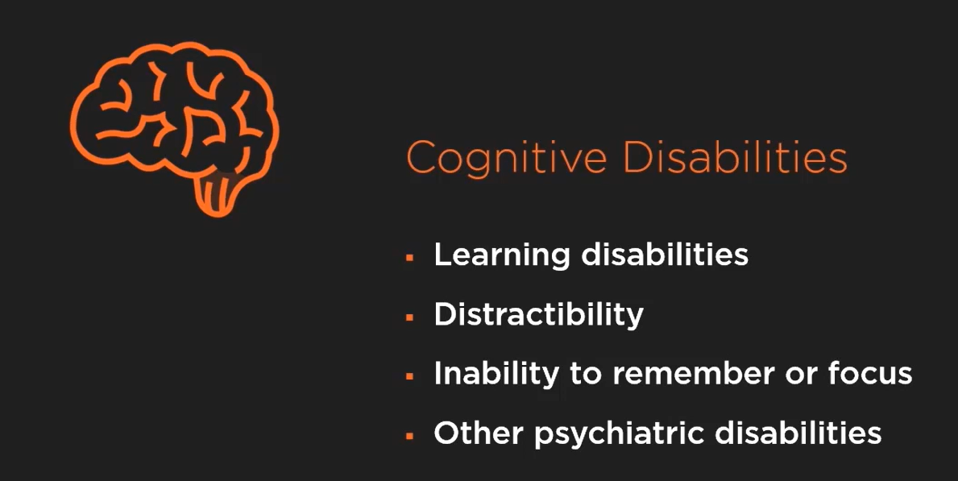

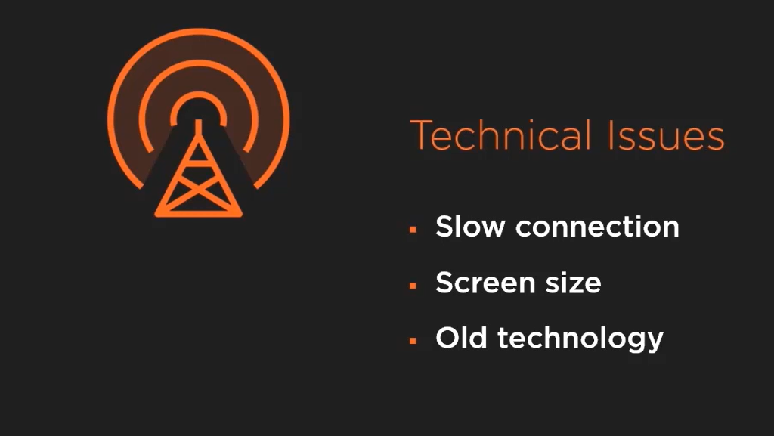

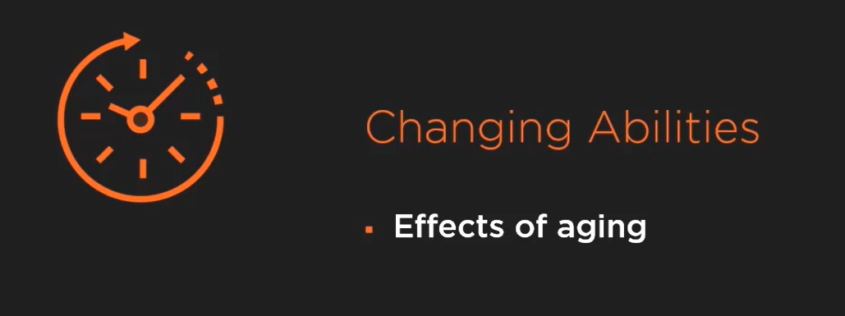

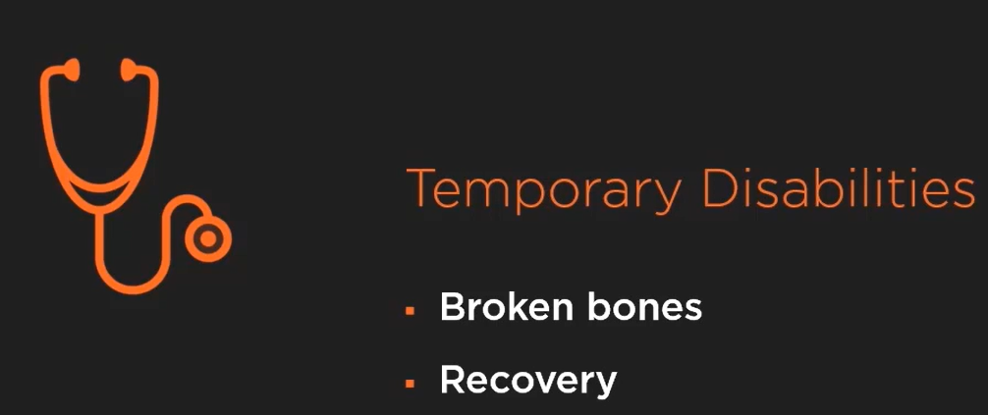

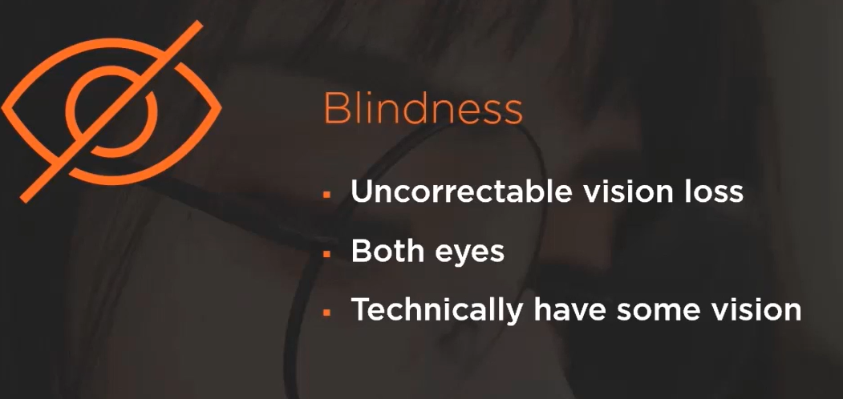

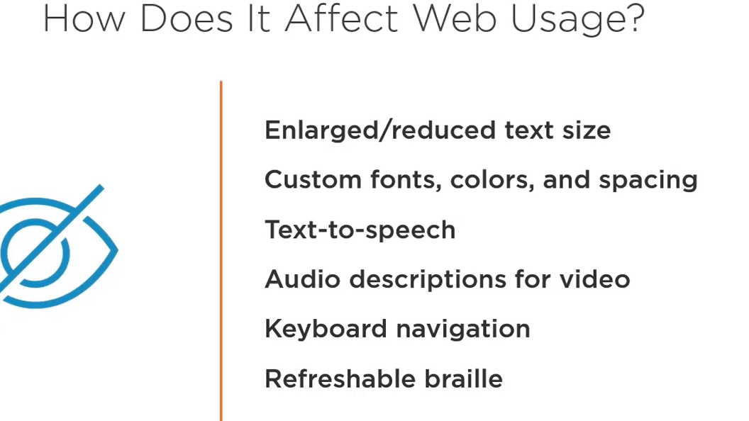

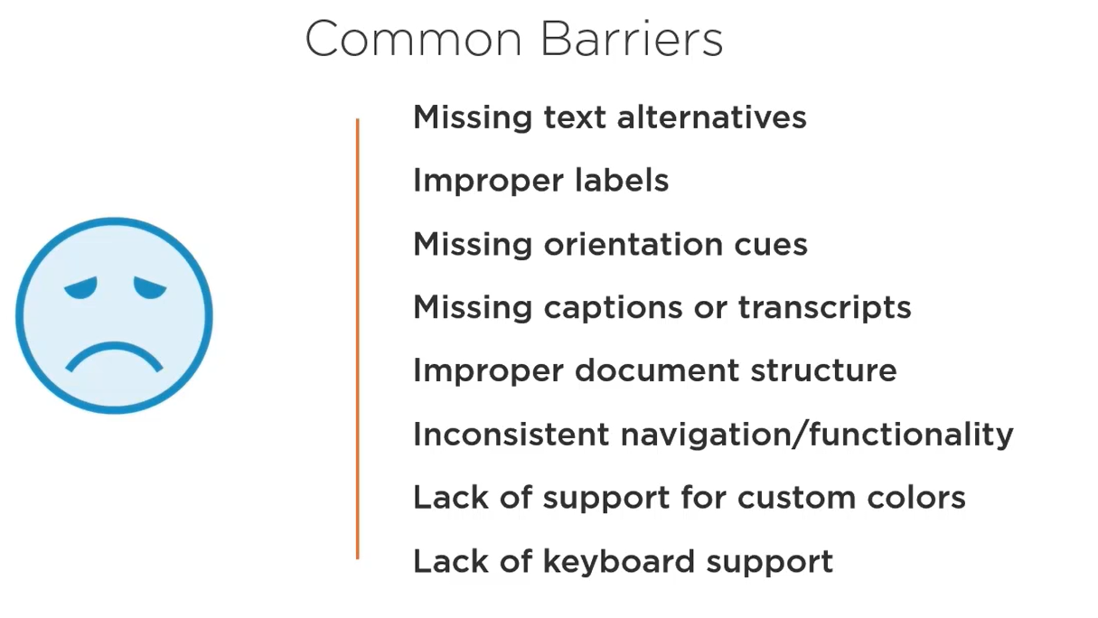

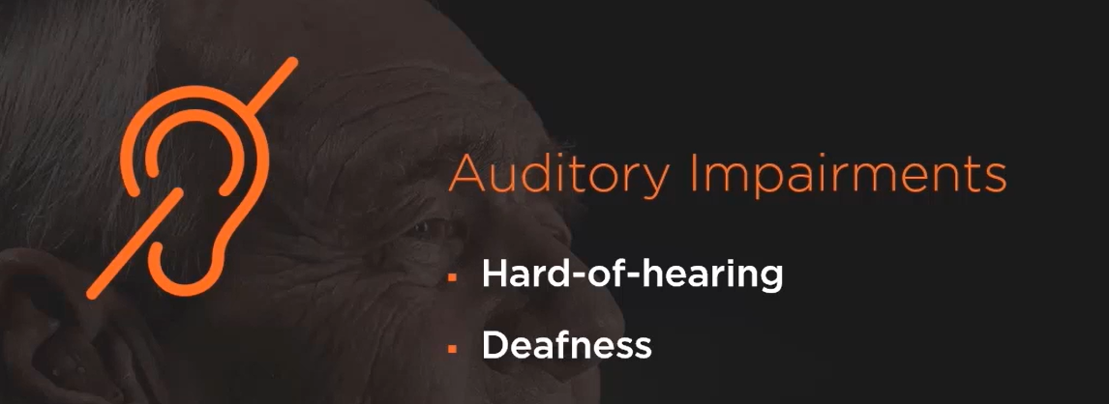

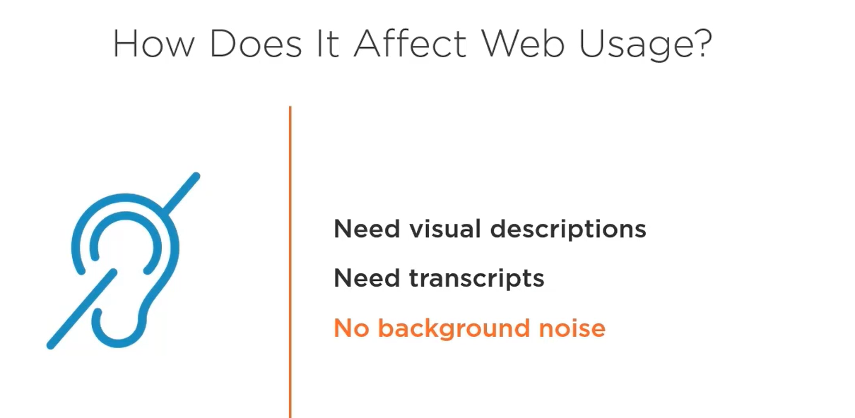

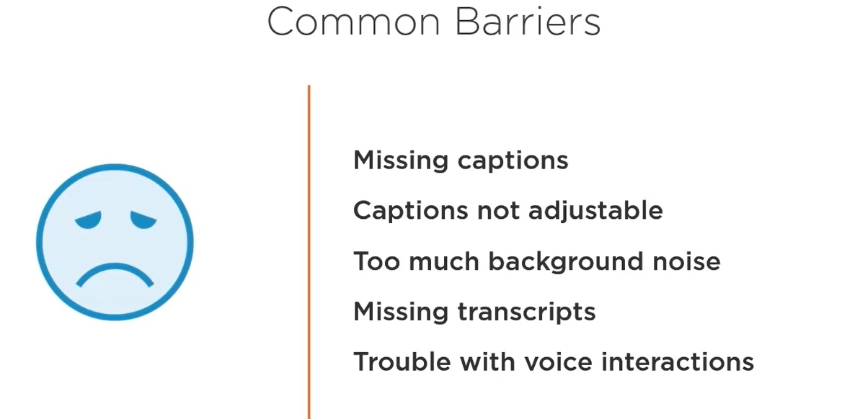

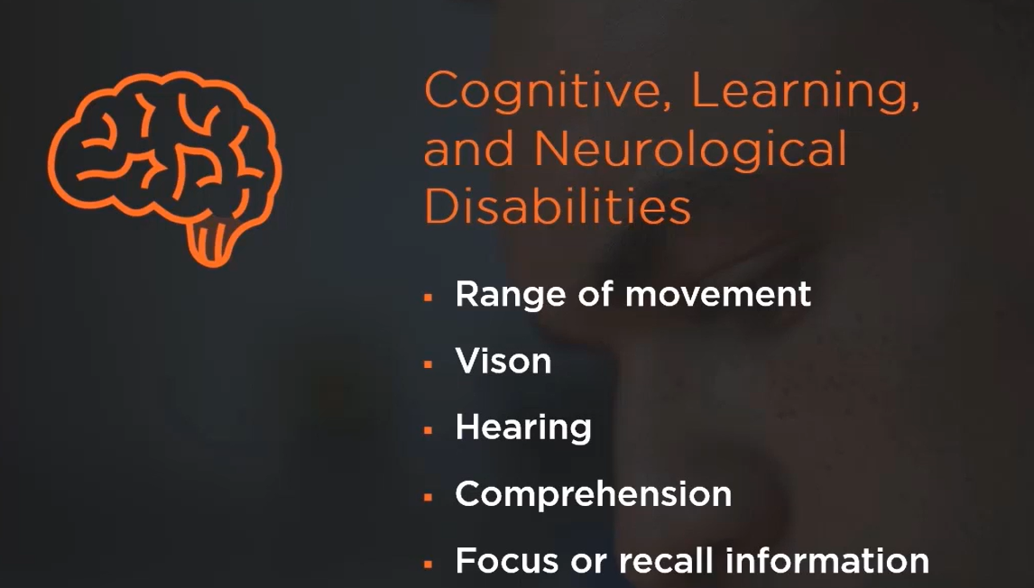

Seizure disabilities like migraine which get triggered on a specific frequency of audio.

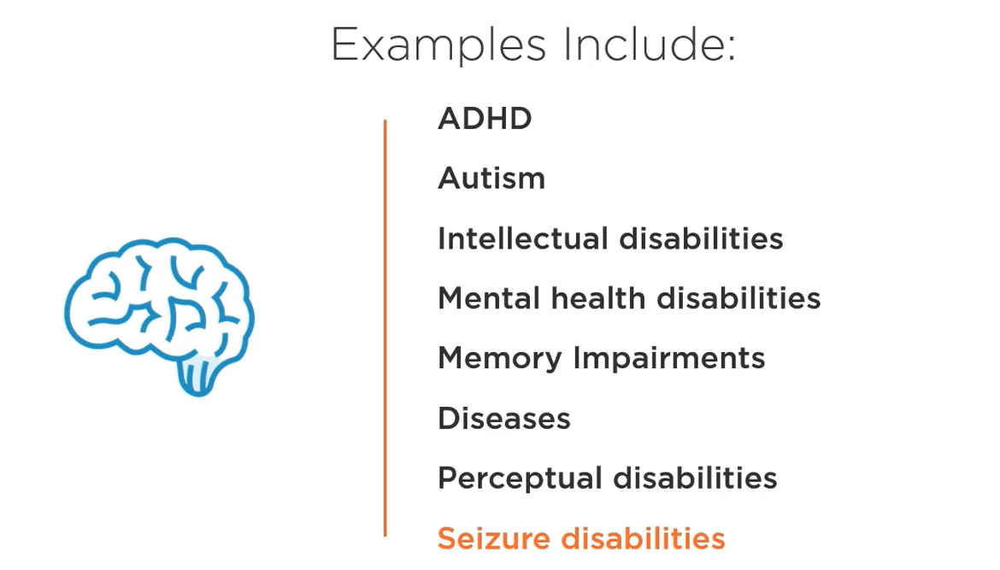

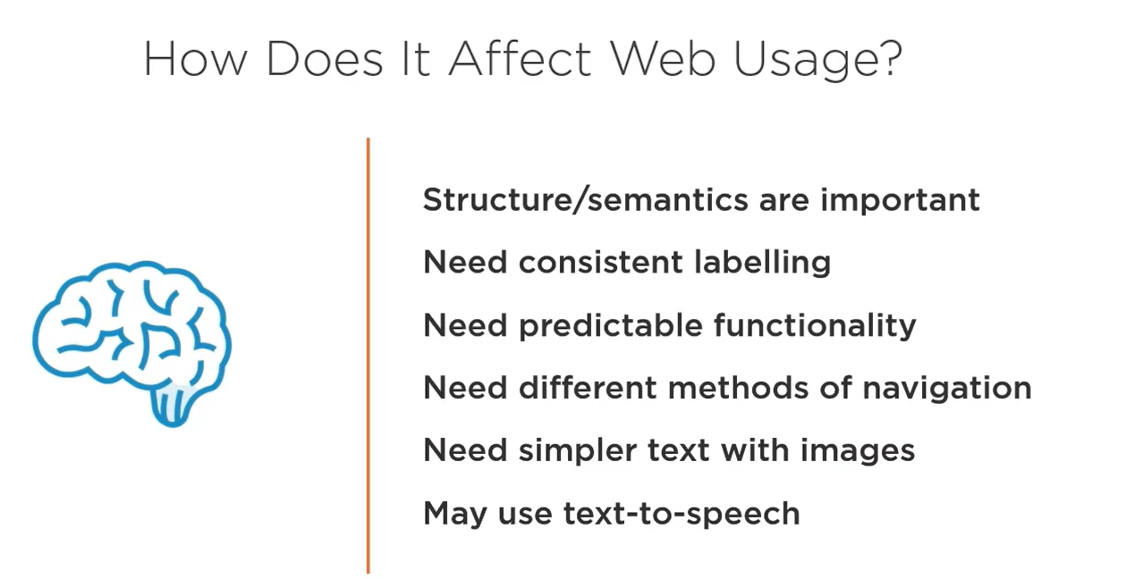

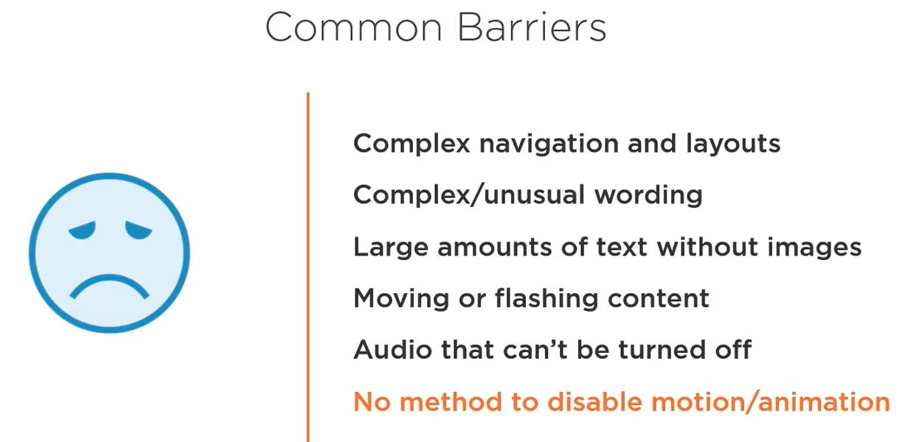

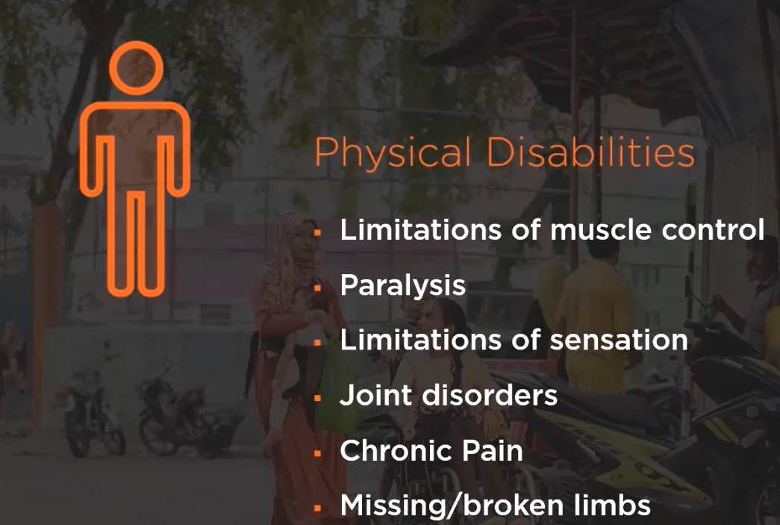

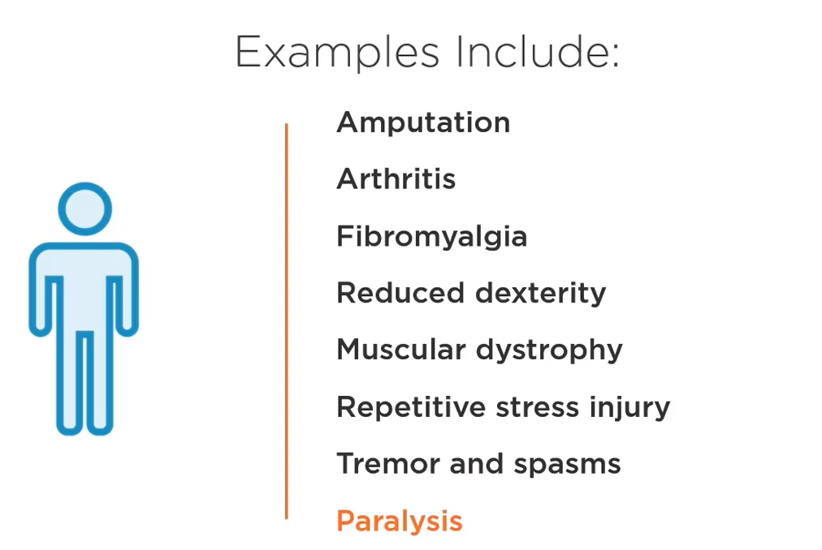

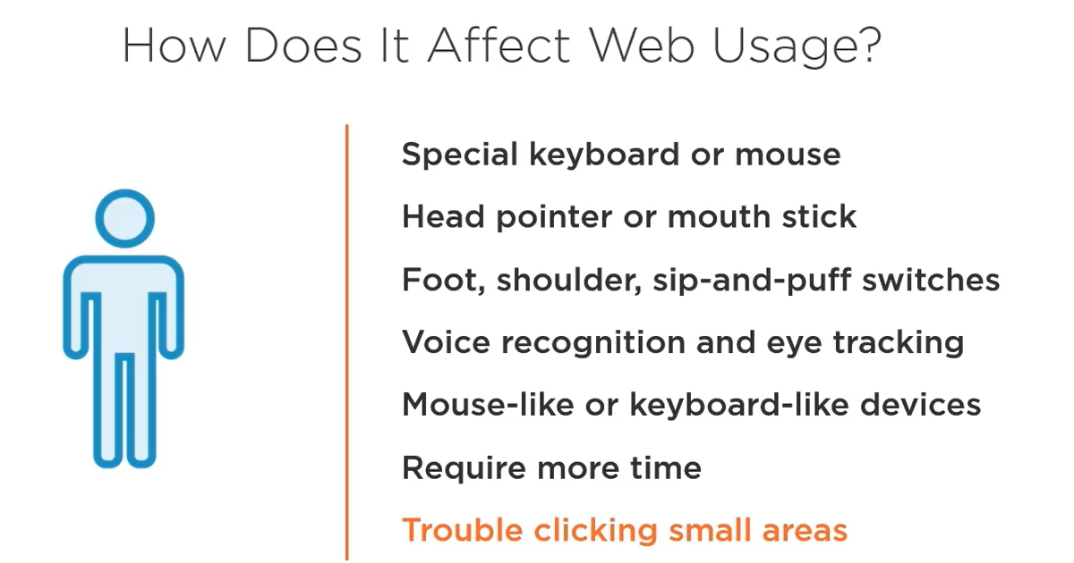

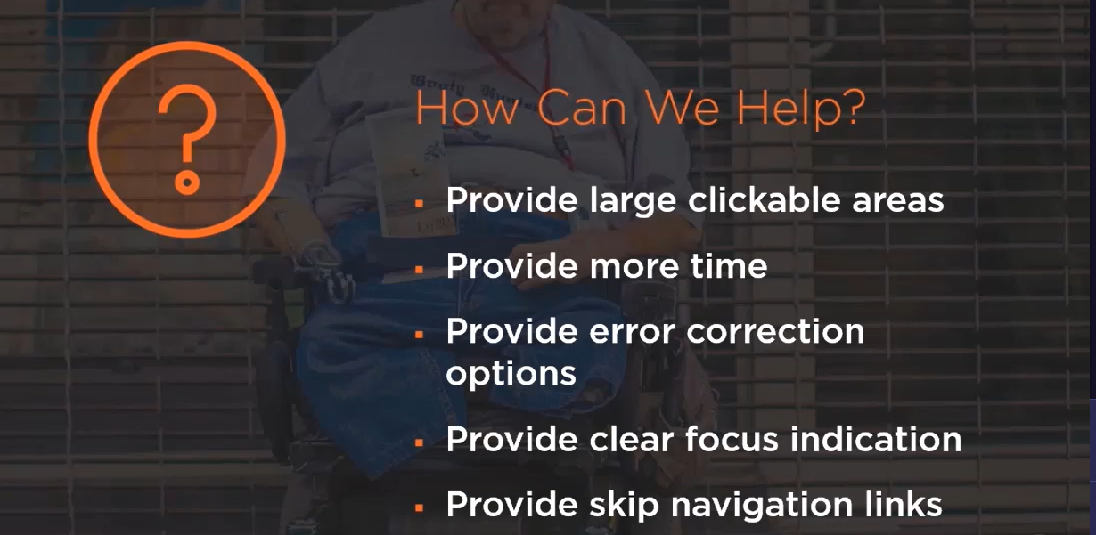

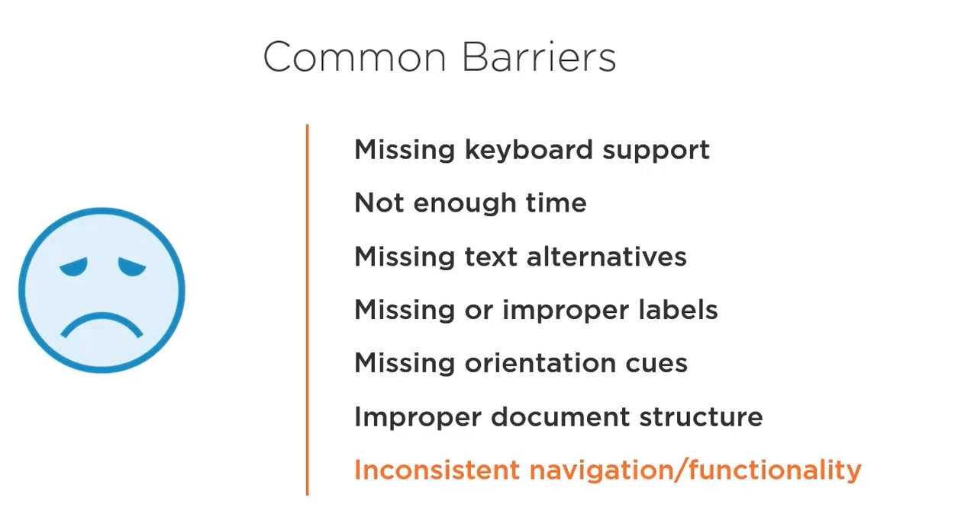

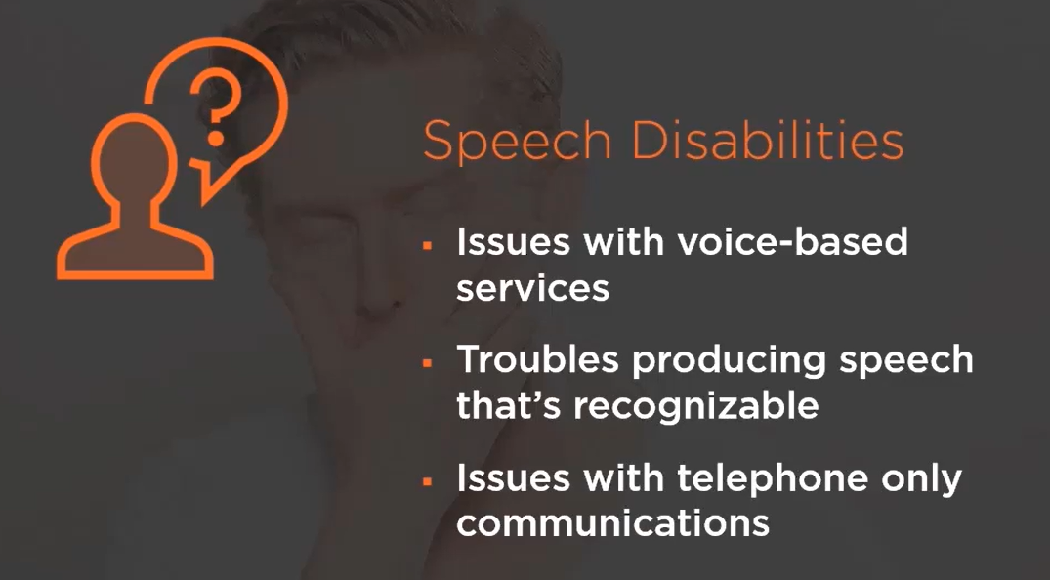

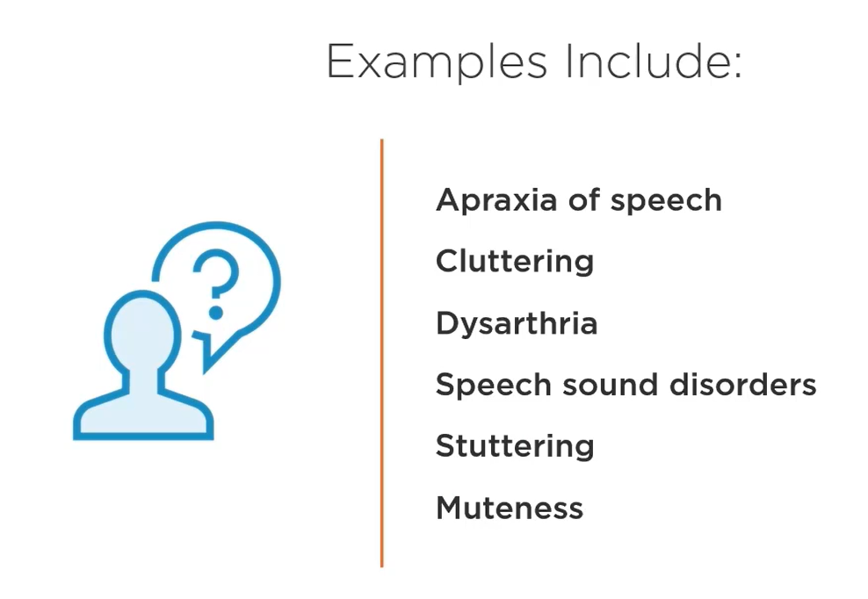

For above we can provide text based chat, email or feedback form in addition to form and keyboard commands to help navigate.

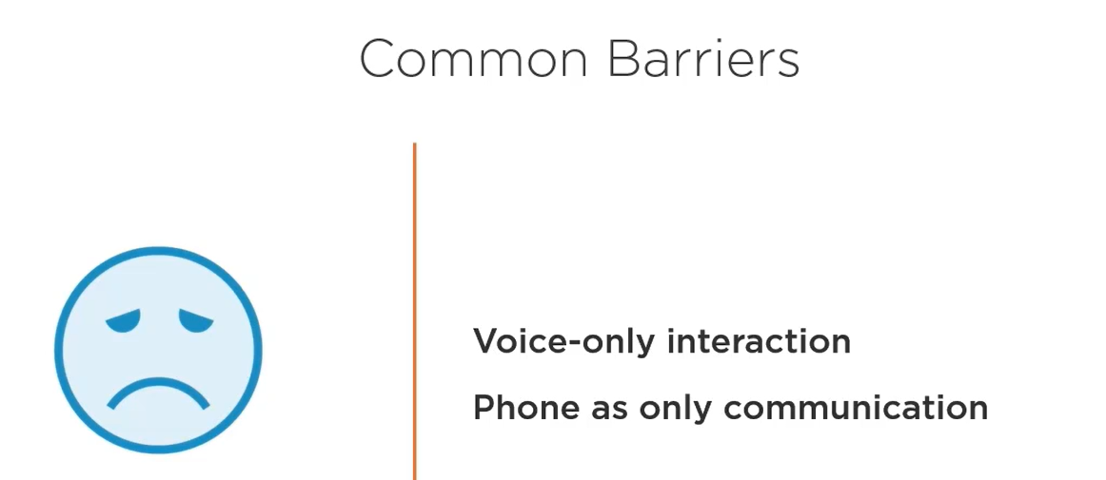

When working with a team who understands it, implementing accessibility doesn’t need much time or money. It should not be an afterthought. But if you do it at the end then it will the things difficult, sometimes impossible, without a complete redesign and rebuild. So before our project starts we should define goal, put someone in charge, evaluate tools and frameworks, research and adapt best practices.

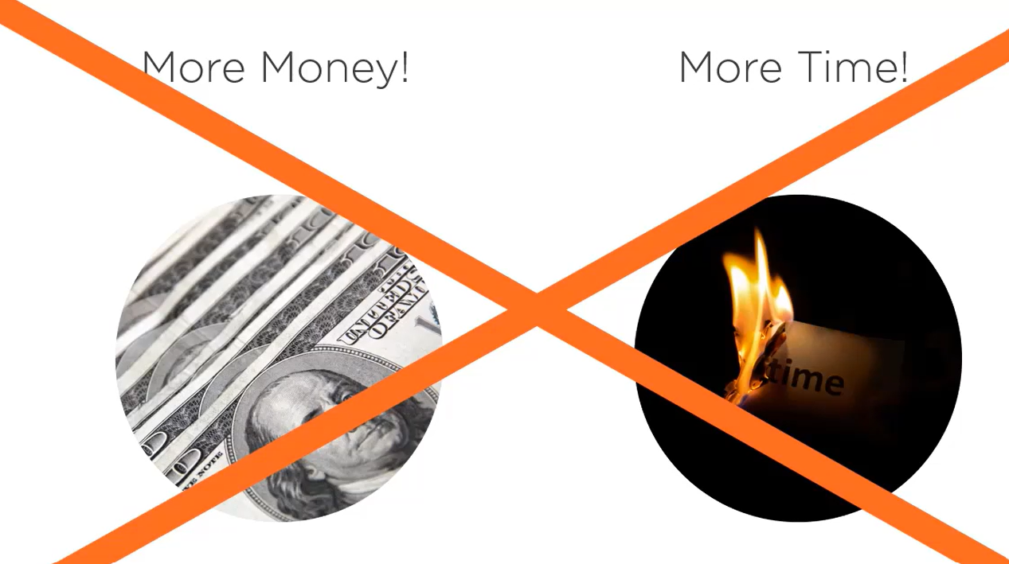

WCAG created by W3C which also maintains the HTML and CSS standands.

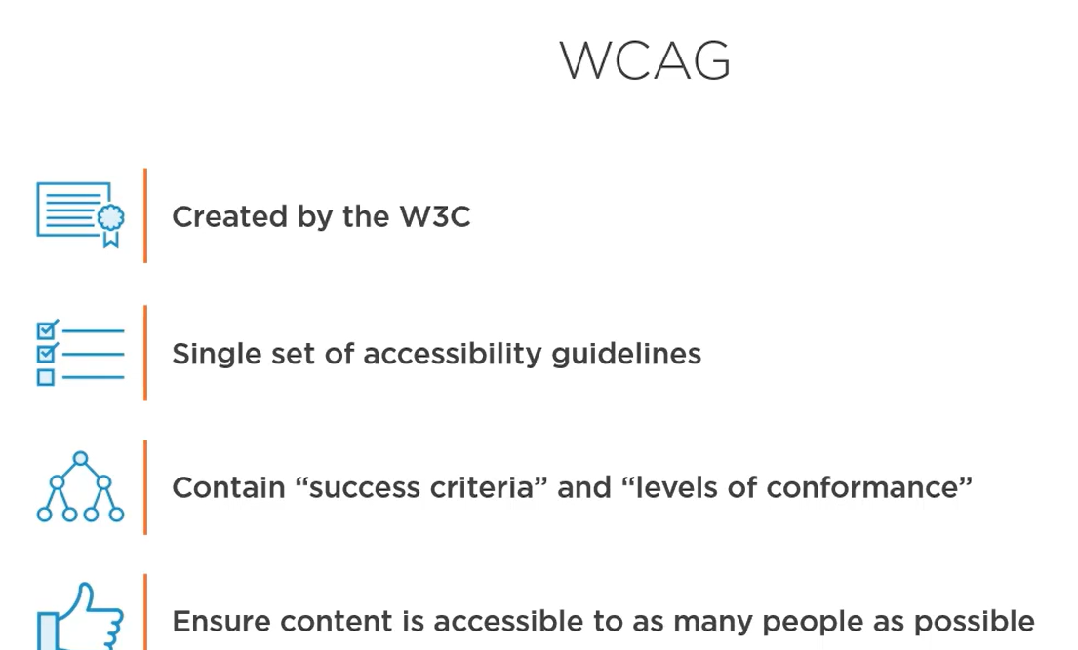

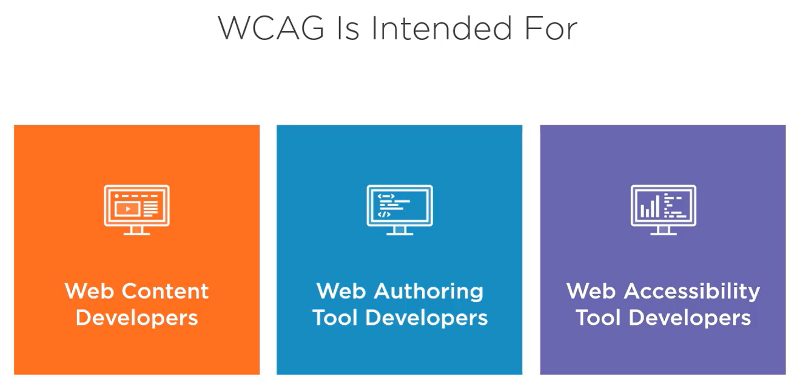

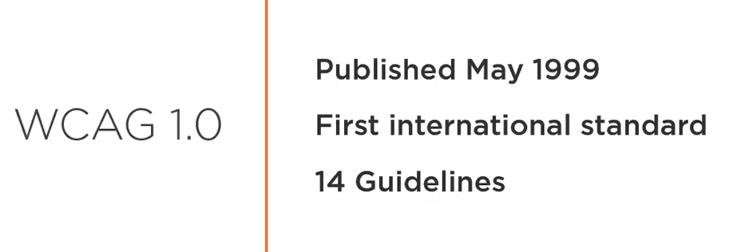

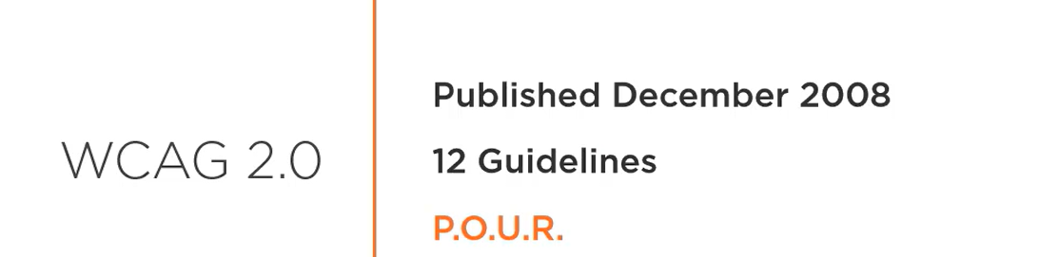

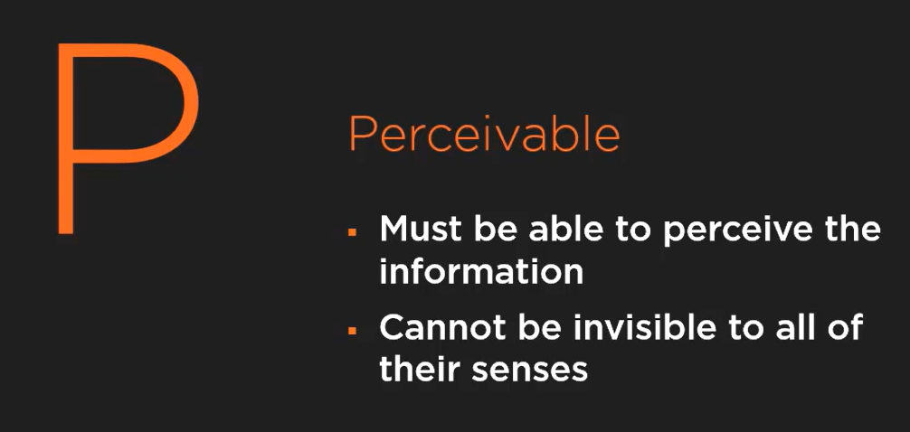

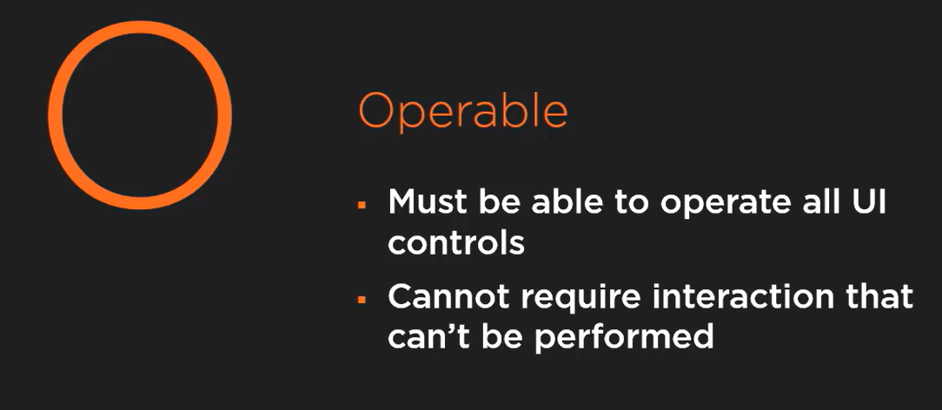

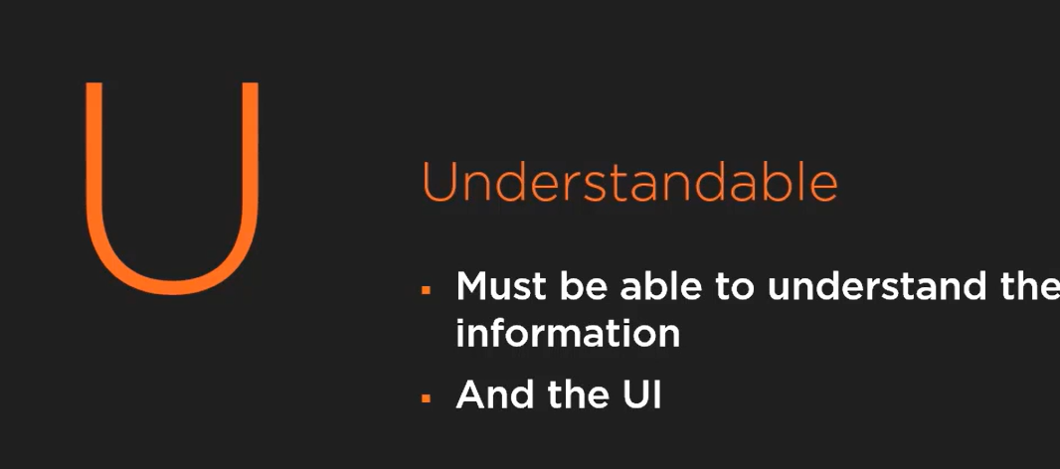

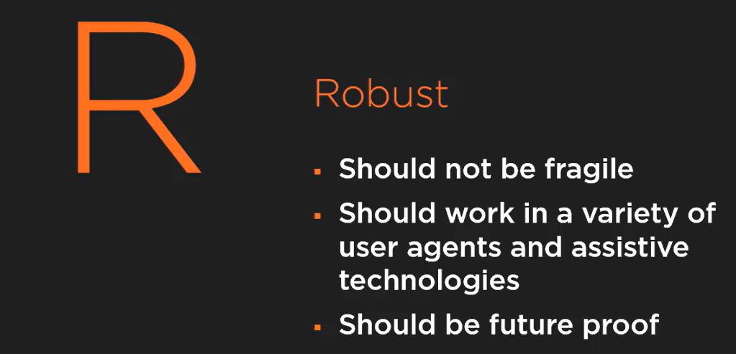

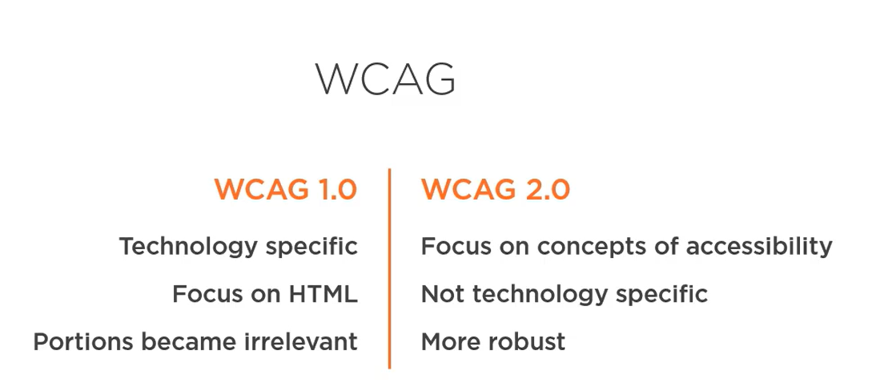

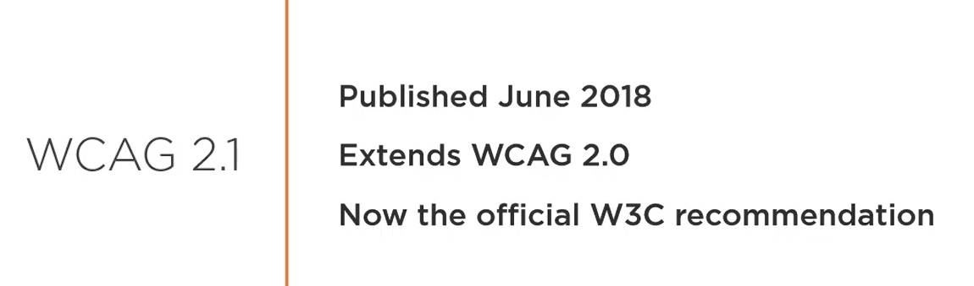

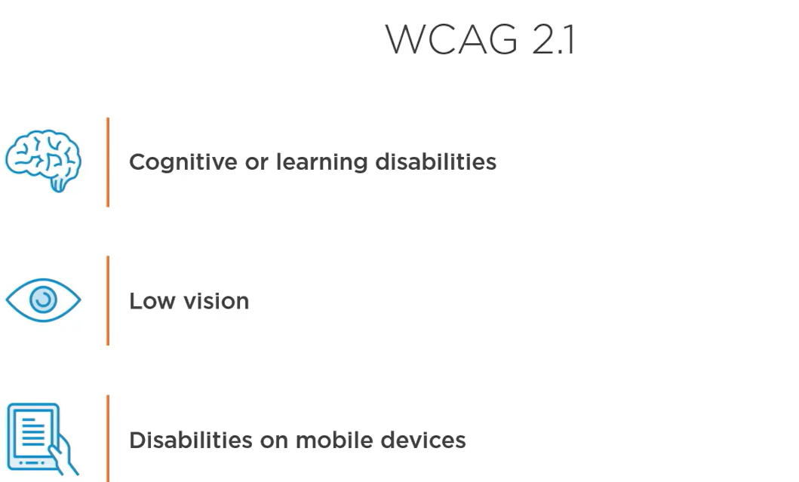

In future the WCAG might be replaced with silver as WCAG 3.0. Silver, also known as WCAG 3.0, is the planned successor to the Web Content Accessibility Guidelines (WCAG). It aims to provide a more flexible and adaptable framework for web accessibility, moving beyond the current true/false success criteria approach. Silver will address a wider range of digital content, including video and mobile apps, and will be written in plain language to be more accessible and translatable.

<https://www.w3.org/WAI/GL/task-forces/silver/wiki/Welcome_to_Silver>

These guidelines will have much broader scope than just web content, hence need for new name.

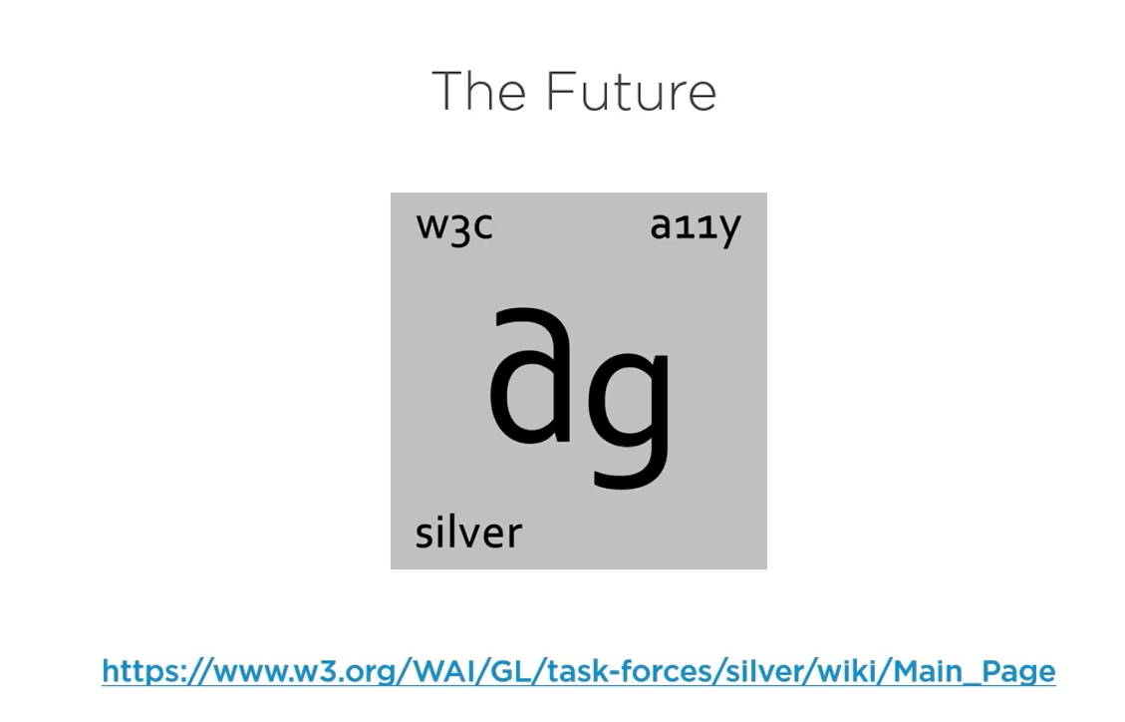

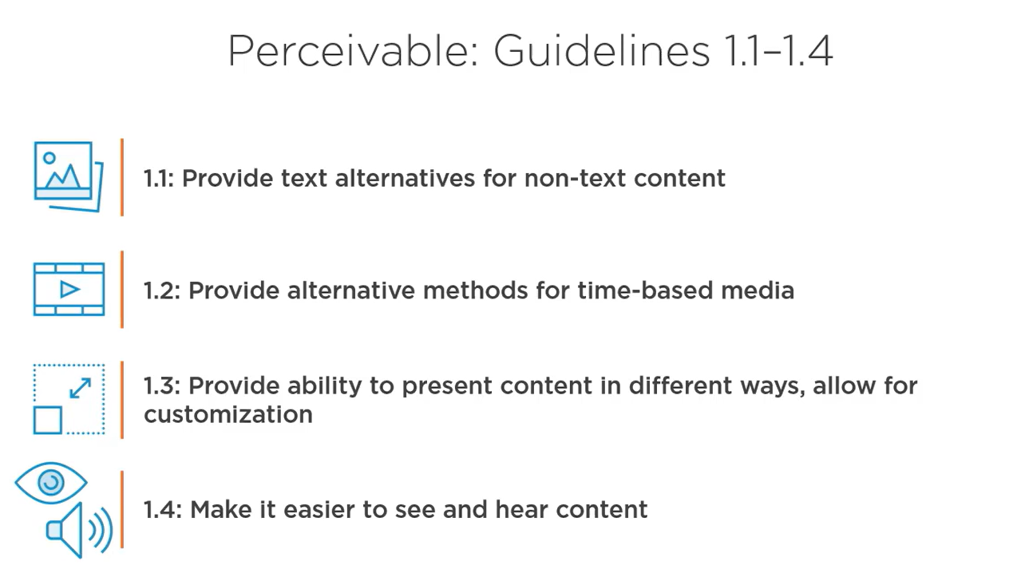

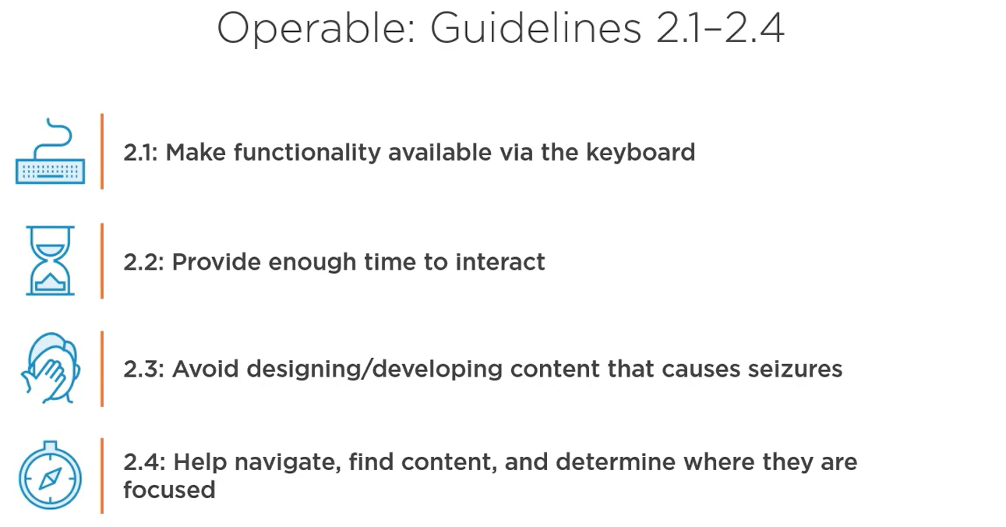

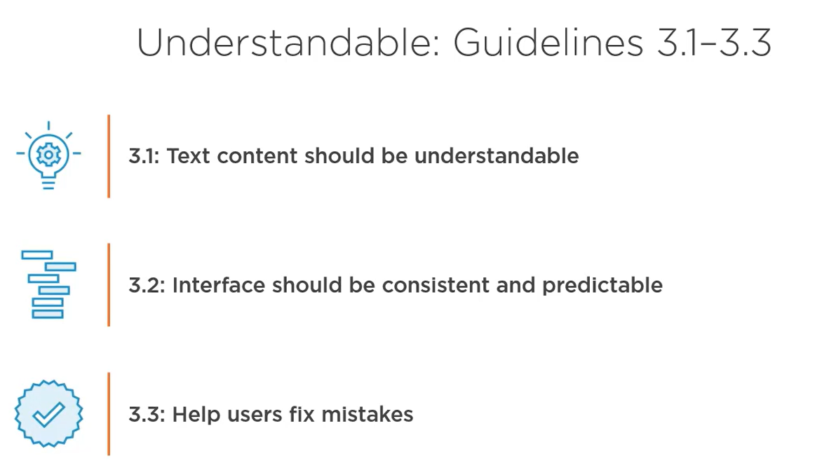

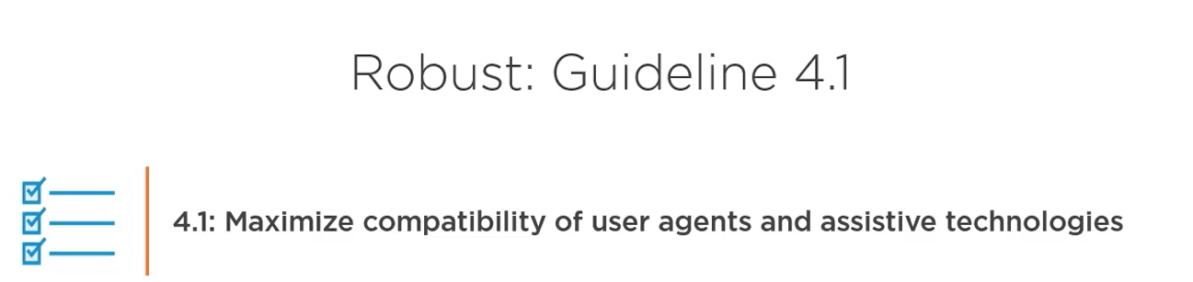

WCAG 2.1 guidelines –

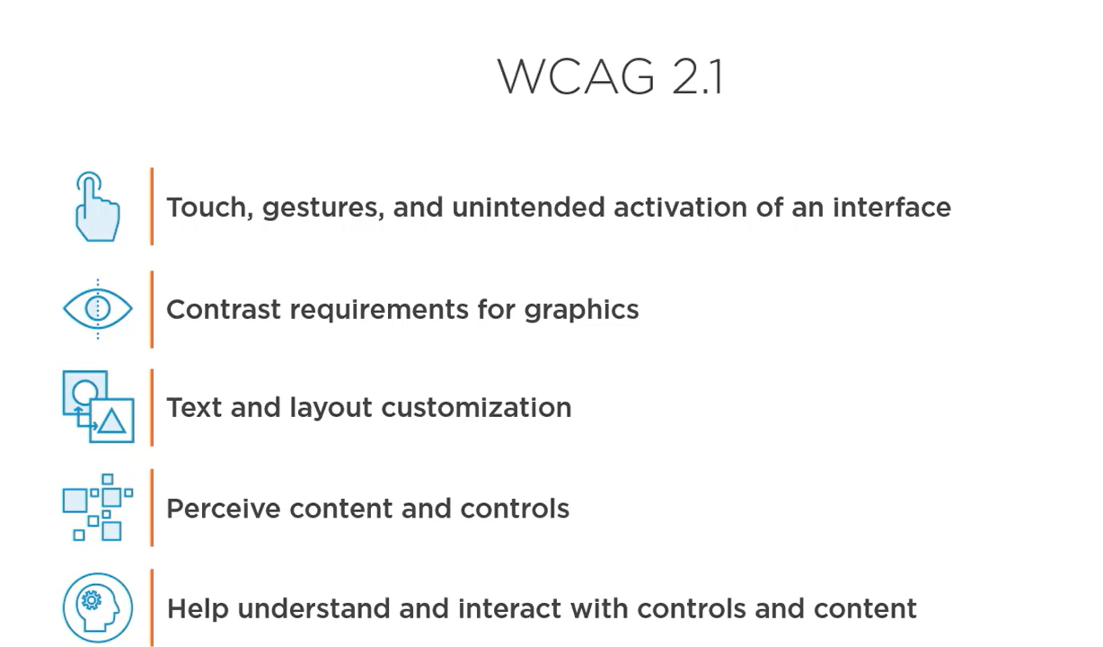

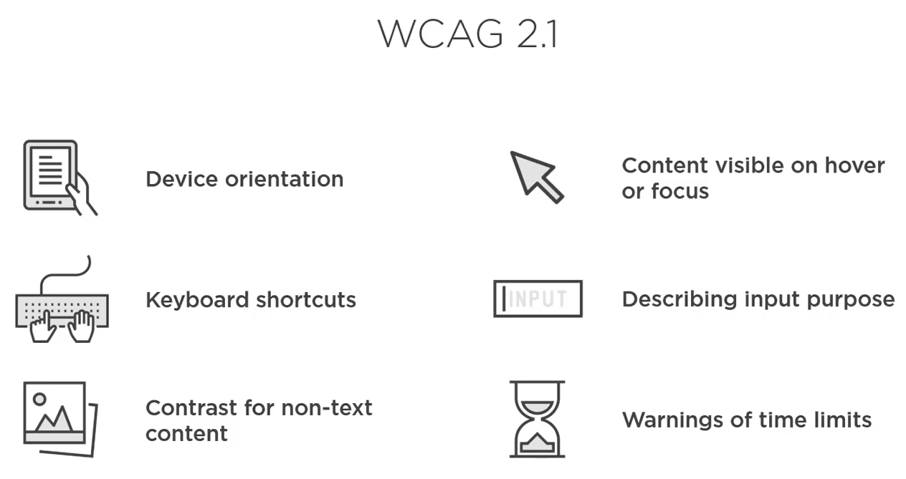

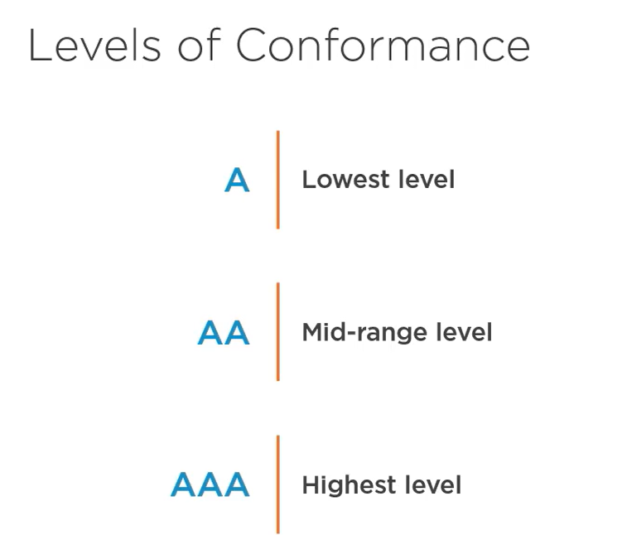

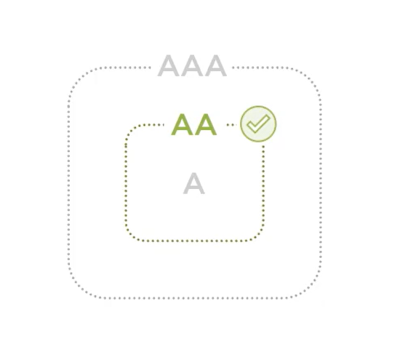

Meeting the success criteria and conformance levels only works on a full page if part of the page does not meet a double A level then whole page does not meet a double A level. Same with process if one page in a series like product selection, cart, checkout payment doesn’t meet the success criteria then whole process doesn’t get confirm the AA level.

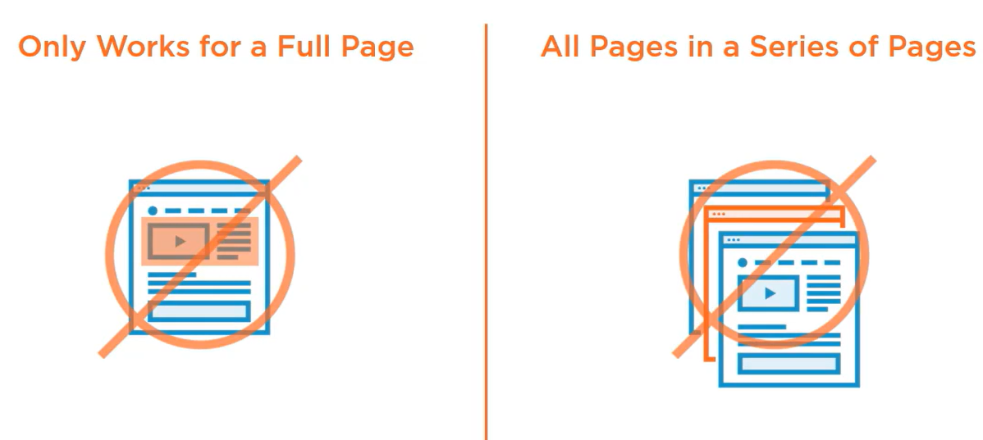

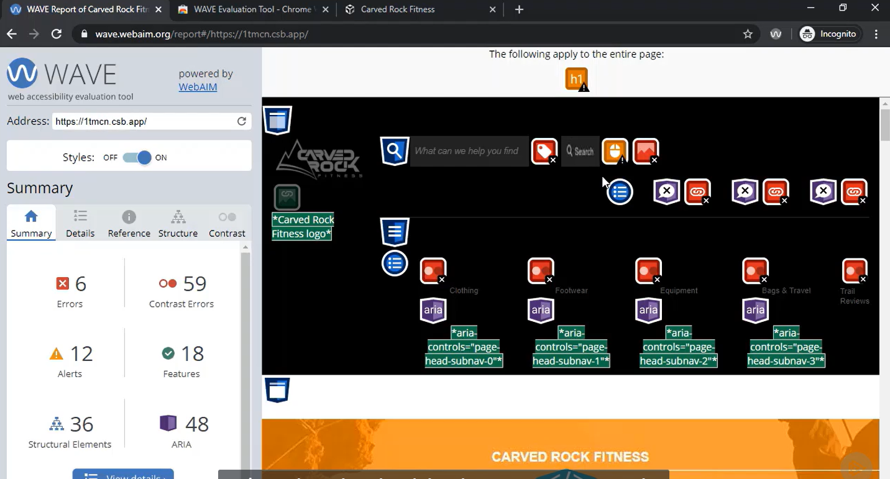

Wave tool also teaches us about the error –

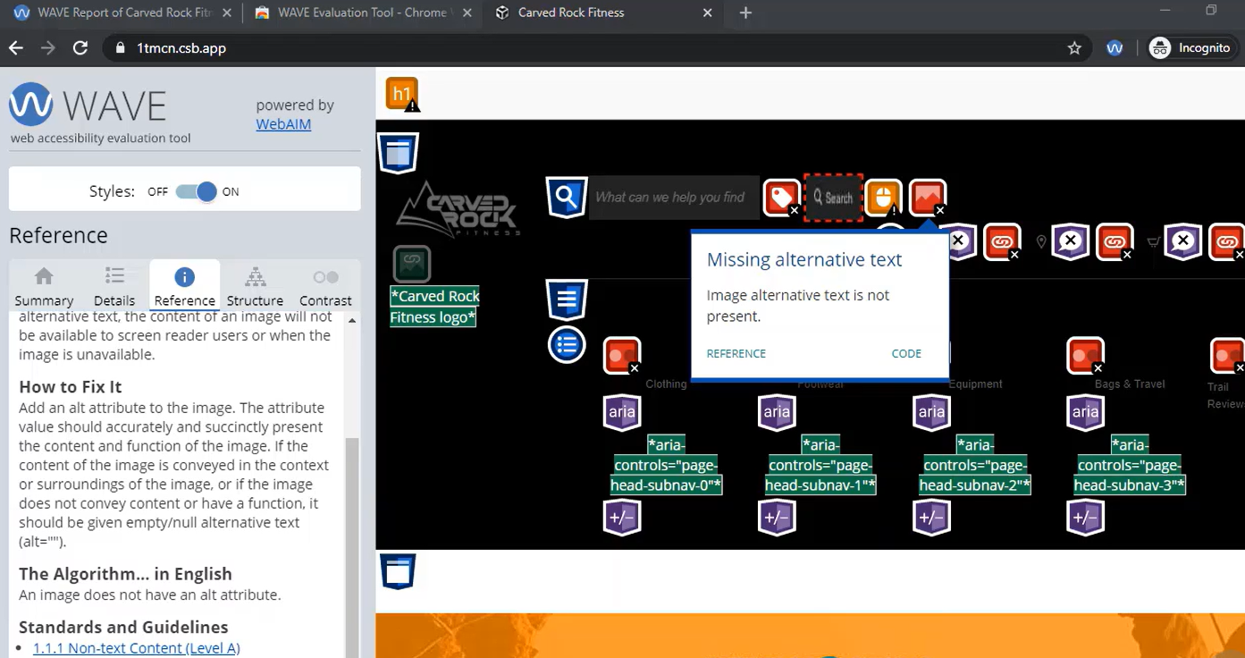

Even WAVE can’t find all the accessible issue even if it shows zero errors, only a human can determine true accessibility. Zero Errors doesn’t mean it is accessible.

AXE core is a accessibility testing engine that has a command line interface that we can use in our build server.

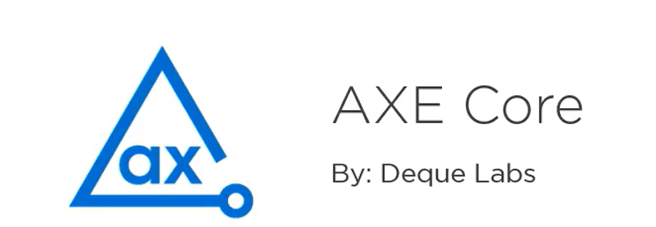

We have everything we need to fix the error like item with the error, error itself, the ways to fix it.

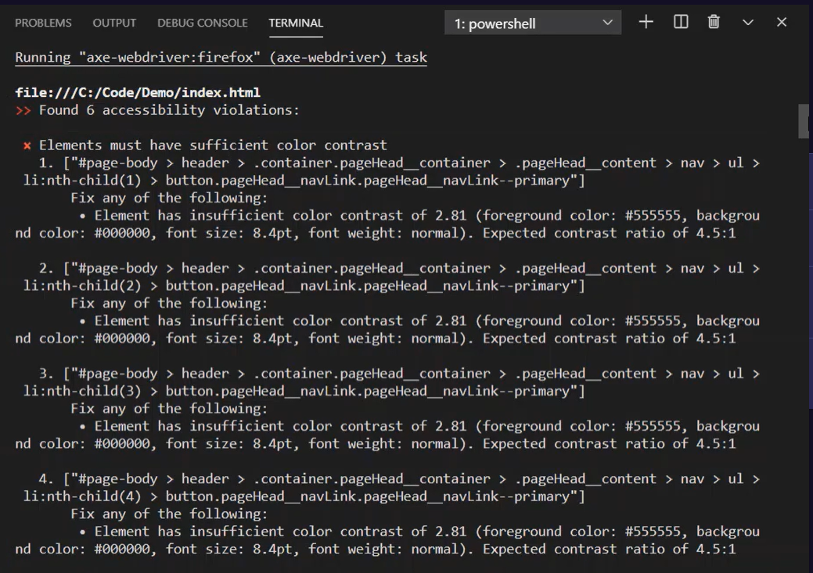

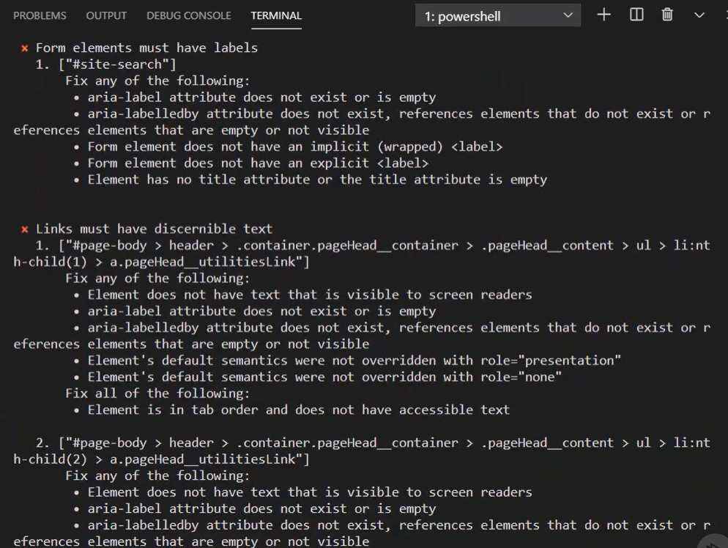

Criteria which we can’t test are like mobile device interaction requires the testing to be done manually on the device. Also hard to test when it requires interactions like the content will be visible after clicking on the certain button. Automation accessibility testing is not a replacement for human evaluation.

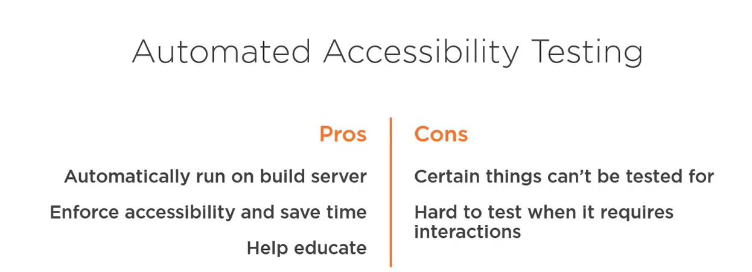

After automation, for manual just few steps – manual keyboard testing, add screen reader testing, add “semi-automated” testing with tools like WAVE then finally add fully automated testing with tools like AXE Core.

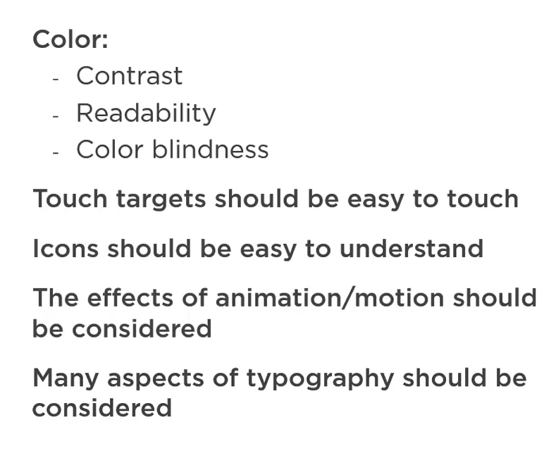

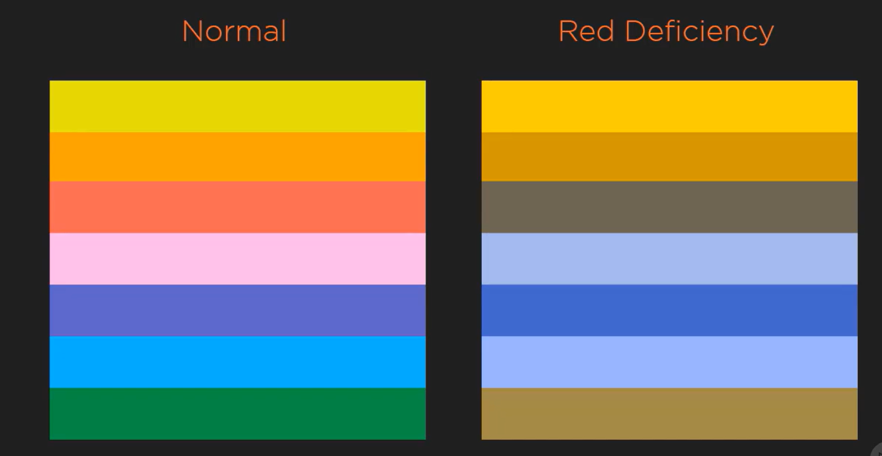

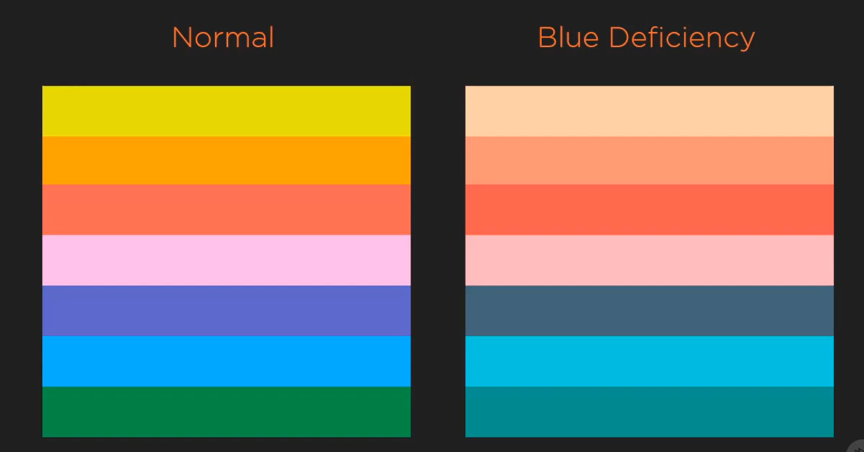

No color defency –

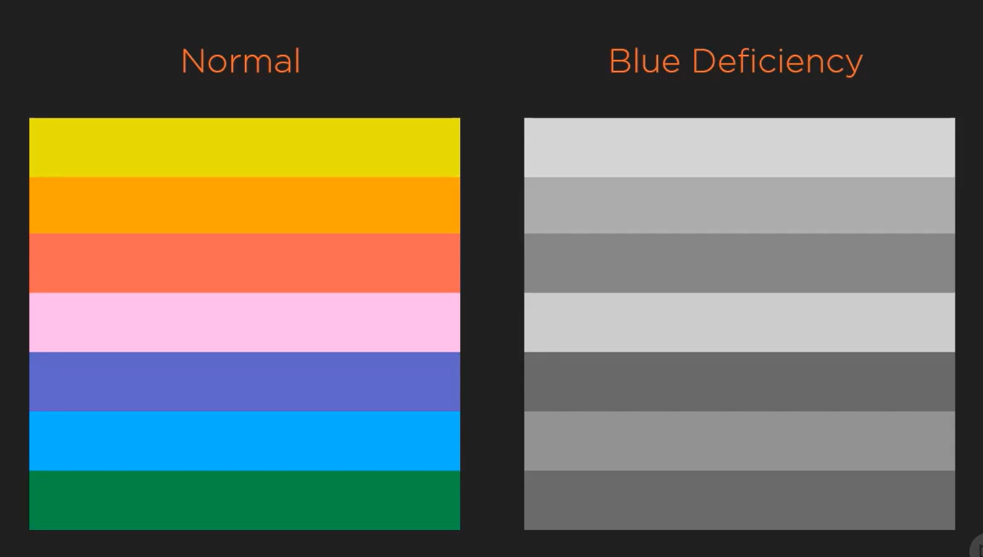

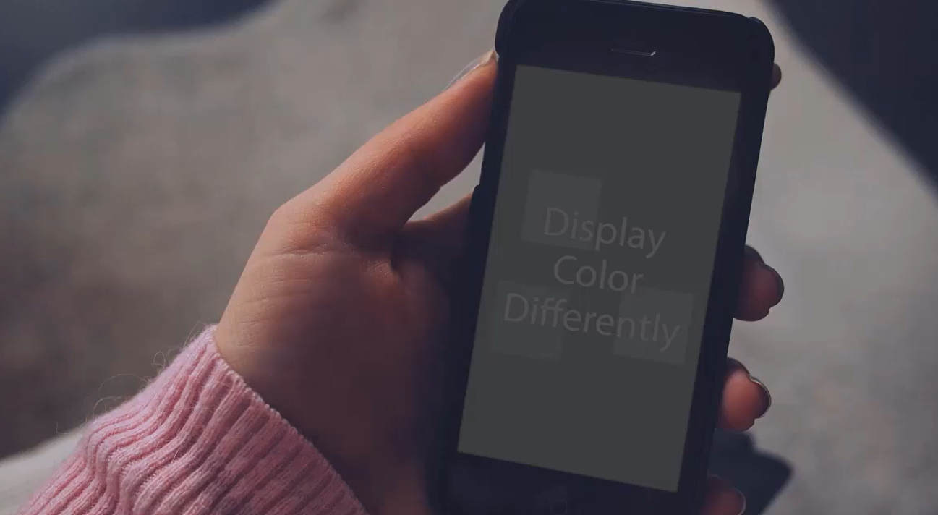

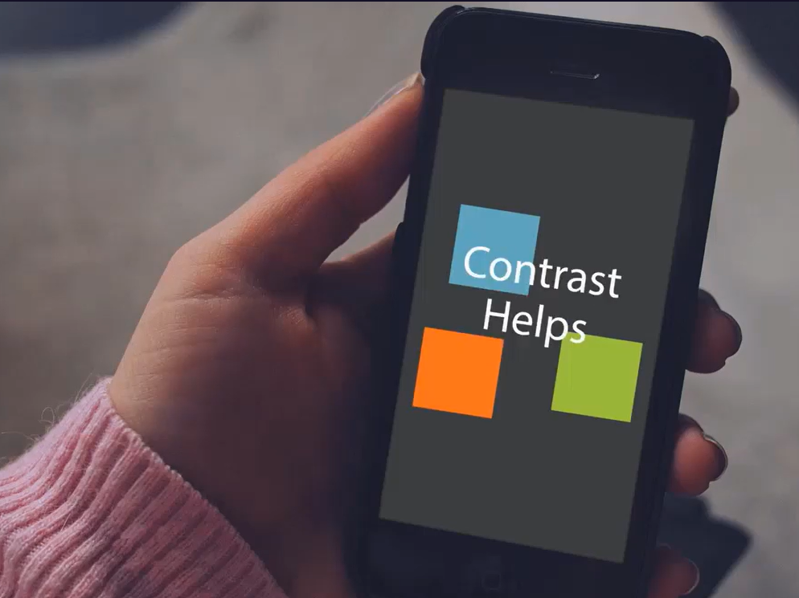

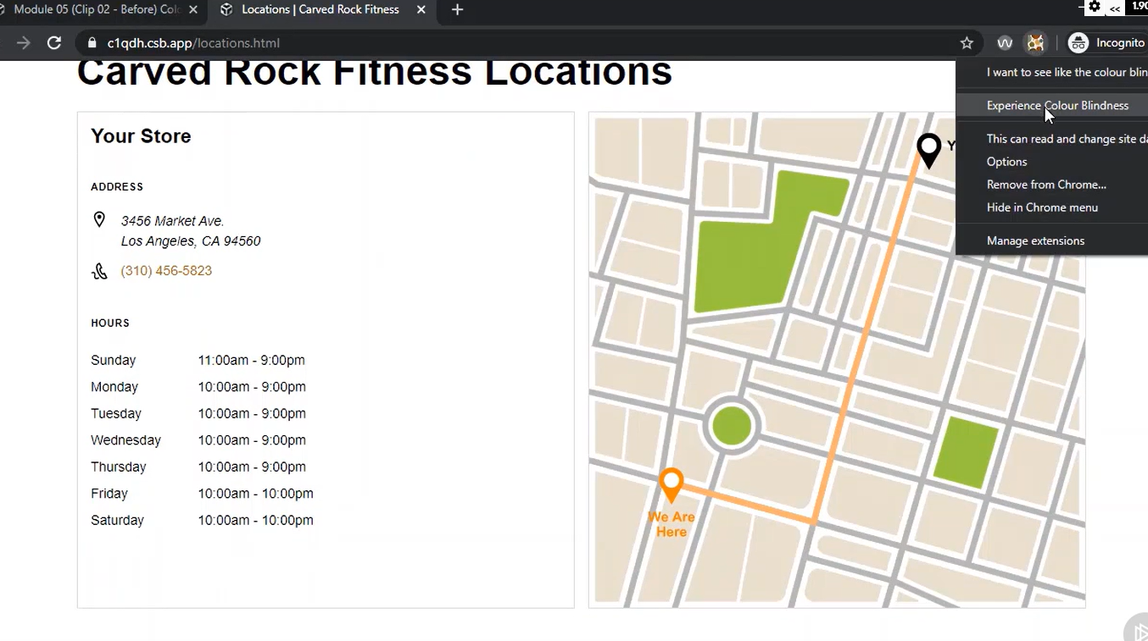

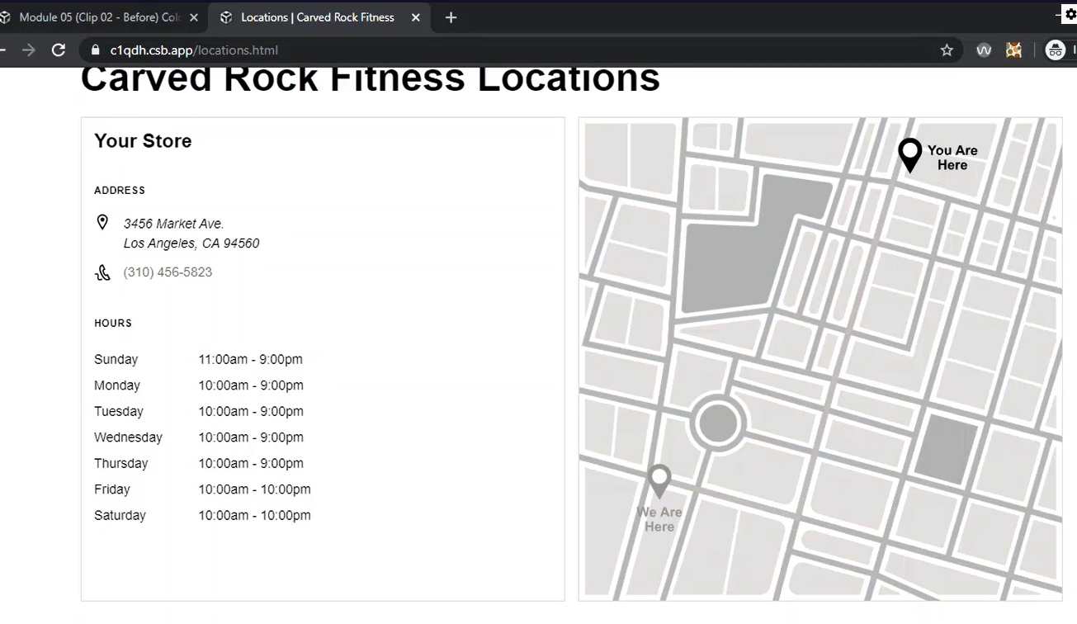

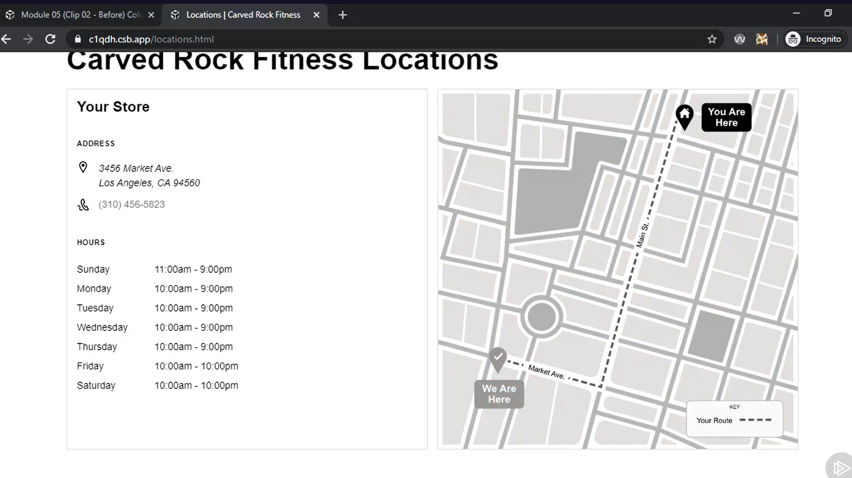

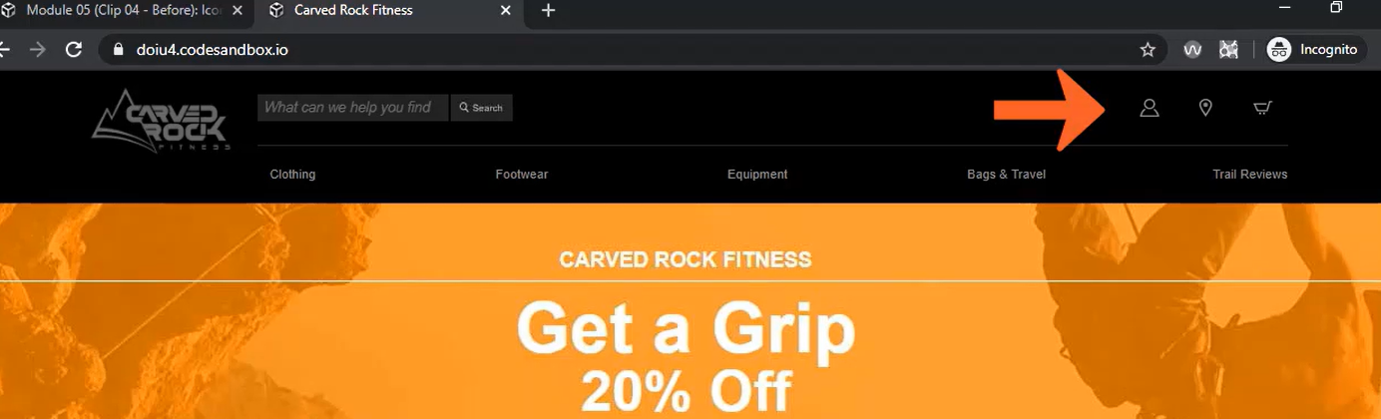

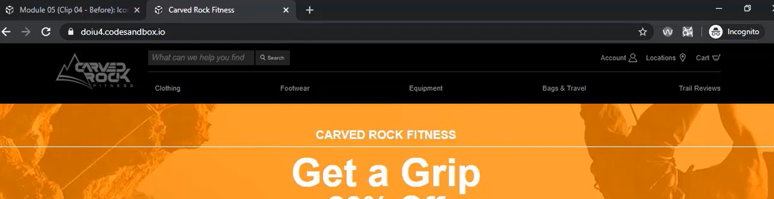

Have a switch to enable and disable the animation – animation can make people sick and disoriented.

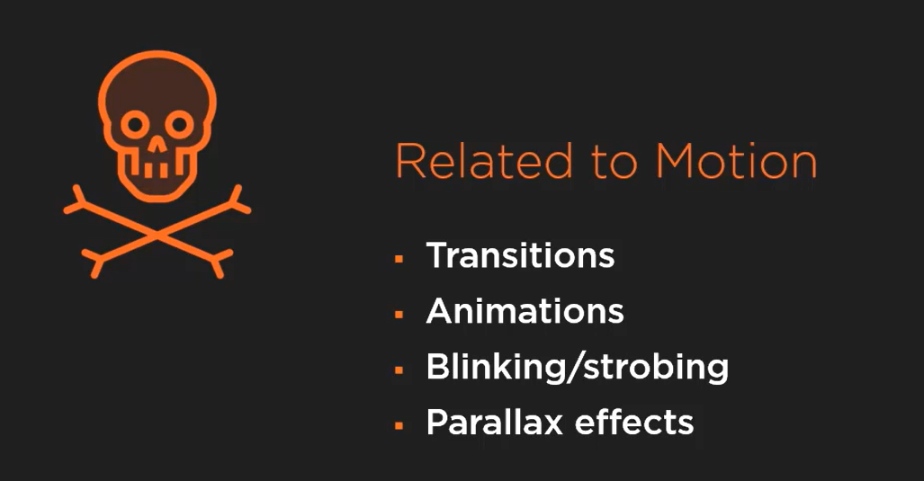

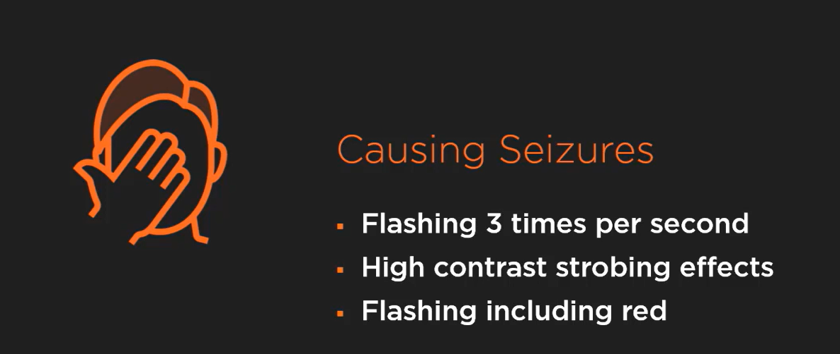

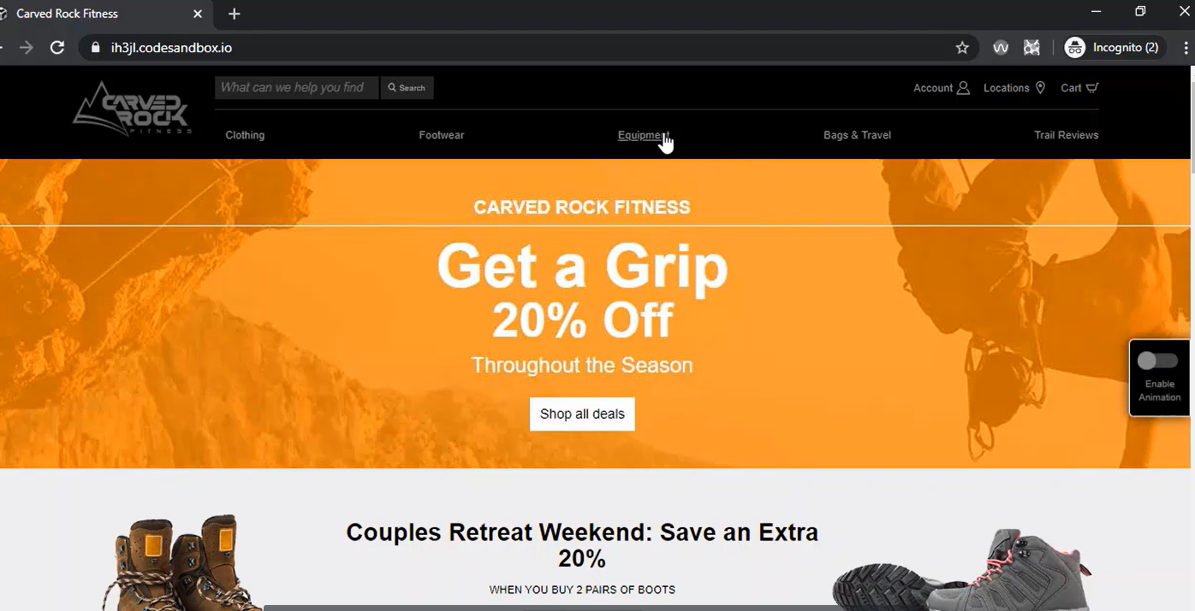

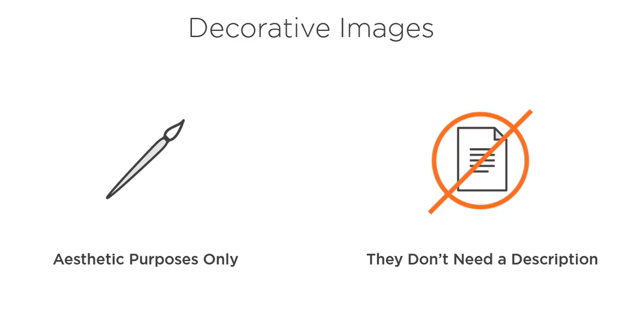

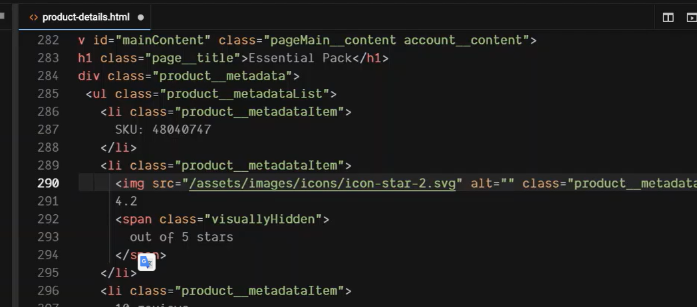

Either use alt as “” or CSS background image or aria-hidden as true for SVG type of images.

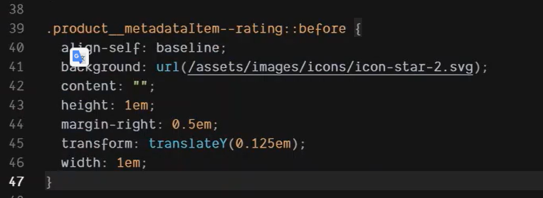

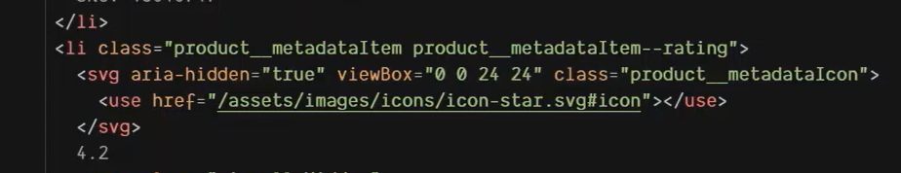

For AAA we need to use transcripts – it allows content to be read in one form or another.

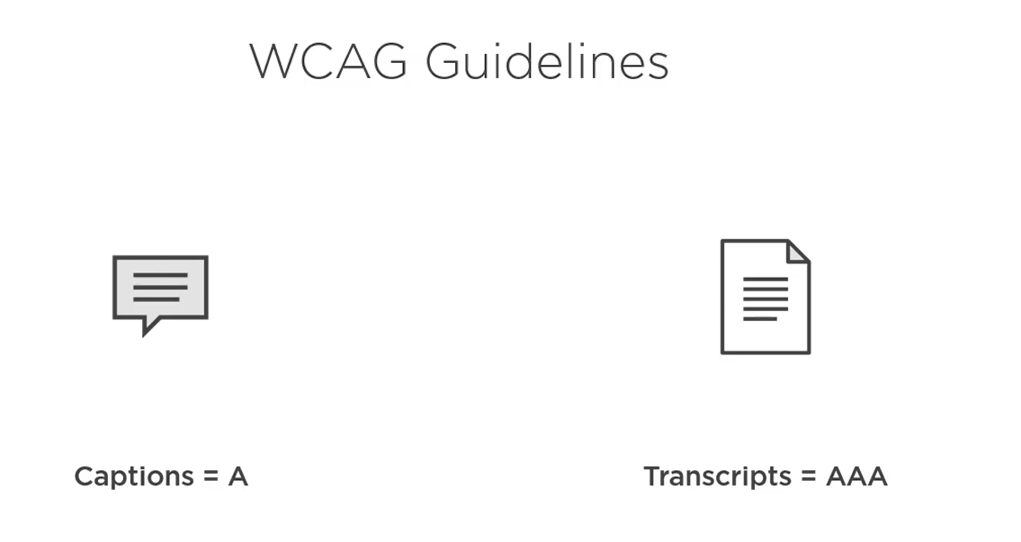

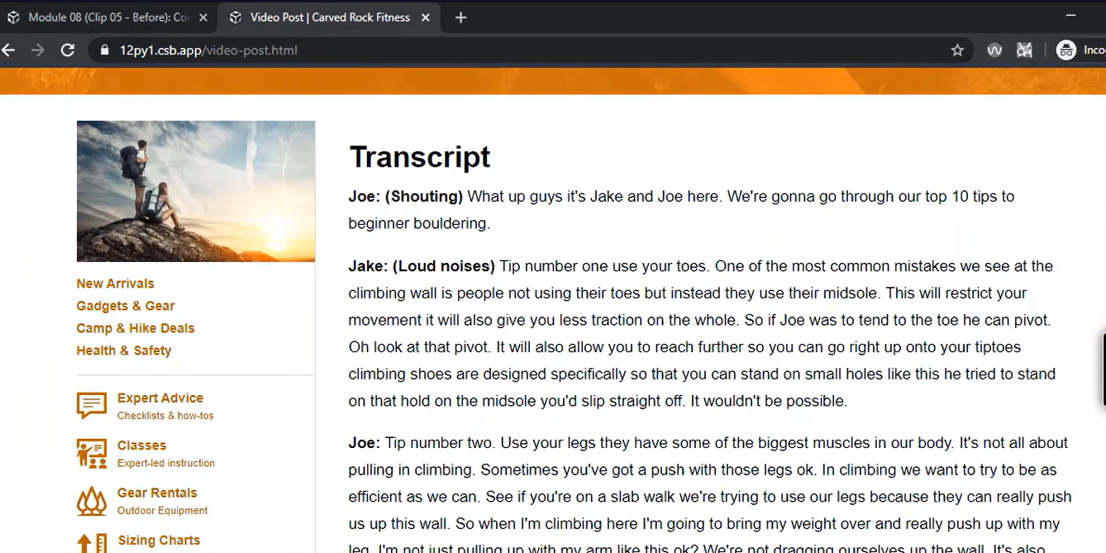

Create questions slide to make images, video, auto accessible, ask questions and provide answers. Links, site navigations,

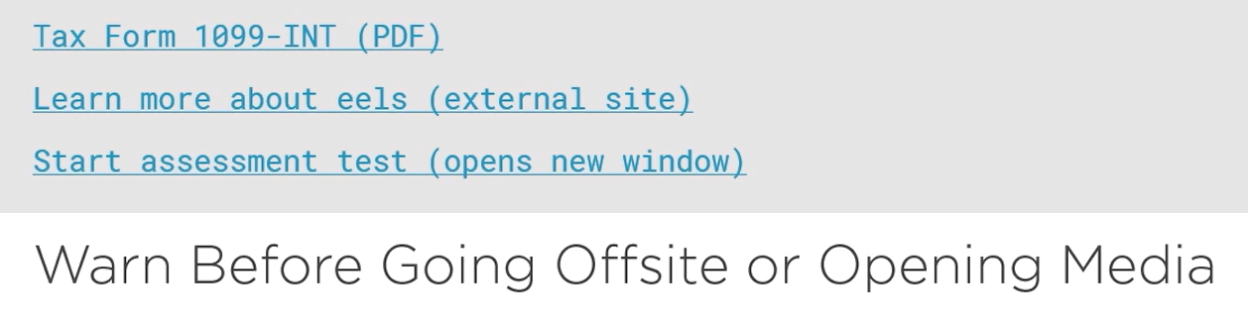

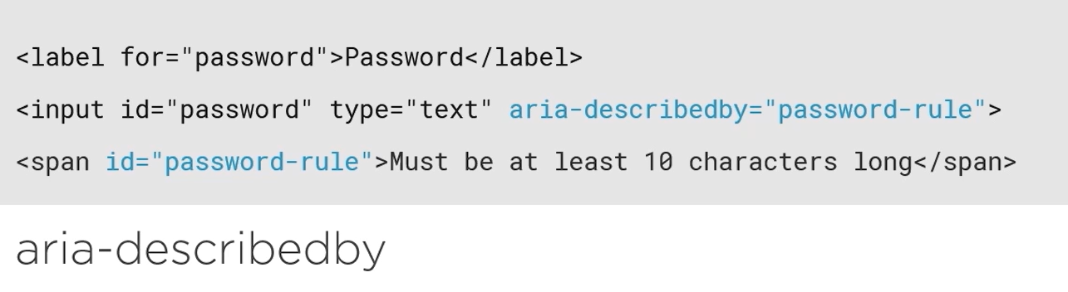

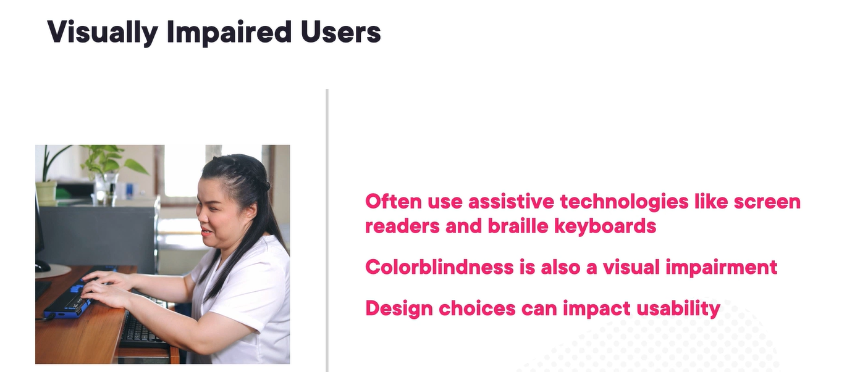

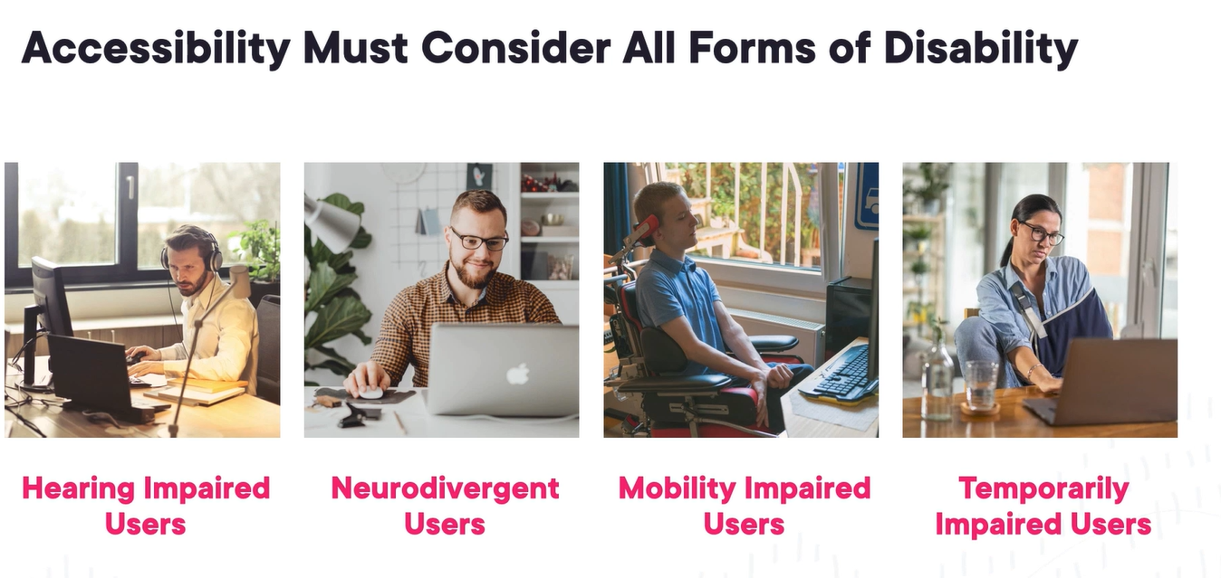

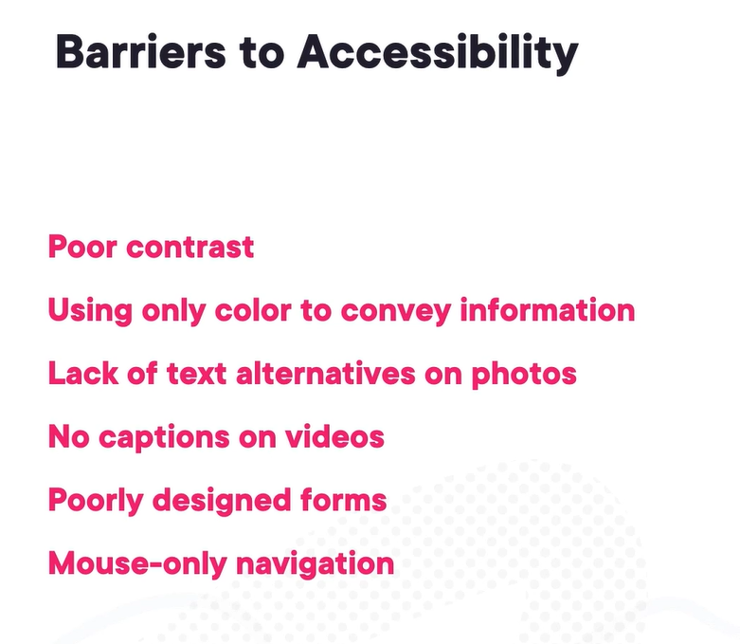

AAA for website which targets specific group for disabled people.

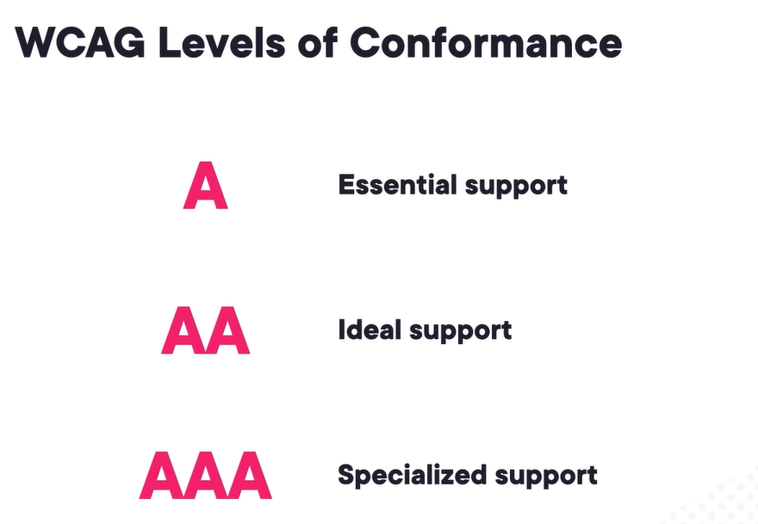

Failing it might attract fines or lawsuits.

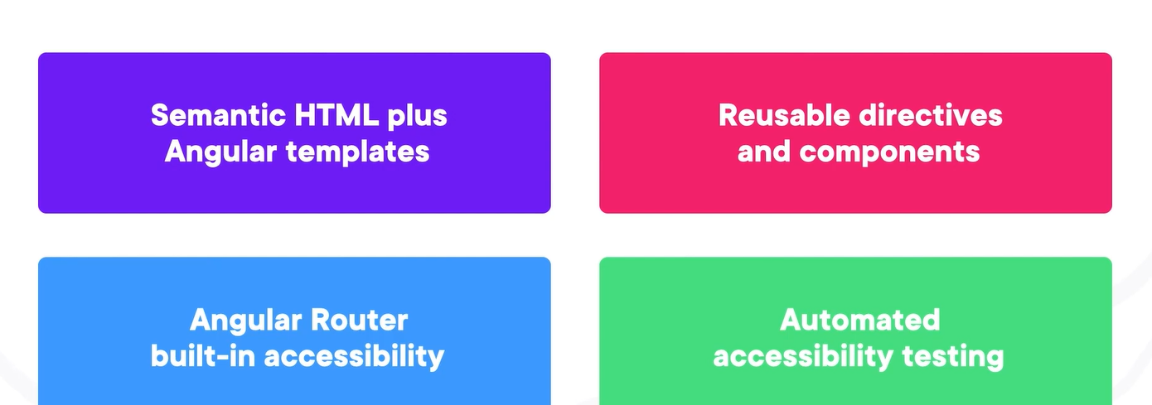

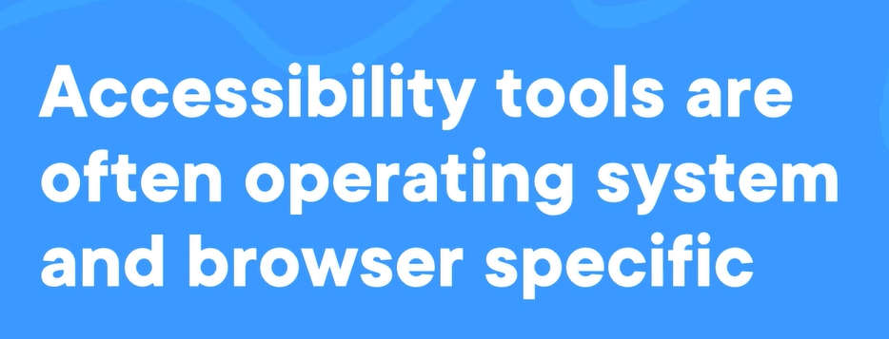

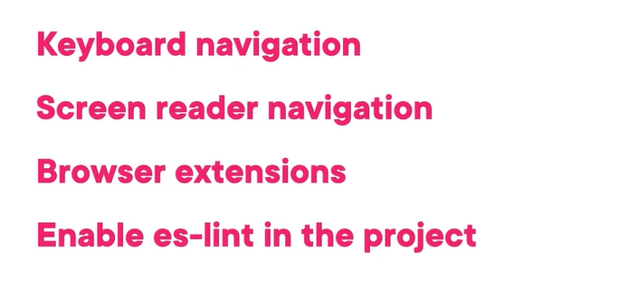

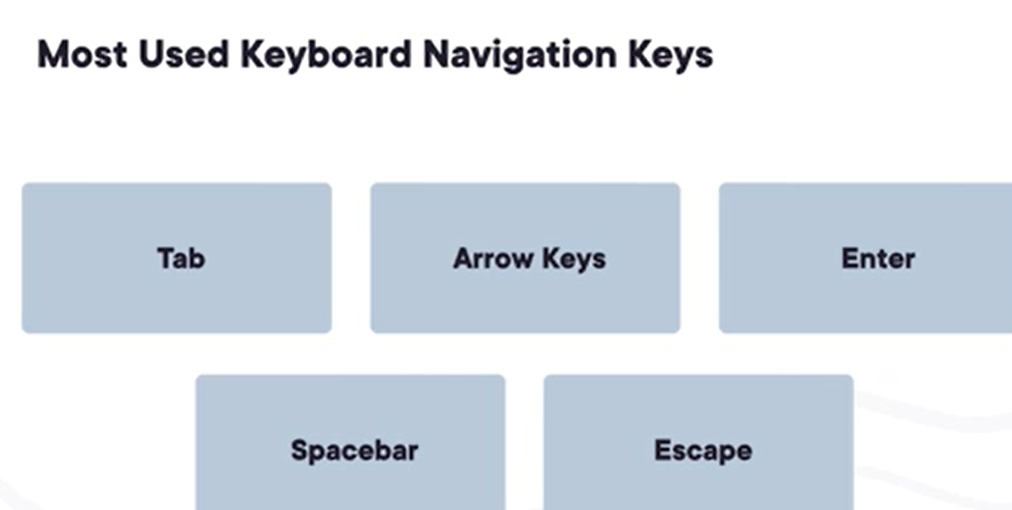

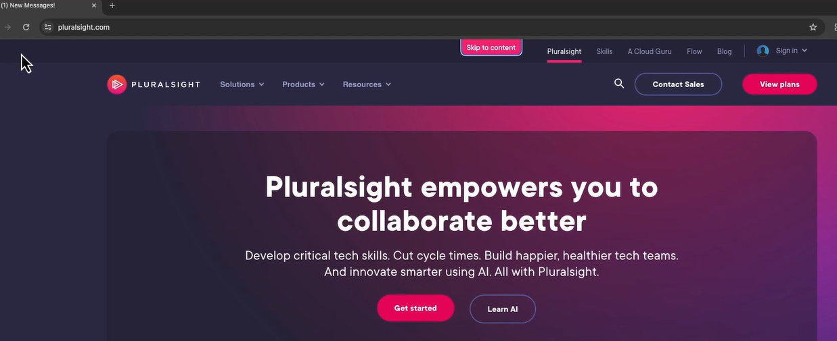

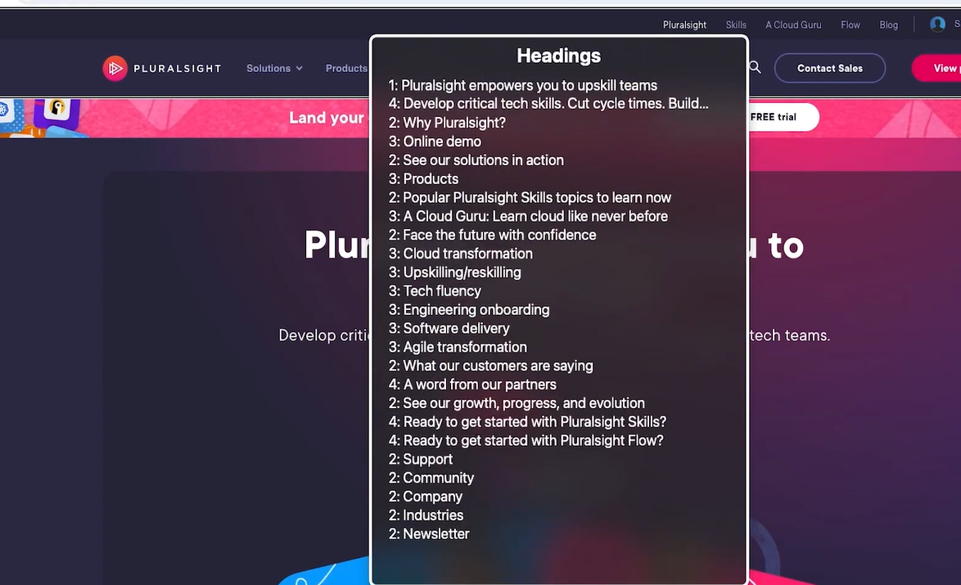

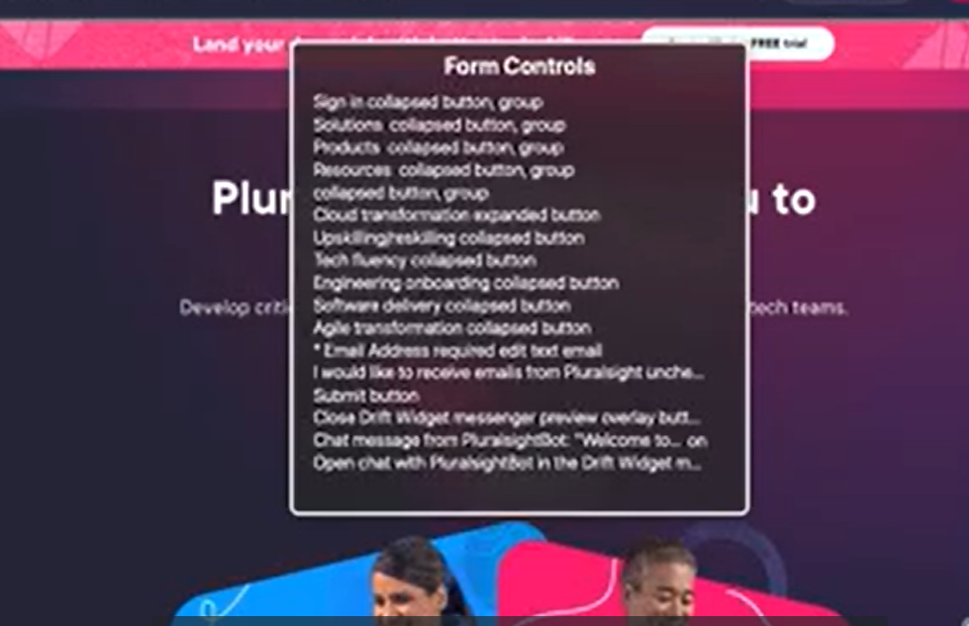

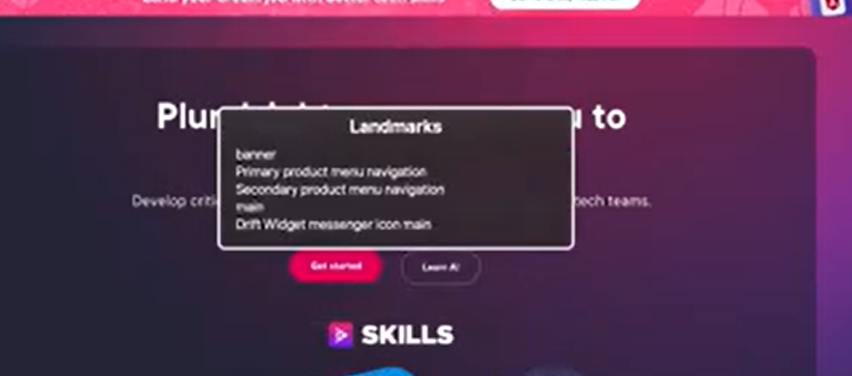

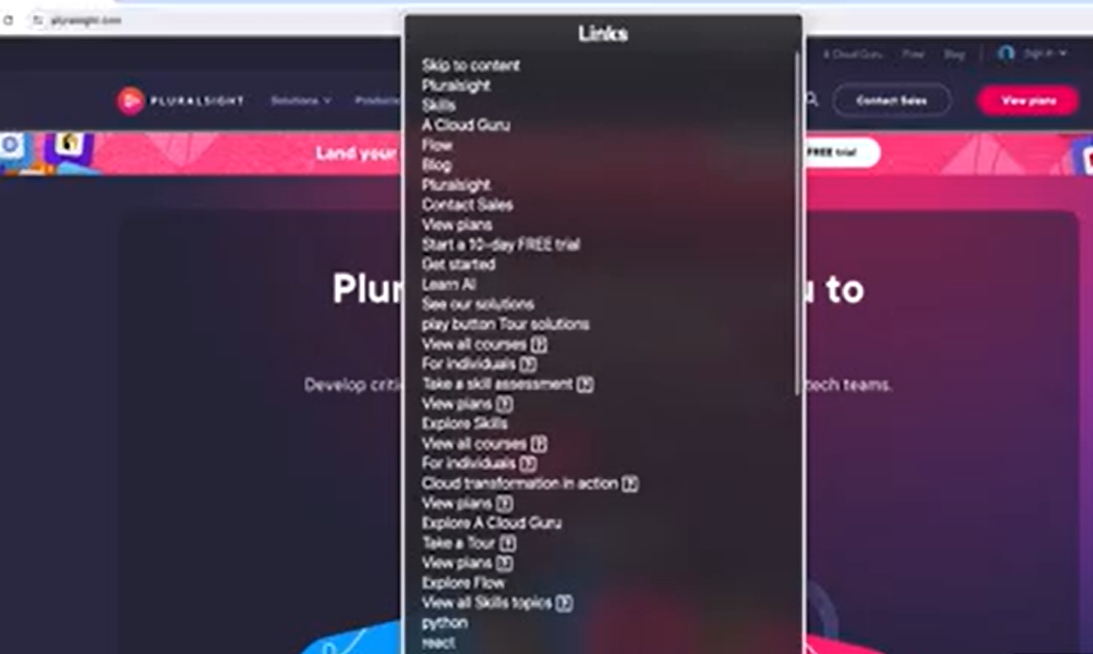

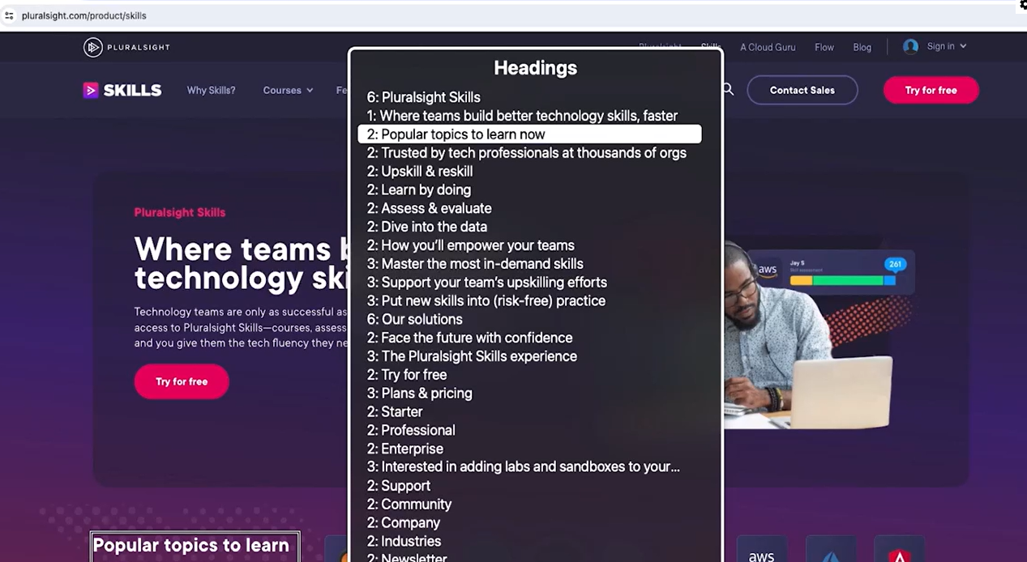

ARIA – Accessible Rich Internet Applications.

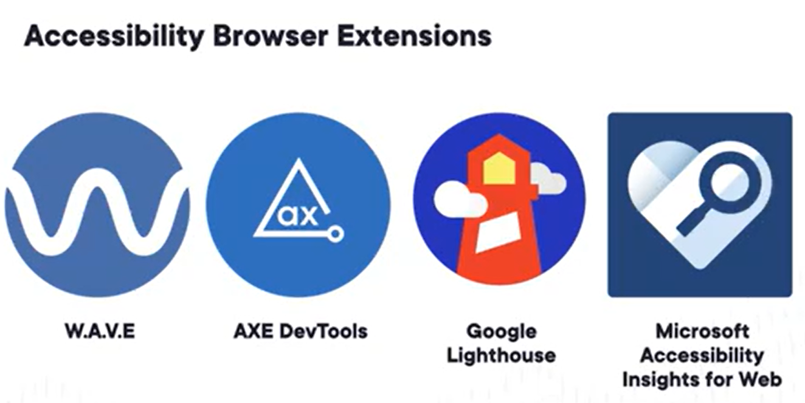

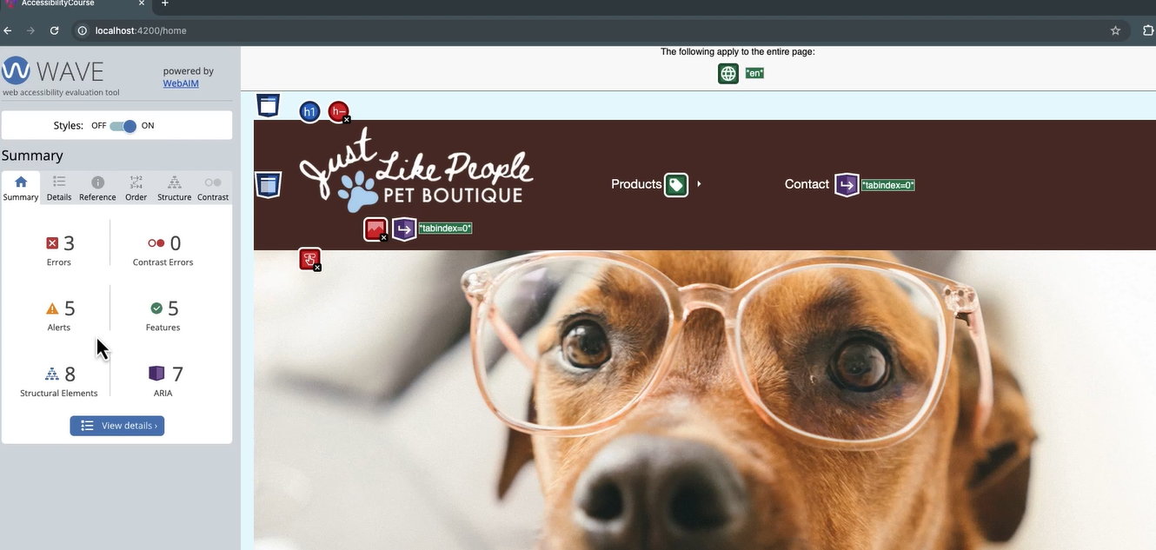

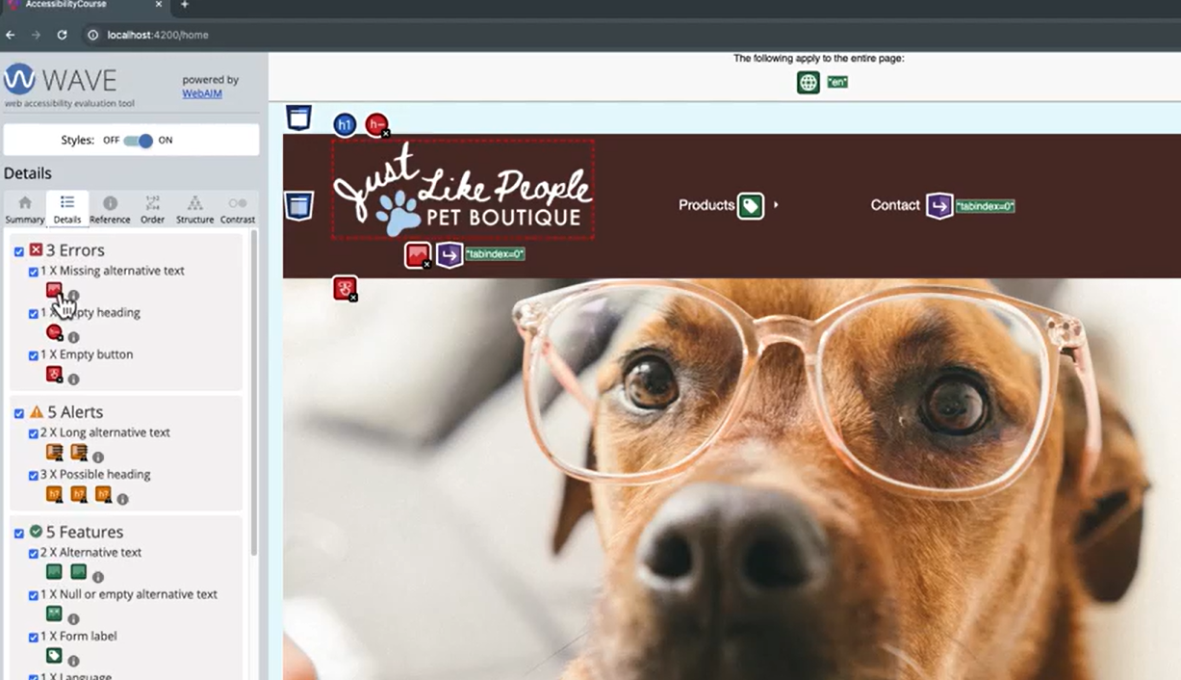

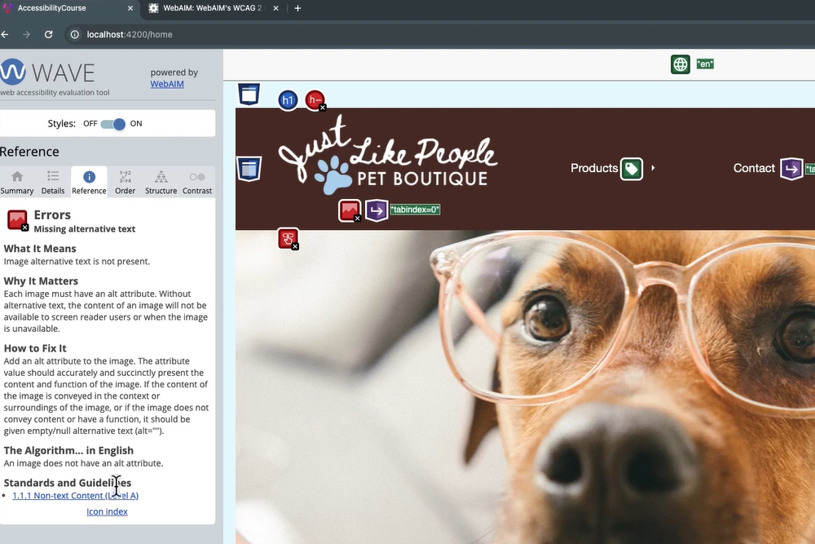

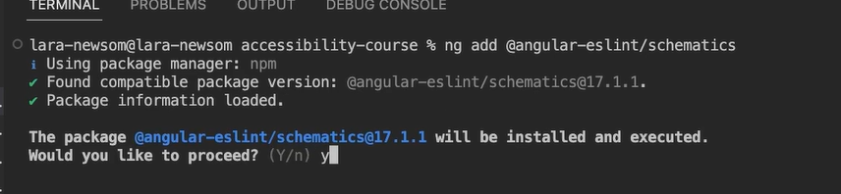

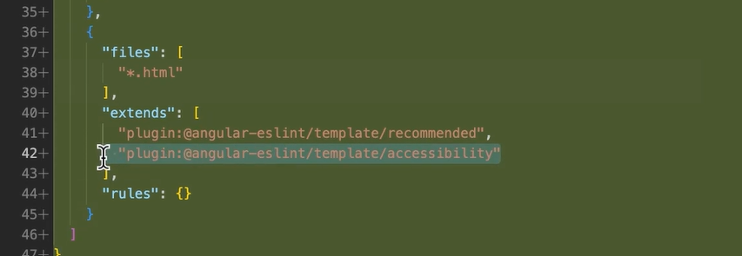

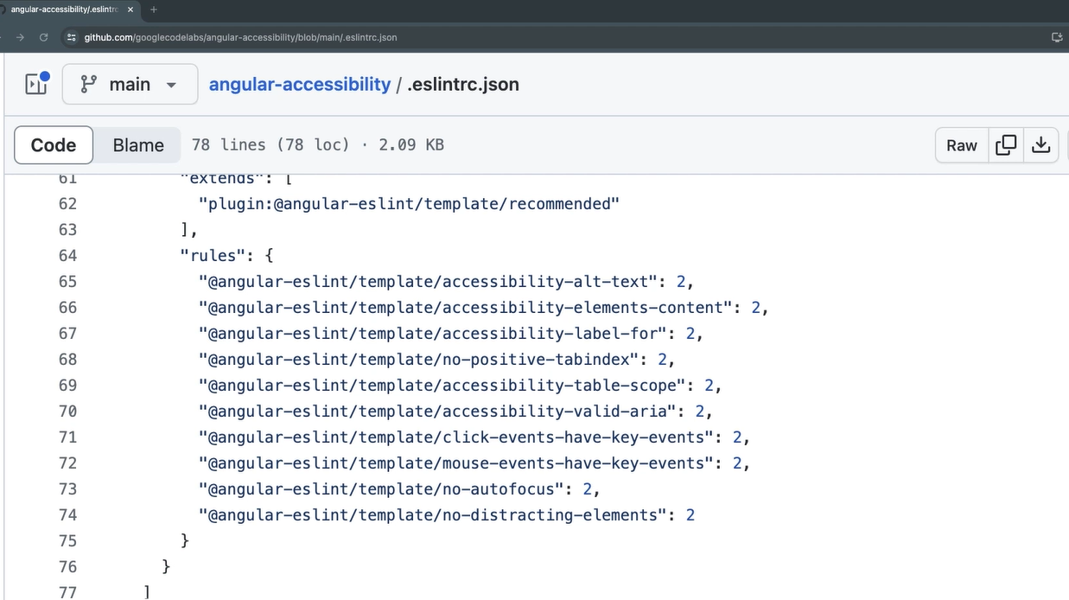

Errors for non-semantic elements –

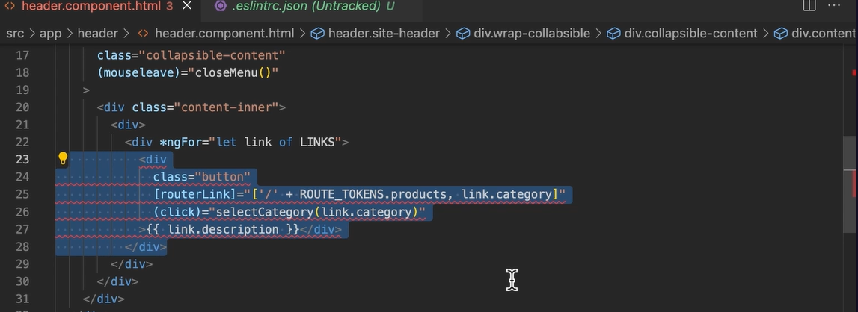

Check using benefit of <html lang=”en”>

Try these videos for demo –

<https://app.pluralsight.com/ilx/video-courses/231b8145-c7c1-4dc1-ac5e-b334c8079621/d23e7e03-130b-4e6a-935b-ca20989c9640/c4946252-360a-4c23-ae22-668314d8d29f>

The more complex components grow it will increase the efforts making it more accessible, which angular material do for it.

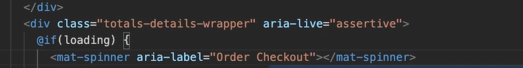

# <https://chatgpt.com/c/684fc229-12c0-800a-8d22-96f7ac1caf4f>

avoid umm, basically, you know, uhh, like

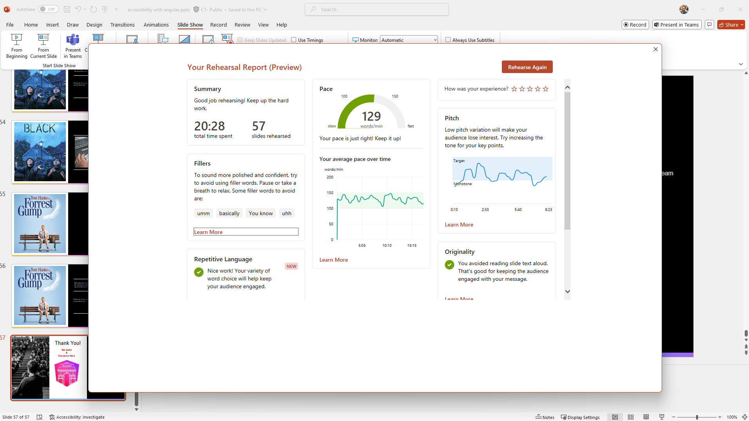

# Presentation – Accessibility with angular

## Opening

Hello everyone!

I’m really excited to be here at NG Delhi 2025 and thank you so much for joining my session.

Today, I want to talk about something that's not just technical but also meaningful — **Accessibility**.

The title of my talk is *“Inclusive by Design: Building Accessible Angular Applications.”*

In simple words — we’ll explore **easy, practical ways** to make sure the web apps we build work for **everyone**, including people with disabilities.

And trust me — this is not about doing extra work. It's about **doing the right thing** while building modern apps.

So let’s dive into how we can make our Angular apps more inclusive — not just for others, but also, as you’ll see later, for **our future selves**.

Before we begin — let me ask you a few quick questions:

* How many of you have *heard of accessibility* in web development before?
* And out of those, how many of you are *actively implementing it in your current Angular projects*?
* Is it something you’re doing *because it’s required*, or *because you genuinely care about it*?

Don’t worry — whatever your answers are, this talk is meant to **guide you, not judge you**. The goal is to give you some *simple, actionable steps* you can start applying right away — even if you're new to accessibility.

**Q: Why is accessibility a hot topic now?**  
A: Great question! Because more countries are adding laws around it, and users are demanding better experiences. Also, companies realize inclusive design reaches more users and boosts business.

## What We’ll Cover

Alright! Here's a quick roadmap of what we’ll cover today.

We’ll start by breaking down what accessibility actually *means* — not just from a technical standpoint, but from a human one.

Then, we’ll talk about *why it matters* — especially in a country as diverse as ours, where users may be navigating apps with assistive tools, different languages, or simply different abilities.

After that, I’ll share some *common mistakes* developers make — even unintentionally — that can harm the user experience.

We’ll look at the *tools available* to help us — many of which are free and super developer-friendly.

Then comes the fun part — a *live code demo*, where I’ll show how a few tweaks can instantly improve accessibility.

We’ll also touch on how *AI can support accessibility* — yes, even ChatGPT can help.

Finally, I’ll leave you with some *simple tips and resources* to explore later, and we’ll wrap up with a *fun quiz* and open *Q&A*.

The idea is: no matter where you are in your accessibility journey, you’ll walk away with *something practical* today.

**Possible Audience Questions:**

1. **“Will this session include accessibility for mobile apps too?”**

You can reply: *"Today we’re focused on web — especially Angular — but many principles apply to mobile apps too. And the mindset is definitely transferable."*

1. **“Do we need to know any assistive tech to follow the session?”**

*"Not at all. I’ll introduce tools like screen readers, but you don’t need any prior experience."*

## About Me…

“Before we dive in, a quick intro about myself.  
I’m **Himanshu Goel**, currently working as an **Architect at SBS in Noida**.

I have around **13+ years of experience in web development**, and for the past **10+ years**, I’ve been working extensively with **Angular**—right from the days of AngularJS to today’s Angular 20.

I’m also a **certified Angular Expert** and have built scalable applications for the **BFSI domain**, working with major firms like **Citi, Deutsche Bank, and Wells Fargo**.

These days, I’m passionate about building **low-code and no-code UI frameworks**, helping teams deliver faster with less effort.

Outside of work, I love building side projects, writing tech blogs, and staying active in the community—whether it's attending conferences like this or local meetups.

And of course, I enjoy **movies**, **gaming**, and **exploring new places and cuisines** whenever I get the chance.

If you’d like to connect or have any follow-up after the talk, you can reach out to me on **LinkedIn**—I’ve dropped the link here on the slide.”

**Possible Audience Questions You Can Prepare For**

1. **“What kind of low-code framework are you building?”**  
   *You can say: “It’s an internal platform to define screens via JSON config, with auto-generated UI and API bindings, heavily built on Angular.”*
2. **“What’s the difference in working with BFSI apps compared to others?”**  
   *“BFSI apps demand high precision, security, accessibility, and a lot of audit logging. The UX has to be both compliant and intuitive.”*
3. **“How did you stay up-to-date with all Angular versions over the years?”**  
   *“I follow Angular changelogs, community blogs, official RFCs, and love testing updates early using ng update. Side projects help too.”*
4. **“How do you manage time for side-projects and blogging?”**  
   *“I usually dedicate a couple of hours over the weekends or evenings, and treat it like my creative break.”*

## Before We Start…

**🎤 Speaker Notes (what you can say during the slide):**

"Before we dive in, I just want to quickly share this disclaimer. Everything I’ll talk about today is based on my personal experience and learning journey. It doesn't reflect any official viewpoint of my company or the NG Delhi team.

This session is meant to be informal and for knowledge-sharing — so feel free to think of it like a conversation.

Also, while I may mention some tools or frameworks that worked for me, they may not be the only or best solution in every context — so you’re welcome to explore alternatives.

And lastly, any logos or screenshots shown are only for demonstration purposes and they belong to their respective owners."

**🙋‍♂️ Questions *you* can ask the audience (to build engagement):**

* “Feel free to share your experience if you’ve used other approaches or tools — I’d love to hear them!”

## What is Accessibility?

**What to Say (Script):**

Let’s start with the basics — *What exactly is accessibility?*  
You might also see it written as **A11y** — where the number 11 represents the number of letters between **A** and **Y** in the word *accessibility*.

At its core, accessibility means designing and building websites and applications that **everyone** can use — including people with **disabilities** like vision, hearing, motor, or cognitive impairments.

Think of it like this meme I’ve used here —  
*(reference meme with Phoebe explaining and Joey looking confused)*  
This is what accessibility can feel like if you’ve never thought about it before. But once it clicks — you’ll start seeing the web from a whole new perspective.

Accessibility isn’t about adding extra work — it’s about **removing barriers**. Just like we build responsive apps for different screen sizes, we need to build accessible apps for different kinds of users.

And believe me — you don’t need to be an expert or overhaul your codebase to get started. Even small efforts can go a long way.

**🤔 Optional Audience Questions to Ask:**

* “How many of you have worked on accessibility features before?”
* “Anyone ever encountered a situation where a user couldn’t use your app because of some limitation?”
* “Quick poll: how many here thought accessibility was only about screen readers?”

## Tim Berners-Lee Quote

**What to Say (Script):**

This quote is from **Tim Berners-Lee**, the inventor of the World Wide Web.

He said:  
*“The power of the Web is in its universality. Accessibility for everyone, regardless of disability, is an essential aspect.”*

That last part really hits it home — “**regardless of disability**.”  
If the web isn't usable by everyone, we’re missing its true potential.

So accessibility isn’t just a feature — it’s a **foundational principle** of the web itself. And as web developers, it’s our responsibility to keep that spirit alive.

## To Put It Simply

Accessibility isn’t just about one kind of disability — it covers a **wide range of needs**.

For example:

* Imagine a blind user trying to explore your website using a screen reader.
* Or someone watching your video tutorial without sound — captions matter.
* Or even a user who struggles with complex layouts or long jargon-heavy text.
* And someone who can’t use a mouse but still wants to fill your form or navigate your app using a keyboard.

These are **real users**. And when we build accessibly, **we include them.**

**❓ 1. How do we test if a screen reader works with our app?**

**✅ Answer:**  
You can use free screen readers like **NVDA** (Windows), **VoiceOver** (Mac), or **TalkBack** (Android). Navigate your app using just the keyboard and listen to how it reads out the content. This helps you understand how a blind user would experience your UI.

**❓ 2. What are common tools for simulating disabilities while testing?**

**✅ Answer:**

* **Screen readers** (NVDA, VoiceOver, TalkBack)
* **Color contrast checkers** (like WebAIM Contrast Checker)
* **Keyboard-only navigation** (just use Tab/Shift+Tab)
* **Browser extensions** like **axe DevTools**, **Accessibility Insights**, or **WAVE**

These tools help test vision, motor, and cognitive challenges.

**❓ 3. Are accessibility features only required by law in some countries?**

**✅ Answer:**  
Yes, in some countries accessibility is legally required (e.g., **ADA in the US**, **EN 301 549 in the EU**, **RPwD Act in India**). But even where it’s not mandatory, it’s still best practice — it improves user experience and broadens your user base.

**❓ 4. How can we write simpler content without oversimplifying for general users?**

**✅ Answer:**  
Use **plain language**, short sentences, and avoid jargon. For example:  
Instead of: “Authentication failed due to invalid credentials.”  
Say: “We couldn’t sign you in. Please check your email or password.”  
It helps *everyone*, not just those with learning difficulties.

**❓ 5. Is supporting keyboard navigation mostly the developer’s job or the framework’s responsibility?**

**✅ Answer:**  
It’s a shared responsibility. Frameworks like Angular/React or libraries like Material/Bootstrap handle some focus and keyboard patterns, but **you must ensure your custom components** (dialogs, modals, menus) support tabbing, focus trapping, and visible focus indicators.

**❓ 6. Do we really need to consider all types of disabilities if our audience is mostly tech-savvy?**

**✅ Answer:**  
Yes. Disabilities can be **permanent, temporary, or situational**. Even a tech-savvy user might have a broken arm, eye strain, or be in a noisy environment. Accessibility helps *everyone* — not just a specific group.

## Types of Accessibility

Let’s now look at a broader perspective. Accessibility is not just for people with permanent disabilities.  
It also supports people in temporary or situational limitations.

For example, someone who **broke their arm** may not be able to use a mouse and rely solely on the keyboard—just like a permanently disabled person.

Or imagine you're in **bright sunlight**, and it's hard to read text on your phone. That’s a situational challenge related to vision.

Watching a video in a **noisy train** without captions? Accessibility features like subtitles benefit not just the deaf, but all of us.

So the point is: **accessibility helps everyone**, not just a specific group.

1. **"Have you ever struggled to read your phone in sunlight?"**
   * (Relates to situational visual challenge.)
2. **"Can you think of a time when captions helped you, even though you weren’t hard of hearing?"**
   * (Triggers relatable moments.)
3. **"What’s an example where you had to use a device one-handed?"**
   * (Links to situational mobility limitations.)

**❓ Questions the Audience Might Ask You:**

1. **"Why is it important to design for situational or temporary disabilities?"**
   * **Answer**: Because these scenarios affect a much larger audience than we think. Designing for them improves the experience for *everyone*, not just a few. It also future-proofs your app.
2. **"How can we test our app for temporary or situational limitations?"**
   * **Answer**: Simulate scenarios—try using your app with one hand, turn off audio and see if captions help, or increase screen brightness outdoors. There are also accessibility testing tools that simulate different disabilities.
3. **"Is accessibility still worth it if our audience is not visually impaired?"**
   * **Answer**: Yes, because accessibility benefits everyone. Fast-loading pages, clear navigation, readable fonts, and captions help a wide range of users in everyday situations.

## Why Accessibility Matters

Demonstration of corporate social responsibility (CSR)

"Now let’s talk about why accessibility really matters.  
There are four simple but powerful reasons:

**1. Digital Equality** – The internet is like a public space. Everyone — regardless of ability — should have the same access to information and services. It’s not just good design, it’s about digital justice.

**2. Legal Requirement** – Many countries have laws in place to ensure accessibility. For example, Section 508 in the US or the upcoming European Accessibility Act in 2025. These laws are built on standards like WCAG, which we’ll touch upon later. Being compliant isn’t just ethical — it protects your organization legally.

**3. Better Business Outcomes** – Accessible websites can reach more people, including aging populations or those with temporary challenges. Bonus: accessibility practices like using semantic HTML also boost SEO and performance.

**4. Promotes Good Design** – Features originally made for accessibility, like dark mode or captions, have become standard. Accessibility pushes us to design more intentionally and inclusively — which improves the experience for everyone."

**❓ Questions You Can Ask the Audience**

* **Q1:** "Can anyone name a feature you use daily that started as an accessibility tool?"  
  **Expected Answer:** Dark mode, captions, voice typing, screen reader support, keyboard shortcuts, etc.
* **Q2:** "Do you think businesses benefit financially from making their products more accessible?"  
  **Expected Answer:** Yes — more reach, better SEO, inclusive branding, legal compliance.
* **Q3:** "Has anyone ever faced a situation where an accessibility feature helped them — even if temporarily?"  
  **Expected Answer:** Answers may vary — using captions in noise, keyboard-only during mouse issues, etc.

**🤔 Questions the Audience Might Ask You (With Suggested Answers)**

* **Q1:** *"What happens if a company doesn't meet accessibility standards?"*  
  **Answer:** They risk lawsuits, fines, or exclusion from public contracts. For example, several high-profile brands have faced legal action due to inaccessible websites.
* **Q2:** *"Is accessibility only about blind or deaf users?"*  
  **Answer:** Not at all. Accessibility covers a wide range of conditions — visual, hearing, motor, cognitive, and even situational challenges like a broken arm or noisy environments.
* **Q3:** *"Is making a website accessible expensive or time-consuming?"*  
  **Answer:** It may take some effort initially, but it’s far more efficient to build accessibly from the start. And many practices, like using semantic HTML or alt text, are simple yet impactful.
* **Q4:** *"Is accessibility only needed for public websites or also for internal tools?"*  
  **Answer:** Both. Employees may also have accessibility needs. Inclusive design benefits internal productivity and ensures equal opportunity.

WCAG 2.0, 2.1, 2.2 next would-be project silver 3.0 which won’t just focus on the web application accessibility but as in whole.

Section 508 (applies to all federal agencies when they develop, procure, maintain, or use electronic and information technology)

WCAG main principles - perceivable, operable, understandable, robust

Most governments and big companies use WCAG 2.1 Level AA compliance



Perceivable - people must be able to find your content. all non-text content has a text alternative, aur captcha has audio alternative, video has transcript alternative.

Adaptable – content ca be presented in different ways without losing context. Responsive UI.

Operable – people must be able to use your website. Focus on accordion and highlight focus

All parts of a website can be accessed using other input devices besides a keyboard. Input modalities - mouse touch screen, speech to text.

Understandable – people must be able to understand your website. Readable – use simple language and avoid jargon when possible. Showing abbreviations., readable by using lang attribute in markups. Input having tooltip or supporting text for input assistance or showing validation errors.

As per WCAG, all functionality must be operable by the keyboard alone except where function depends on the path of movement not endpoints like signature or handwriting, drawing an art program.

WCAG was created by W3C which also maintains the HTML and CSS standards.



In future the WCAG might be replaced with silver as WCAG 3.0. Silver, also known as WCAG 3.0, is the planned successor to the Web Content Accessibility Guidelines (WCAG). It aims to provide a more flexible and adaptable framework for web accessibility, moving beyond the current true/false success criteria approach. Silver will address a wider range of digital content, including video and mobile apps, and will be written in plain language to be more accessible and translatable.

These guidelines will have much broader scope than just web content, hence need for new name.

## Accessibility in Numbers

Let’s take a look at some eye-opening numbers that highlight just how important accessibility really is.

* **97.4%** of websites fail at least one WCAG 2.1 AA requirement. That means most of the web is still not usable for everyone.
* **71%** of users will leave a site immediately if it's not accessible. That’s a huge impact on user retention and engagement.
* In **2023**, over **5,500 lawsuits** were filed in the U.S. alone related to accessibility violations.
* The combined disposable income of people with disabilities and their families globally is a massive **$8 trillion**.
* Interestingly, **86% of accessibility issues** are detectable by automation tools – yet many of them are still ignored.

So accessibility is not just a moral or legal issue — it’s a practical one. It affects user experience, business, and risk.

**❓Questions You Can Ask the Audience:**

1. **How many of you think accessibility is only about permanent disabilities?**
   * (Use this to re-emphasize earlier slide about permanent, temporary, and situational needs.)
2. **Why do you think 86% of accessibility issues go ignored even though tools can detect them?**
   * (Leads to discussion about priorities, lack of awareness, or overconfidence in visual-only checks.)
3. **What do you think happens when 71% of users leave your app due to inaccessibility?**
   * (Highlight bounce rates, lost revenue, bad word of mouth.)

**❓Questions Audience Might Ask You (with Answers):**

**Q1: What is WCAG 2.1 AA and why is it important?**  
**A:** WCAG (Web Content Accessibility Guidelines) 2.1 Level AA is a widely accepted standard for accessibility. Meeting these ensures your app is usable by most people, including those with vision, hearing, and motor disabilities.

**Q2: Are these lawsuits only in the US? Should we worry in other countries?**  
**A:** The U.S. has the highest number of accessibility lawsuits, but laws are strengthening worldwide. For example, the **European Accessibility Act** will be enforced in 2025. Countries like India, UK, Canada, and Australia also have strict accessibility regulations.

**Q3: How do I check if my app is accessible?**  
**A:** Start with tools like **axe**, **Lighthouse**, or **WAVE** to detect common issues. Also, try using your site with just a keyboard or screen reader to spot usability problems.

**Q4: $8 trillion is a big number — does it really matter for smaller businesses or personal projects?**  
**A:** Absolutely. Accessibility is about **inclusion**, not just profits. But from a business view, tapping into even a fraction of that market can give you a strong edge, especially in underserved niches.

## Most Common Accessibility Issues

Let's talk about the most common accessibility issues found across websites.

According to data, **96% of accessibility problems** fall into just **six categories**, which means even addressing these few areas can have a huge impact.

* The biggest culprit is **low-contrast text**—this makes reading difficult for users with visual impairments or in bright environments.
* **Missing alt text** prevents screen readers from conveying image content.
* **No form labels** can leave users confused about what to enter.
* **Empty links and buttons** are common, where users don’t get any context or action when using assistive tech.
* And finally, **missing document language** causes screen readers to mispronounce content.

These are low-effort, high-impact fixes.

There’s a general misconception that accessibility is only for people with disabilities. But think about aging users, people with injuries, or even ourselves in the future.

As the quote says,  
*“We’re not making the web accessible just for disabled people — we’re making it for our future selves.”*

**❓Questions You Can Ask the Audience:**

1. **Which of these issues do you think is the most common on your projects?**
   * *(Encourages reflection and participation)*
2. **Have you ever encountered any of these while browsing a website?**
   * *(Brings real-life relevance)*
3. **Why do you think things like empty buttons or missing labels still happen, even with modern frameworks?**
   * *(Drives a discussion around dev practices and awareness)*
4. **How many of you use automated tools like Lighthouse or axe-core to catch these?**
   * *(A poll-style question for interactivity)*

**🤔 Questions the Audience Might Ask You (with Suggested Answers):**

**Q1. Why is low-contrast text so common even today?**  
**A:** Designers often prioritize aesthetics over readability. Without proper contrast checks, stylish but unreadable text makes it into production.

**Q2. Isn’t alt text only important for blind users?**  
**A:** It’s critical for screen reader users, but it also improves SEO and helps when images fail to load or for users on slow connections.

**Q3. What tools can help detect these issues?**  
**A:** Tools like Lighthouse, axe-core, WAVE, and browser extensions can automatically flag most of these issues during development.

**Q4. Is accessibility testing all about automation?**  
**A:** Not entirely. Automation catches ~86% of issues, but manual testing is needed for things like logical reading order and dynamic content.

In web accessibility, **landmarks** are key elements that help screen readers and assistive technologies understand the **structure and purpose** of a web page. They allow users to **quickly navigate** between different sections of the page without having to go through everything linearly.

**Benefits of Using Landmarks:**

* Helps **screen reader users** jump to important sections quickly.
* Improves **keyboard navigation**.
* Enhances **semantic structure** for assistive technologies.
* Makes the site **more predictable and usable**.

The lang attribute in HTML is used to specify the language of the content within an HTML element. It's a global attribute, meaning it can be used on any HTML element. It's primarily used to help search engines and assistive technologies understand the language of the content.

It's placed within an HTML tag, for example, <html lang="en"> to indicate the page is in English. You can also use it within other tags like <p lang="fr"> to specify a paragraph in French.

* + **Importance:**
    - **SEO:** While not a direct ranking factor, it can improve the quality of search results by helping search engines understand the page's language.
    - **Accessibility:** Assistive technologies (like screen readers) use the lang attribute to correctly pronounce words and apply appropriate text-to-speech rules.
    - **Translation:** It aids translation tools in identifying the appropriate language for translation.

## Common Accessibility Pitfalls

**What You Can Speak:**

Let’s now look at **common accessibility pitfalls** — these are small misses that may seem minor during development but actually **create big barriers** for users with disabilities.

* **Missing Semantic HTML** – When we don’t use proper elements like <button>, <nav>, or headings in a logical order, assistive tech users get lost on the page.
* **Inaccessible Forms** – If form fields don’t have proper labels or descriptions, screen readers can’t guide users correctly.
* **Relying on Visual Cues Alone** – For example, saying "click the red button" doesn't help users with color blindness.
* **No Alternative Text** – Images without alt text are invisible to blind users using screen readers.
* **Poor Error Recovery** – If a form submission fails but doesn’t clearly tell the user what went wrong or how to fix it, it becomes unusable for many.
* **Auto-Playing Videos or Sounds** – These can disorient users, especially those using screen readers or with cognitive challenges.
* **Poor Keyboard Navigation** – If you can’t navigate your site using just the keyboard, that’s a big accessibility red flag.
* **Inadequate Colour Contrast** – Low contrast makes it hard to read for people with low vision or color blindness.
* **Dynamic Content Not Announced** – If your content updates dynamically (like a modal opening or a list updating), and it’s not announced to screen readers, users can get confused or miss it entirely.

So, accessibility isn’t just about checking a few boxes — it’s about creating an inclusive experience.

**❓ Questions You Can Ask the Audience:**

* How many of you rely on keyboard navigation or know someone who does?
* Have you ever missed a form error because it wasn't clearly visible or spoken aloud?
* Can you think of a time when a video auto-played and startled you? Imagine that happening with screen readers running too.
* Which of these pitfalls do you think is the most common in the projects you work on?
* How do you test for dynamic content changes in your current workflow?

**💬 Questions the Audience Might Ask You:**

1. **How can we detect missing semantic HTML in a large app?**
   * You can use tools like Lighthouse or axe DevTools to catch missing landmarks or incorrect heading structures.
2. **What’s the best way to make dynamic content accessible?**
   * Use ARIA live regions (aria-live="polite", for example) to announce content changes to screen readers.
3. **How do we ensure error recovery is accessible?**
   * Provide clear, visible, and programmatically associated error messages for each input.
4. **What tools help with keyboard navigation testing?**
   * Simply try tabbing through your page manually. Tools like **Accessibility Insights**, **axe**, and **NVDA screen reader** help you simulate more complex cases.
5. **Is color contrast testing manual or automated?**
   * Both. You can use automated tools (like the WCAG contrast checker), but it’s good to review visually to catch subtle problems.

Using color alone to convey meaning, icon-only buttons

Decorative and informative image

Headings (semantics, nesting)

Don’t use placeholder instead of label, connect the label with form control using “for” attribute like for radio buttons it will give bigger clickable area

Prefer always the usage of semantic HTML elements

[attr.aria-describedby], aria-atomic, aria-live, aria-current, using angular router to set unique page titles by TitleStrategy, aria-live by using Live Announcer, aria-hidden, cdk.a11y-visually-hidden() attribute, we can use different eslint rules from @angular-eslint/schematics

Use proper heading’s structure (H1 > H2 > H3…)

## Available Tools for Accessibility

“Let’s now talk about the tools that can help us build accessible applications.  
Angular actually provides a strong foundation for accessibility through built-in support like Angular Material, which already follows many accessibility standards out-of-the-box.  
We also have the CDK a11y package — it provides utilities for focus management, keyboard interaction, and screen reader announcements.  
Angular validators and form control states make it easier to build accessible forms — by default they give you classes and states to reflect validity.  
You can also dynamically bind ARIA attributes in Angular templates to improve the experience for screen reader users.  
And with Angular Universal, server-side rendering helps bots and assistive tech pick up content more effectively.

Outside of Angular, there are some fantastic tools available.  
Axe-core is one of the most popular libraries for automated accessibility checks.  
Lighthouse, which is built into Chrome DevTools, gives you a quick accessibility score and suggestions.  
NVDA and VoiceOver let you test how your app sounds to screen reader users.  
You can even integrate Cypress-axe into your E2E tests.  
Then there are browser extensions like WAVE and Microsoft’s Accessibility Insights that visually highlight accessibility issues on any webpage.”

**❓Interactive Questions You Can Ask the Audience**

1. **"How many of you have used Lighthouse before to audit accessibility?"**
2. **"Have you ever tried navigating your app without a mouse — using just a keyboard?"**
3. **"Anyone here familiar with ARIA attributes or know what ARIA stands for?"**  
   (*Follow-up: "It stands for Accessible Rich Internet Applications"*)
4. **"How do you currently test if your app is screen-reader friendly?"**
5. **"Can you guess what Angular package helps with focus trapping and live announcers?"**  
   (*Answer: CDK a11y*)

**👂 Possible Audience Questions You Should Be Ready For**

1. **"How mature is Angular’s support for accessibility compared to React or Vue?"**  
   ➤ *Answer:* Angular Material and CDK offer very structured support out-of-the-box. While React offers flexibility, you often rely on third-party libraries. Angular offers more guidance and defaults when it comes to accessible components.
2. **"Is using Angular Material alone enough to make my app fully accessible?"**  
   ➤ *Answer:* It helps a lot, but not entirely. You still need to add meaningful alt texts, ARIA roles, manage keyboard focus, and test with screen readers. Think of Material as a solid foundation — but you still need to build responsibly.
3. **"Can axe-core or Lighthouse catch 100% of accessibility issues?"**  
   ➤ *Answer:* No, they are great for catching obvious and common issues. But manual testing — especially using screen readers and keyboard — is still essential to ensure a good experience.
4. **"Does server-side rendering (Angular Universal) really impact accessibility?"**  
   ➤ *Answer:* Yes. It helps bots and assistive technologies read the content immediately, even before client-side JavaScript kicks in. It’s especially useful for SEO and screen readers on slower connections.
5. **"Can I automate accessibility checks in my CI/CD pipeline?"**  
   ➤ *Answer:* Absolutely. You can integrate axe-core or Cypress-axe into your CI runs and fail builds if serious issues are found.

Automated testing is useful for things like - color contrast, suspect markup, missing content like image alt text and document <title>, touch target size

Angular CDK Accessibility - LiveAnnouncer, FocusTrap, Regions, FocusMonitor, CSS class as cdk-visually-hidden and cdk.high-contrast.

Even WAVE can’t find all the accessible issue even if it shows zero errors, only a human can determine true accessibility. Zero Errors doesn’t mean it is accessible.

AXE core is an accessibility testing engine that has a command line interface that we can use in our build server.

## How AI is Breaking Accessibility Barriers

"Now let’s talk about something really exciting—**how AI is helping improve accessibility** in ways we couldn’t even imagine a few years ago.

* For example, tools like **Google’s Project Relate** or Microsoft’s **AI for Accessibility** can **convert sign language to voice or chat**, helping bridge communication gaps.
* AI can also **personalize content**—say a person with dyslexia opens a blog, the AI can rewrite that content into simpler language automatically.
* Tools like **axe-core combined with GPT**, or **Evinced**, can **automatically detect and even fix accessibility issues** in code.
* There are now **smarter screen readers** that use AI to understand the context, not just read the screen line by line.
* You can also **use your voice** to navigate instead of a mouse or keyboard—tools like **Google Assistant** or **Alexa for apps** are doing just that.
* For videos, **AI-generated captions** are now smarter—they don’t just transcribe dialogue, they also capture **moods and sounds**, like “door creaking” or “music intensifies.”
* Some tools, like **Google Sound Notifications**, can even detect ambient sounds.
* There are **emotion-aware interfaces** too—imagine an app that knows if you’re frustrated or tired and adjusts itself accordingly. That’s what tools like **Affectiva** or Microsoft’s **Emotion API** are working on.
* And finally, **AI-powered alt text generation** is helping blind users by describing what an image shows, making visual content more inclusive."

**💬 Questions You Can Ask the Audience (To Make the Session Interactive)**

1. “Have you ever used Google Assistant or Alexa to control apps or perform tasks hands-free?”
2. “What do you think about AI rewriting web content to suit individual needs—helpful or creepy?”
3. “Can anyone guess how Netflix or YouTube generate subtitles automatically for sounds and moods?”
4. “Do you think AI will ever fully replace human decision-making in accessibility design?”
5. “How many of you have tried using screen readers? Can you imagine how context-aware AI can improve that experience?”

**🙋‍♀️ Questions the Audience Might Ask You**

1. **"How accurate are AI-generated alt texts or captions?"**

"They're improving rapidly, but still not perfect. They’re great for general descriptions, but may miss nuance or cultural context."

1. **"Is it safe to rely entirely on AI for accessibility testing?"**

"Not yet. AI tools are great helpers but should complement—not replace—manual and user testing."

1. **"Do tools like GPT or Evinced require coding knowledge to use?"**

"Some do, but many are moving towards no-code or low-code interfaces, especially plugins and browser extensions."

1. **"Can AI detect emotional frustration accurately in all users?"**

"Emotion detection is still evolving. It works best with consistent input and might not be universally accurate."

1. **"How do you ensure the AI doesn’t make incorrect assumptions when rewriting content?"**

"That’s why human oversight is still important—it’s a collaborative process, not a hands-off solution."

## Tips and Resources

Let’s wrap up with a few practical tips and resources that can help you integrate accessibility from day one.

* **Start Early**: Accessibility shouldn’t be an afterthought. Bake it into your design and development from the start.
* **Use Semantic HTML**: Tags like <header>, <nav>, <article>, and <button> are not just for SEO—they help assistive tech make sense of your content.
* **Log Bugs with a11y in Mind**: Just like performance or security, log accessibility bugs too. Treat them as real issues, not "nice-to-haves."
* **Test with Real Users**: There’s no substitute for testing with users who actually use screen readers or navigate with a keyboard.
* **Use Linters**: Tools like eslint-plugin-jsx-a11y can catch accessibility issues while you write code.
* **Think Keyboard First**: If your site works with a keyboard, it will likely work well with assistive tech too.

**🙋‍♂️ Questions You Can Ask *the Audience* (to engage them)**

1. "When do you usually think about accessibility—during development or after release?"
2. "How many of you regularly use semantic HTML elements in your components?"
3. "Do you log accessibility bugs in your backlog like any other issue?"
4. "Have you ever tested your app using only a keyboard?"
5. "Anyone here using linters or automated tools to catch a11y issues?"

**❓ Questions *Audience Might Ask You* (with suggested answers)**

**1. Q: What are some good tools to check accessibility early in development?**

**A:** You can use tools like ESLint with accessibility plugins, axe-core browser extension, and Angular’s CDK accessibility tools. They give feedback during development itself.

**2. Q: What’s the benefit of semantic HTML over using just divs and spans?**

**A:** Semantic HTML improves accessibility by giving meaning to the structure, helping screen readers and other assistive tools interpret the content correctly.

**3. Q: What if the client doesn’t care about accessibility bugs?**

**A:** Even if stakeholders deprioritize accessibility, it’s our responsibility as developers to educate them about its importance—legal compliance, inclusivity, and better UX.

**4. Q: How do we test with real users when we don’t have access to them?**

**A:** You can simulate many scenarios using screen readers (like NVDA, VoiceOver) and keyboard navigation. You can also join accessibility communities to find testers.

**5. Q: Are keyboard-first designs enough for screen readers?**

**A:** Not entirely, but it’s a good start. Screen readers rely on proper semantics and ARIA attributes in addition to keyboard support.

## Learning Resources

**Speaker Script (What You Can Say)**

Now that we've seen the importance of accessibility, how AI is playing a role, and what tools are available, the next logical step is learning more.

These resources can help you deepen your knowledge and actually put accessibility into practice.

The first one is [**Accessibility in Angular**](https://angular.dev/best-practices/a11y) – this is directly from Angular’s official documentation and focuses on best practices like ARIA roles, keyboard interaction, and accessibility testing tools specific to Angular.

Next is the **WCAG**, the Web Content Accessibility Guidelines – this is the gold standard when it comes to accessibility. It's detailed, but it’s what most compliance requirements are based on.

Then we have Microsoft's **Inclusive Design Toolkit** – this is more than just code, it teaches you to think inclusively from the start, with examples and exercises.

Finally, **Google Lighthouse** – a tool you may already be using for performance audits – can also run accessibility checks on your pages.

These resources are practical, reliable, and regularly updated. Whether you're a developer, tester, or designer – there's something in here for you.

**🙋‍♂️ Interactive Questions You Can Ask the Audience**

1. **How many of you have used Google Lighthouse for accessibility checks?**
   * (Optional follow-up: *Did you find the suggestions useful?*)
2. **Have you ever read or referenced the actual WCAG guidelines?**
   * *If yes:* “Did you find them easy to understand or a bit overwhelming?”
3. **Anyone here used the Angular a11y documentation or ARIA roles in their components?**
4. **Quick poll: What do you use most for learning—official docs, blogs, YouTube, or courses?**

**🤔 Questions the Audience May Ask You**

1. **Is WCAG 2.1 the latest version, or is there a newer one we should follow?**
   * *(Tip: WCAG 2.2 was released in 2023 with some additional success criteria.)*
2. **Are these tools only for frontend developers or useful for testers and designers too?**
3. **Can Lighthouse catch all accessibility issues, or do we still need manual testing?**
4. **How beginner-friendly is the Microsoft Inclusive Toolkit for developers?**
5. **Is there any Angular-specific online course you'd recommend for learning accessibility?**

## Let’s Test Our Awareness!

### First Movie

"Let’s pause and do a quick awareness test. Take a look at this movie poster. If you’ve seen this film, you may recall the young boy’s struggles. Anyone remembers what condition he had?"

*(After audience answers or you reveal it)*

"Yes, he had **Dyslexia**—a learning disability that makes reading and writing difficult. He wasn’t lazy or disobedient. He simply processed language differently."

"Now, imagine someone like him using your app or website. What would they need to have a better experience?"

"Here are some **things we can do**:

* Use clean, distraction-free layouts
* Use readable fonts like **OpenDyslexic**
* Stick to **simple language**
* Avoid flashy animations
* Ensure **good spacing and contrast**"

"These small changes can create big impact for people with cognitive or reading disabilities."

**❓ Questions You Can Ask the Audience:**

* "Can you guess what disorder the child in this movie is dealing with?"
* "What elements on a website might be challenging for someone with Dyslexia?"
* "Have you ever used a font or design that you later realized was hard to read?"
* "Do you think most websites today are friendly for people with reading difficulties?"

**🙋 Questions Audience Might Ask You (with Answers):**

**Q: Is Dyslexia considered a disability under accessibility laws?**  
**A:** Yes, it falls under cognitive disabilities and is included in accessibility considerations in standards like WCAG and laws like the ADA or EN 301 549.

**Q: Are there specific tools to help design for Dyslexia?**  
**A:** Yes! Fonts like OpenDyslexic or Lexend are designed for better readability. Tools like Grammarly or Hemingway also help ensure text is simple and easy to read.

**Q: Do screen readers help people with Dyslexia?**  
**A:** They can, especially when combined with text highlighting. But simpler layouts and readable fonts are even more effective for this group.

**Q: Can AI help users with Dyslexia?**  
**A:** Absolutely! AI can rewrite text in simpler words, summarize long paragraphs, and even read out content aloud in natural voices.

### Second Movie

**What You Can Say (Narration / Explanation)**

“Let’s look at another example from cinema that highlights the importance of accessibility. This story is about a girl who is both deaf and blind. It shows us how patience, empathy, and the right support can truly change lives.

Now think about your own product or website. If someone like this girl tried using it—could they navigate it without help?

We may not realize it, but many people use assistive technologies—like screen readers or keyboard navigation—to interact with digital platforms. And it’s our job to ensure our design and code work for them too.”

Then you explain the solutions clearly:

“We can:

* Make sure everything works with a keyboard, not just the mouse.
* Use semantic HTML and ARIA roles so screen readers understand our content.
* Add captions or transcripts for audio or video content.
* Use ALT text for all images.
* And make sure buttons, links, and headings are properly labeled and easy to identify.”

**❓ Questions You Can Ask the Audience**

To make it interactive, ask:

* “Can anyone share how they’ve tested their website for screen reader compatibility?”
* “Have you ever tried navigating your site using just a keyboard?”
* “What happens on your homepage if someone can’t see and can’t hear—can they still understand what to do?”
* “Do your videos or training materials include captions or transcripts?”
* “Have you ever added meaningful ALT text for all your images?”

Encourage short responses or raise-of-hands to keep the energy up.

**💬 Questions the Audience Might Ask You**

Be ready to answer things like:

1. **“What is ARIA and how is it used?”**  
   *Answer: ARIA (Accessible Rich Internet Applications) roles and attributes help bridge the gap when HTML alone isn’t enough to describe elements to assistive tech like screen readers.*
2. **“How do we test for keyboard accessibility?”**  
   *Answer: Use the Tab key to navigate. Make sure every interactive element—links, buttons, forms—is reachable and usable without a mouse.*
3. **“Do we need to add captions manually or are there tools?”**  
   *Answer: You can use tools like YouTube’s auto-caption, but always review them. For better accuracy, manual captions are recommended.*
4. **“What tools can check if our site works with screen readers?”**  
   *Answer: Tools like NVDA (Windows) or VoiceOver (Mac), and browser extensions like Axe or Lighthouse can help.*
5. **“Do we need to do all this for internal apps too?”**  
   *Answer: Yes! Accessibility isn’t just for public sites. Even internal tools should be usable by everyone, including team members with disabilities.*

### Third Movie

“Now, let’s take a moment to reflect on a well-known character—**Forrest Gump**. Many of us know his story: a man with a low IQ who ends up having extraordinary life experiences.

In the digital world, there are many users like Forrest—smart in their own way but who might need extra clarity and simplicity to use websites or applications effectively.

So how do we help them?

* First, by **using simple and plain language**. Avoid jargon or long sentences.
* Provide **audio or visual guidance**—sometimes icons or simple voice prompts are easier than large blocks of text.
* Ensure your navigation is **crystal clear**, and clickable elements are **large and obvious**.
* Enable **text-to-speech options** so users who struggle with reading can still understand.
* And finally, avoid time-bound tasks or overly complex flows—because not everyone processes information at the same speed.

Our goal is to ensure everyone can move through your app confidently, even if they process things differently.”

1. “Have you ever come across a form that was too complicated or had too much text? How did you feel while filling it out?”
2. “What small changes can you think of that would make your app easier for someone who reads slowly?”
3. “Why do you think having large clickable elements can help users with intellectual disabilities?”
4. “How many of you have seen Forrest Gump? Can you relate any part of the story to how we should design digital products?”
5. **Q:** *What’s the difference between intellectual disability and learning disability like dyslexia?*  
   **A:** Great question. An intellectual disability affects general mental capabilities like learning, problem-solving, and reasoning. Dyslexia, on the other hand, is specific to reading and writing abilities. Both require different forms of support in digital design.
6. **Q:** *Can tools like screen readers help users with intellectual disabilities?*  
   **A:** Yes, but they are more effective when paired with simple language and clear design. These users may not rely on screen readers as heavily, so we must also support comprehension through visuals, audio, and simplified flows.
7. **Q:** *How do we test if our design is suitable for such users?*  
   **A:** One way is user testing with diverse participants, including those with cognitive challenges. Also, tools like WAVE and [Lighthouse](https://developer.chrome.com/docs/lighthouse/) can help flag overly complex elements or readability issues.
8. **Q:** *Is it okay to simplify language even for enterprise apps?*  
   **A:** Absolutely. Clear, concise language helps *everyone*, not just those with cognitive challenges. It reduces misunderstandings and improves usability.

## Thank you (closing slide)

“That brings us to the end of our session on accessibility.  
Thank you so much NG Delhi and everyone here for being such a wonderful audience.  
I hope you leave today a little more aware, a little more empathetic, and a lot more ready to build inclusive experiences.

I’m Himanshu Goel, part of the NG Delhi mentor team. If you have any more questions, feedback, or thoughts to share, I’d love to connect with you. feel free to reach out after the session.

Let’s make the web more accessible — one app at a time.  
Thank you again!”

**❓Question You Can Ask the Audience**

“Before we wrap up — just curious, how many of you are already thinking of one thing you can improve in your own app to make it more accessible?”  
(*Raise your hand to prompt them too.*)

Optional follow-up:

“Would anyone like to quickly share what that one thing is?”

**🤔 Possible Audience Questions + Your Answers**

**Q1: “What’s the easiest first step I can take to improve accessibility in my Angular project?”**  
**A:**“Start with semantic HTML and keyboard accessibility. You don’t need a complete overhaul — just begin with things like using button tags instead of divs for actions, and checking if you can navigate your site without a mouse.”

**Q2: “Are accessibility features expensive or time-consuming to implement?”**  
**A:**“Great question — they’re not, especially if you start early. Many things like proper labels, contrast, and keyboard support just need awareness, not budget. Retrofitting is harder — so integrating accessibility from the start saves effort later.”

## Tips and Common Issues

**Start Strong**

* **Introduce yourself** with warmth, a smile, and confidence. Example:

"Hi everyone, I’m Himanshu Goel, part of the NG Delhi mentor team. I’m thrilled to kick off today’s sessions!"

* Keep your **voice loud and clear**, not rushed.
* Make **eye contact**. Pick a few friendly faces across the room.

**🧠 Know Your Audience**

* Most are **college students or early Angular devs**, so:
  + **Simplify** technical jargon.
  + **Use relatable examples** — like common UI bugs or forms.
  + **Explain acronyms** (like WCAG, ARIA, etc.) briefly.

**🪜 Structure Your Flow Clearly**

* Begin with **why accessibility matters** (make it human).
* Then go into **Angular specifics** with small code examples.
* End with **simple takeaways or checklist**.

**💬 Be Interactive**

* Ask small things like:

“Have you ever faced a form you couldn’t submit?”  
“Do you test your app without a mouse?”

* You could even do a **live poll** using show of hands.

**🧰 2. Practical Tricks**

| **Trick** | **Why It Helps** |
| --- | --- |
| **Bring a bottle of water** | Helps if throat dries up or you need a break |
| **Use speaker notes** | Don’t memorize everything, just glance to stay on track |
| **Use visuals & demos** | Especially helpful for college audience — they retain more |
| **Have 1-2 jokes or light comments** | Helps ease tension, e.g. “The only thing more invisible than proper contrast is a developer’s CSS at midnight 😄” |
| **Practice with a friend or mirror** | Builds confidence and timing |

**🧨 3. Common Issues + Graceful Recovery**

| **Issue** | **What You Can Do** |
| --- | --- |
| **Mic not working** | Stay calm. Say: “Tech loves surprises — let’s switch mics or go unplugged for now!” |
| **Slides not loading** | Improvise: “While we get this sorted, let me just walk you through what I was going to show…” |
| **You forget something** | Say: “Let me rephrase that” or “We’ll circle back to this in a minute” — then continue |
| **Audience is quiet** | Try humor: “Wow, either I made total sense — or none at all!” Then re-engage |
| **Someone asks a tough question** | “That’s a great question — let’s discuss it after the session so I can give you a complete answer.” |
| **Laptop/projector fails** | Always have a PDF/backup, or continue by explaining concepts on whiteboard or verbally |

**🧘 4. Mindset: Calm & Confident**

* **Remember:** You are not there to be perfect — you are there to **share and connect**.
* Most people **don’t notice small mistakes** unless you make it awkward.
* Don’t apologize too much. Be **friendly, not overly formal**.
* The audience is already rooting for you — especially since it’s your first talk.

**🧩 Bonus Tips:**

* Arrive early, check your setup (slides, mic, pointer, etc.).
* Take **3 deep breaths** before going on stage.
* **Smile when you speak** — your voice will automatically sound more confident.
* End with a **positive call to action**, like:

“Let’s all start building apps that *everyone* can use.”

**[Start: 0:00–0:30 | Greeting & Introduction]**

“Hi everyone! 👋  
Welcome to NG Delhi! I’m Himanshu Goel, part of the NG Delhi mentor team, and I’m super excited to be kicking off today’s session.

I hope you’re all charged up because today, we’re not just going to talk about Angular — we’re going to talk about making **apps more inclusive and accessible** for *everyone*, including people with disabilities.”

**[0:30–1:30 | Setting Context with Accessibility]**

“Before we dive into the tech side, quick question:  
👉 *How many of you have actually tested your app for accessibility before?*

[Pause – look around, smile, react lightly to raise of hands or silence]

It’s okay if you haven’t — that’s what we’re here for!

Accessibility, or **a11y**, is about making sure that people with visual, auditory, motor, or cognitive disabilities can **use our websites just as easily as anyone else.**

It’s not just a good practice — it’s often the law in many countries. But beyond the legal angle, it’s simply the right thing to do.”

**[1:30–2:30 | Movie Slide Example - Dyslexia]**

“To make this relatable — let’s do something fun.  
Do you recognize this movie?”

[Show movie poster – pause]

“This boy struggles with reading and writing. What disorder is this about?”

[Let audience guess — respond warmly.]

“Yes, **Dyslexia**.  
Now think — if a child with dyslexia is using your app, how can you help?

A few ways:

* Use readable fonts like OpenDyslexic.
* Avoid cluttered layouts.
* Keep your language short and simple.

Small changes, but they can make a huge difference.”

**[2:30–3:30 | Movie Slide Example - Deaf & Blind]**

“Let’s take another example — a girl who can’t see or hear.  
Any guesses about the disorder?”

[Pause again]

“Yes — she’s **Deaf and Blind**.  
This story is powerful — because it shows how **support and empathy** can change a life.

As devs, what can *we* do?

* Add screen reader support.
* Use ALT text for all images.
* Include captions or transcripts for videos.

Accessibility isn’t about edge cases — it’s about real people.”

**[3:30–4:30 | Quick Takeaways + Resource Slide Reference]**

“To make this easier for you later, I’ve shared a few great learning resources:

* Angular's a11y docs
* WCAG guidelines
* Google Lighthouse
* Microsoft Inclusive Toolkit

These tools and checklists help you build better — not just prettier.”

**[4:30–5:00 | Wrap-up]**

“Accessibility is not just a feature — it’s a mindset.  
And it’s up to us as Angular developers to build **for everyone**.

Thank you so much for being such a great audience — and I hope this session sparks a new thought whenever you open your code editor next time!”

*“Let’s make the web better — for all.”*

**🔧 Common Technical & Logistical Issues (Most Frequent)**

**1. Projector or Display Not Working**

* **Symptoms**: No signal, resolution issues, wrong aspect ratio.
* **Prevention**: Test before your session. Carry your own HDMI adapter and a backup (e.g., USB-C to HDMI).
* **Fix**: Stay calm. Ask the AV team. Talk to the audience while it's being fixed, e.g., "While we fix the screen, let me share how this topic connects to real life..."

**2. Microphone or Audio Failure**

* **Symptoms**: No sound, static, battery issues.
* **Prevention**: Test it beforehand. Know how to project your voice without a mic.
* **Fix**: Speak loudly and clearly. Ask the front row if they can hear. If not, move closer to the audience or ask for a mic swap.

**3. Wi-Fi Not Working**

* **Symptoms**: Can't show online demos or open websites.
* **Prevention**: Download resources/screenshots/videos in advance.
* **Fix**: Narrate what would have happened. Offer to share resources post-event.

**4. Clicker/Slide Remote Doesn’t Work**

* **Symptoms**: Slides don’t move, lag.
* **Prevention**: Carry fresh batteries. Know keyboard shortcuts.
* **Fix**: Calmly walk to the laptop and use keyboard controls.

**5. Font/Color Rendering Issues**

* **Symptoms**: Unreadable text, wrong fonts, layout breaks.
* **Prevention**: Use standard fonts. Export a PDF backup of your slides.
* **Fix**: Apologize and continue. Open the PDF if needed.

**6. Video/Audio Demo Fails to Play**

* **Symptoms**: No sound or playback lags.
* **Prevention**: Preload videos. Test sound beforehand.
* **Fix**: Describe the video and offer to share it later.

**🤔 Medium-Level Issues (Require Mental Agility)**

**7. Live Demo Crashes**

* **Symptoms**: Errors, bugs, app doesn’t load.
* **Prevention**: Record a backup screencast of the demo.
* **Fix**: Joke lightly ("Ah, the demo gods are angry today"), and walk through the code or use the video.

**8. Unexpected Audience Questions**

* **Symptoms**: You don’t know the answer.
* **Fix**: Smile and say, "That’s a great question! I’ll need to double-check before giving a complete answer. Let’s chat after the talk.”

**9. Panic or Blank Out**

* **Symptoms**: You forget what to say.
* **Prevention**: Have slide cues and a few bullet notes.
* **Fix**: Pause, breathe, refer to the slide, or say, “Let me give you a moment to absorb this while I catch my breath.”

**10. Running Over Time**

* **Symptoms**: You notice time is up mid-way.
* **Fix**: Skip non-essential parts. Say: “Due to time, I’ll briefly highlight the rest—feel free to ask me later.”

**🔥 Worst-Case Scenarios (Rare but Possible)**

**11. Your Laptop Dies**

* **Prevention**: Bring a charger, keep backup on USB or cloud.
* **Fix**: Borrow a laptop and open the backup. Or narrate the content without slides.

**12. Your File is Corrupted or Missing**

* **Prevention**: Backup on Google Drive, USB, and email.
* **Fix**: Use PDF backup or even speak without slides using visual storytelling.

**13. Host Skips Your Slot or Shortens It**

* **Fix**: Adapt quickly. Say, “I’ll focus on the key takeaways in the time we have.” Cut to the most important points.

**14. Hecklers or Disruptive Questions**

* **Fix**: Stay polite but firm. "Let’s take this offline so I can cover the topic for everyone."

**15. You Trip or Drop Something**

* **Fix**: Smile, laugh it off. It makes you human.

**✅ Quick Tips to Tackle Issues Gracefully**

* Keep smiling. A calm demeanor reassures the audience.
* Don’t over-apologize. Acknowledge and move on.
* Have a **“Plan B”**: PDF, screenshots, or even hand-written notes.
* Make the **audience feel involved** while waiting or transitioning.

Here are some of the **worst real-life presentation failures** from history—ranging from technical disasters to moments of personal embarrassment. These examples are not to scare you, but to **prepare and reassure you** that even in high-stakes settings, mistakes happen, and people recover from them:

**💥 1. Steve Jobs' iPhone 4 AntennaGate (2010)**

* **What happened:** During the iPhone 4 demo, the device lost signal when held a certain way.
* **Result:** It triggered widespread criticism and the term *"Antennagate"*.
* **Lesson:** Always check live demo hardware/software thoroughly and have backups or simulations.

**💥 2. Bill Gates' Windows 98 Blue Screen (1998)**

* **What happened:** During the launch presentation of Windows 98, the system crashed with a Blue Screen of Death.
* **Reaction:** The audience laughed, and Gates recovered humorously: “That must be why we’re not shipping Windows 98 yet.”
* **Lesson:** Be ready to **laugh it off** and move on with confidence.

**💥 3. Elon Musk’s Cybertruck Window Fail (2019)**

* **What happened:** Musk claimed the Cybertruck windows were shatterproof—then smashed them with a metal ball... and they broke.
* **Public Reaction:** Embarrassing, but Elon handled it calmly and it became a viral meme.
* **Lesson:** Don't overpromise on a live demo, and **acknowledge failures with humility or humor**.

**💥 4. Michael Bay’s Samsung Presentation Exit (2014)**

* **What happened:** The famous director froze on stage when the teleprompter failed, panicked, and walked off.
* **Lesson:** Always **prepare for tech fails** and have a printed or memorized backup outline. **Practice without slides**.

**💥 5. BBC Reporter Goes Live With Kids Crashing In (2017)**

* **What happened:** During a live interview, his kids burst into the room. Hilarious and viral.
* **Lesson:** If something unexpected happens, stay calm and embrace the human moment.

**⚠️ Common Worst-case Presentation Issues (From Most to Least Recoverable)**

| **Issue** | **Recovery Tip** |
| --- | --- |
| **Slides not loading / corrupted** | Keep a copy on a USB or Google Drive. Be ready to explain with visuals or a whiteboard. |
| **Microphone/audio failure** | Speak up confidently, or ask for a handheld mic. Don’t panic. |
| **Live demo fails** | Show screenshots or have a recorded fallback video. |
| **You forget what to say** | Pause, breathe, and glance at your slide or notes. Reconnect with the audience. |
| **Audience questions throw you off** | Say: “That’s a great question, let me think for a second,” or “Let’s discuss that after the talk.” |
| **Tech setup delay at start** | Start with a story, intro, or ask the audience a warm-up question. |
| **You mispronounce a word / get stuck** | Laugh it off or correct it casually. Nobody minds. |
| **Wardrobe malfunction** | Ignore unless it's serious. Stay confident. |
| **You’re interrupted (e.g., phone rings, alarms)** | Smile and silence it. Use humor to ease tension. |

**✅ Final Advice:**

* **Always test your setup the day before.**
* **Print your slide notes or keep them on your phone.**
* **Have a “plan B” for demos.**
* **Smile and maintain eye contact—it builds trust.**
* **Remember: the audience wants you to succeed.**

If anything goes wrong, **own it gracefully**—you’ll actually win more respect than if everything went perfectly.

The phrase **"The audience is already rooting for you — especially since it’s your first talk"** means:

The audience **wants you to succeed** and is **supportive** of you, particularly because they know it's your first time presenting.

**Why this is true:**

* **Empathy**: Most people have been nervous speakers at some point. They understand the pressure and relate to your situation.
* **Positive bias for beginners**: Since you're just starting out, they’re likely to **lower their expectations slightly**, and any good point you make will **feel even more impressive**.
* **Encouragement culture**: In communities like developer meetups or tech conferences, there's a strong culture of **supporting new speakers**.

**How this helps you:**

* You don’t need to be perfect. The audience isn’t expecting a TED Talk — they’re expecting your **honest, authentic self**.
* Even if you fumble a little, the audience will likely **cheer you on rather than judge you**.

In short: **They’re on your side.** You're not facing critics; you're facing a room full of potential friends.

## Code Demo

Show skip link example, accessibility tree in chrome for headings, Use chrome extension for live color blindness simulation

<https://app.pluralsight.com/ilx/video-courses/231b8145-c7c1-4dc1-ac5e-b334c8079621/d23e7e03-130b-4e6a-935b-ca20989c9640/c4946252-360a-4c23-ae22-668314d8d29f>

Good afternoon, everyone! How’s everyone doing? Awake? Half awake? I know it’s just after lunch so let’s start with a quick poll to wake up your brains. In this session we’ll see how Scrum teams can add accessibility into their Definition of Done - so our products don’t just look modern but truly work for everyone.

Also, As Scrum teams, we talk a lot about delivering value. But value isn’t really complete unless it reaches every user, regardless of ability or disability. Accessibility isn’t just compliance; it’s empathy, inclusivity, and ultimately, product excellence." Agile teams, we must consider accessibility in our user stories and acceptance criteria.”

*“Raise your hand if you’ve ever heard the term ‘accessibility’ before today.”*

*“Now, raise your hand if you’re confident that your product can be fully used with just a keyboard—no mouse at all.”*

Great! To get us thinking practically, let’s do a quick fun exercise. I’ll show a movie character, and I want you to think—if this character were using your product, what accessibility improvements would you suggest? Don’t worry, it’s just for fun, but it will also give us a sense of real user needs.

Accessibility issues don’t always come from big design mistakes. In fact, most barriers are created by small misses—things that quietly slip through our process.

For example, many teams don’t add accessibility acceptance criteria in user stories. That means accessibility never gets tested or even considered.

It’s also common to see accessibility treated as later work—something to fix after release. But we all know what happens to those ‘later tasks’—they usually never come back.

Another miss is not having accessibility in the Definition of Done. If it’s not in DoD, it’s not really mandatory.

Reviews are another gap—code reviews often skip accessibility checks completely.

Then there’s relying only on visuals—like using color to show success or failure. That leaves people with color blindness behind.

Dynamic content is another tricky area. If you don’t explain changes to screen readers, the user might not even know something changed.

No keyboard testing is another classic miss. Many assume mouse and touch are enough, but for many users, keyboard is the only way they can interact.

And of course, auto-playing content—videos, carousels, or sounds—can be a nightmare for accessibility.

Finally, unclear error messages. If an error just says ‘Invalid input’ instead of telling you what’s wrong, it blocks users from moving forward.

**1. How do you recommend adding accessibility acceptance criteria in stories?**

**Answer:**

* Include it in the **“Given/When/Then” acceptance steps**.
* Examples:
  + *“All buttons have descriptive labels for screen readers.”*
  + *“Dynamic content updates are announced to assistive technologies.”*
* Make it part of the **Definition of Done** so it’s mandatory, not optional.
* Tools like **Lighthouse, AXE, or Accessibility Insights** can be referenced to verify the criteria.

Now that we’ve seen the common accessibility misses, let’s talk about tools that make accessibility easier and more achievable.

Starting with **framework support**, modern UI frameworks like Angular, React, or Vue provide **built-in ARIA helpers and UI components** that are already partially accessible. They also include **form validators** that help enforce accessibility rules, like proper labels and error messages.

For testing accessibility in code, tools like **axe-core** integrated with **Cypress** make it easy to catch issues automatically during development. And, of course, **screen readers** such as NVDA for Windows or VoiceOver for Mac are essential for manual testing, so you can experience your app the way users with visual impairments do.

Now, for **Product Owners and Scrum Masters**, accessibility isn’t just a developer task—it’s about guiding the team and ensuring quality. Tools like **Lighthouse reports** and **Accessibility Insights** give easy-to-understand metrics. Browser plugins like **Wave** or **Web Developer toolbar** help quickly spot issues.

Checklists and toolkits like **WCAG** and the **Inclusive Design Toolkit** are great for reference and to create team standards. And don’t forget **collaboration and feedback tools**, like UserZoom, which help gather input from real users with disabilities to validate designs and features.

Let’s wrap up the accessibility discussion with some practical tips that can really make a difference.

First, **start early**. Accessibility isn’t something to add at the end of development—it’s easier and cheaper to build in from the start.

Second, **design with empathy**. Try to put yourself in the shoes of users with different abilities. Think about color vision differences, screen reader users, or people who rely on keyboard navigation.

Third, **think keyboard first**. Every interactive element should be usable without a mouse. This also improves usability for power users and mobile users.

Fourth, **test with real users** whenever possible. Automated tools help, but nothing replaces feedback from actual users with disabilities.

Fifth, **automate and audit**. Use tools like Axe, Lighthouse, or Accessibility Insights to catch issues early and often.

Finally, **log bugs with a11y in mind**. When creating Jira tickets or backlog items, explicitly mention accessibility issues so they get prioritized and don’t get lost.

If your team follows these tips, you’ll reduce barriers, improve user experience, and make accessibility a natural part of your workflow—not a side task.

**1. General Accessibility Understanding**

**Q:** What’s the difference between accessibility, usability, and inclusive design?  
**A:** Accessibility ensures people with disabilities can use your product. Usability ensures everyone can use it efficiently and effectively. Inclusive design is a broader approach to designing for all users, considering diversity in abilities, culture, and context.

**Q:** How do we measure if a product is truly accessible?  
**A:** By using a combination of automated tools (like axe-core, Lighthouse), manual checks, and testing with real users with disabilities. Compliance with WCAG 2.1 AA is a widely accepted benchmark.

**Q:** Can accessibility really help people without disabilities too?  
**A:** Yes! Features like captions, voice control, high-contrast modes, and keyboard navigation benefit everyone, especially in situational challenges (e.g., noisy environment, bright sunlight).

**2. Accessibility in Scrum/Agile Context**

**Q:** How can we include accessibility in the Definition of Done without slowing down sprints?  
**A:** Include automated accessibility checks in CI/CD pipelines and define clear acceptance criteria. Small, incremental improvements can be part of every sprint instead of a big, separate task.

**Q:** Should accessibility testing happen during development or at the end?  
**A:** Accessibility should be integrated from the start. Early testing prevents costly fixes and ensures accessibility is baked into the design.

**Q:** How do you convince Product Owners/Scrum Masters to prioritize accessibility when deadlines are tight?  
**A:** Highlight legal requirements, potential lawsuits, user reach, and business benefits like SEO and competitive advantage.

**3. Tools & AI Helpers**

**Q:** Can you explain how axe-core + GPT workflow works?  
**A:** Axe-core identifies accessibility issues automatically. GPT can suggest code fixes or improvements, speeding up remediation without manual research for each violation.

**Q:** Which tools are better for automated vs manual accessibility testing?  
**A:** Automated: axe-core, Lighthouse, Accessibility Insights. Manual: keyboard navigation testing, screen reader testing (NVDA, VoiceOver), user testing with people with disabilities.

**Q:** Are AI tools enough, or do we still need human testing?  
**A:** AI tools catch many issues but cannot fully replicate human perception, especially for cognitive, emotional, or situational challenges. Human testing is essential for real-world validation.

**Q:** How do you design for people with multiple disabilities?  
**A:** Combine strategies: alt-text for blind users, captions for deaf users, simple layout for cognitive challenges, and keyboard/mouse-free navigation for mobility issues.

**7. Testing & QA**

**Q:** How do you test accessibility with real users effectively?  
**A:** Recruit users with diverse disabilities, conduct usability sessions, observe their interactions, gather feedback, and iterate improvements.

**Q:** Can accessibility testing be integrated into CI/CD pipelines?  
**A:** Yes. Tools like axe-core, Lighthouse, Cypress-axe can run automated accessibility checks on every build to catch issues early.

**8. Business Impact**

**Q:** How does accessibility improve SEO and reach?  
**A:** Semantic HTML, alt-text, and proper headings improve search engine indexing. Accessible products reach a larger audience, including people with disabilities.

**Q:** Are there case studies showing revenue improvement through accessibility?  
**A:** Yes. Companies like Microsoft, Apple, and Target report higher customer retention, better brand loyalty, and reduced legal risk after focusing on accessibility.

**Q:** How do you convince stakeholders that accessibility is worth the investment?  
**A:** Present legal compliance, user reach, competitive advantage, ethical responsibility, and improved business outcomes like SEO and customer satisfaction.

**Q:** What exactly is Definition of Done in Scrum?  
**A:** It’s a shared checklist of what makes a user story “complete,” including testing, documentation, and accessibility.

**Q:** What’s the biggest accessibility mistake teams make?  
**A:** Thinking accessibility can be done later or relying only on visual cues.

**Q:** When should we start accessibility in a project?

📌 Example of a simple DoD checklist for a user story:

Code is written and peer-reviewed.

Unit tests are created and passed.

Integrated into the main branch without conflicts.

Functional and accessibility testing passed.

Documentation updated (if needed).

Approved by Product Owner.

“This government website is already doing fairly well with a 75% accessibility score. That means they’ve covered quite a few best practices.”

“But, as we see in the report, there’s still room for improvement — for example, contrast issues and missing labels. Fixing these could easily push the score closer to 100%.”

“The positive part is: with small improvements, the site could become much more accessible for everyone.”